**API TESTING**

**Process#01: Supplier Management:  
API:1.1: Register New Supplier**

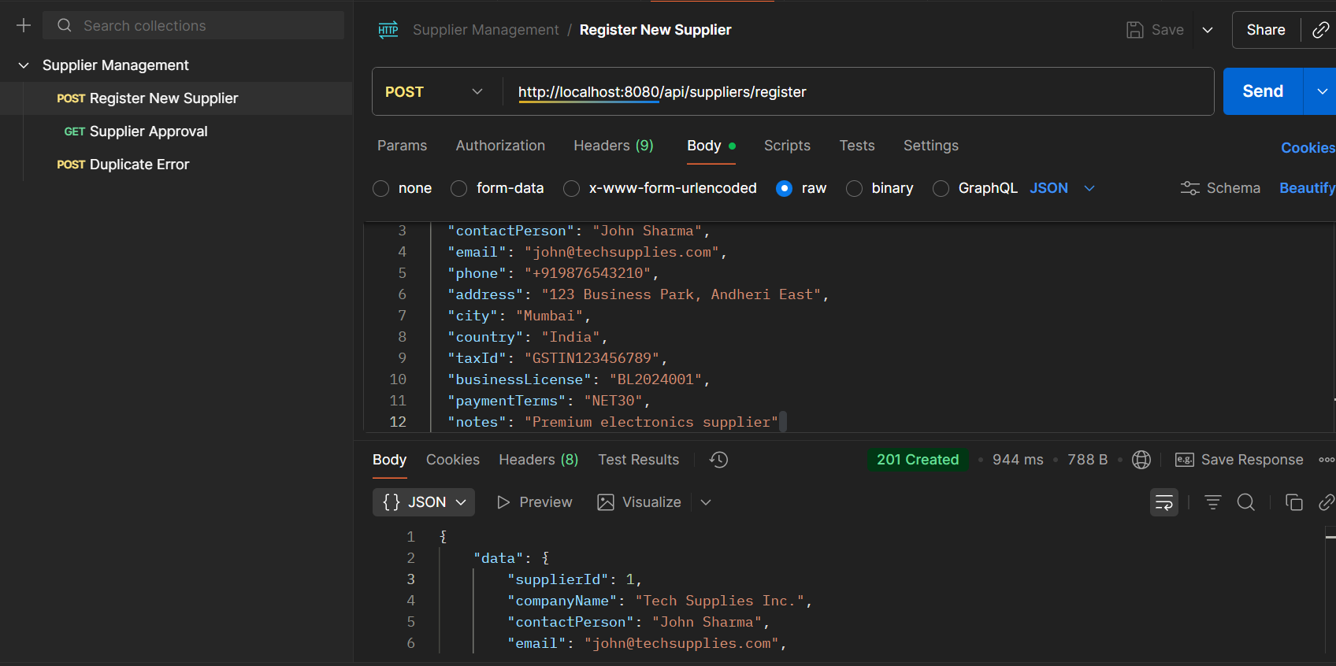

* **API Name: Register New Supplier**
* **Endpoint: http://localhost:8080/api/suppliers/register**
* **Method: POST**
* **Description: Creates a new supplier in the system and registers their details. The supplier is initially created with a PENDING status.**
* **Request Body:**

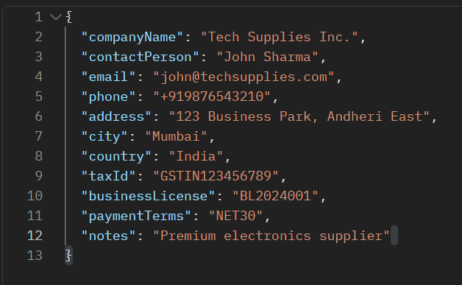

* **Respond Body:**

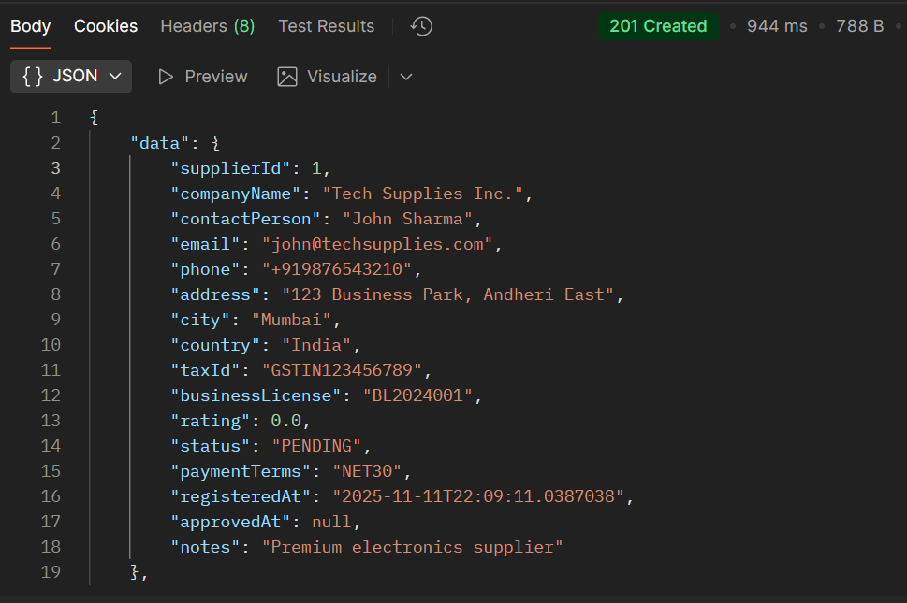

**API:1.2:**

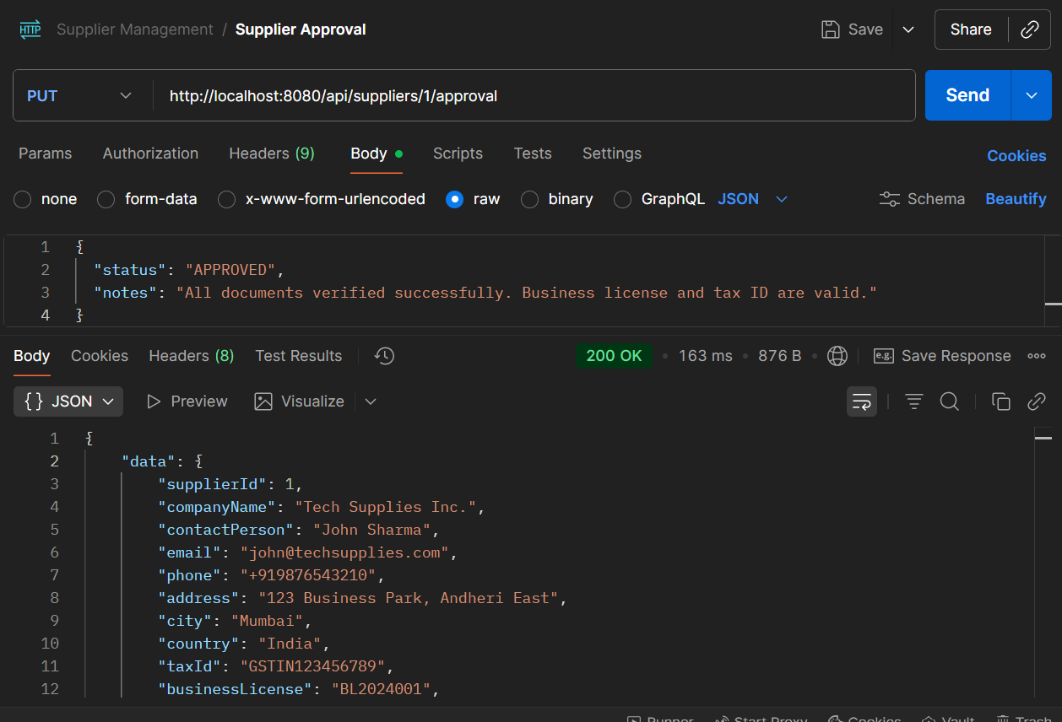

* **API Name: Update Supplier Approval Status**
* **Endpoint: http://localhost:8080/api/suppliers/1/approval**
* **Method: PUT**
* **Description: Updates the approval status and related information for a specific supplier. The {1} in the endpoint is a path parameter representing the supplierId.**
* **Request Body:**

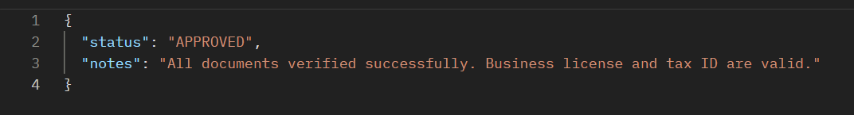

* **Respond Body:  
  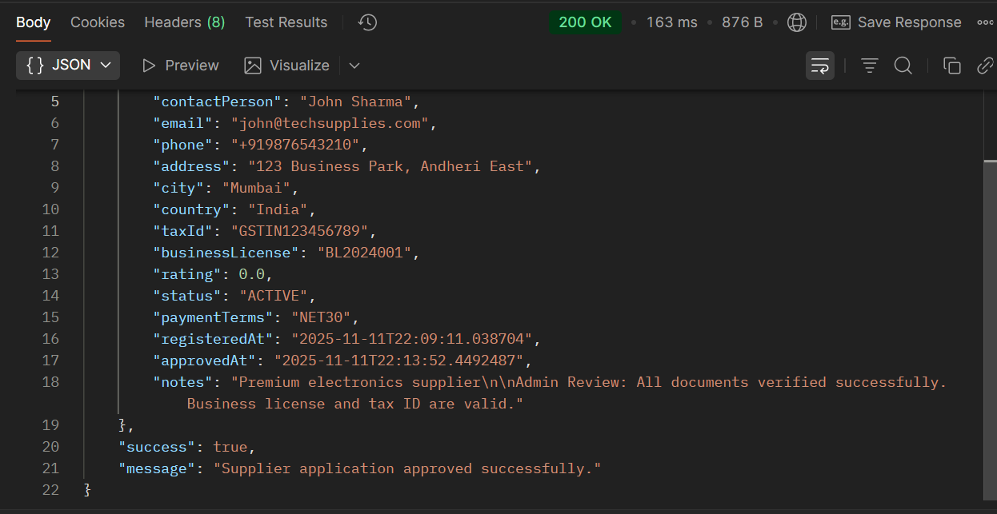**

**Error TESTING SCENARIOS For Process 1:**

**Error 1: Missing Required Fields:**

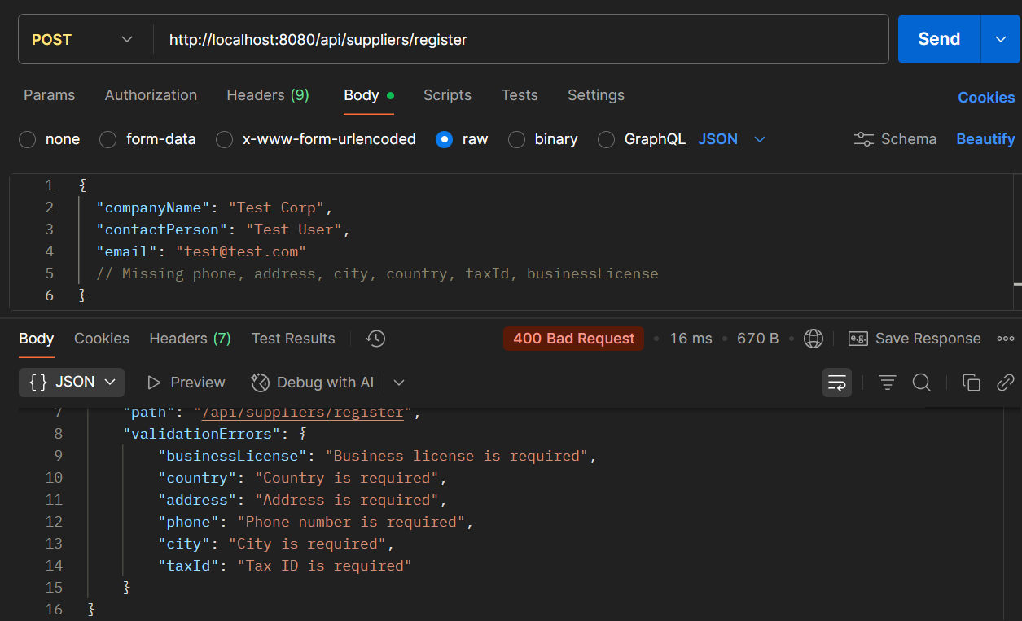

**2. Invalid Data Types:**

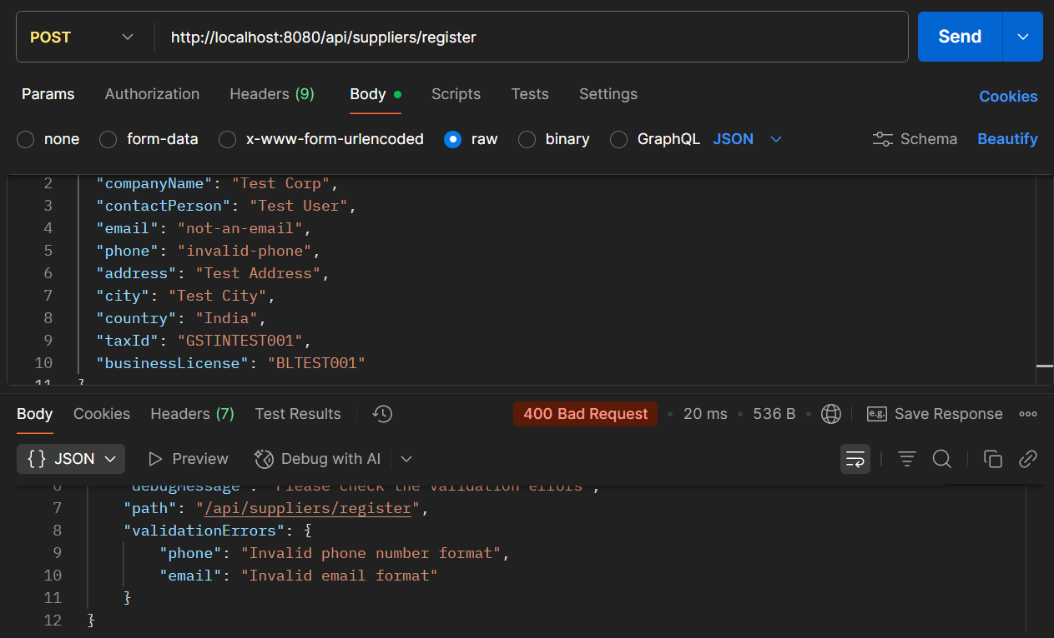

**3. Duplicate Entries:**

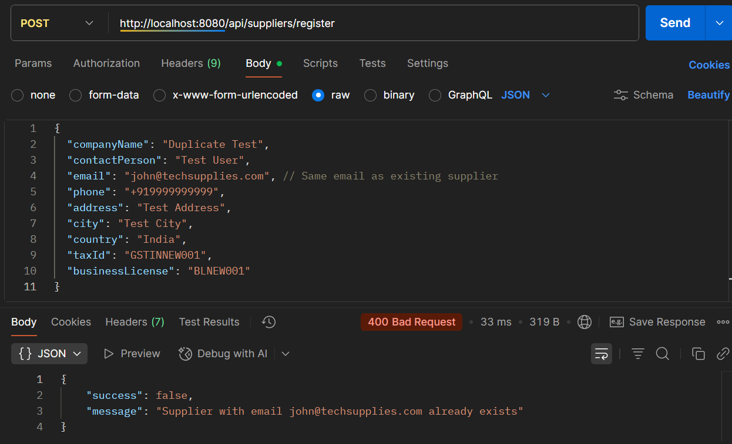

**PROCESS 2: VENDOR CONTRACT MANAGEMENT**

**API 2.1: Create Contract**

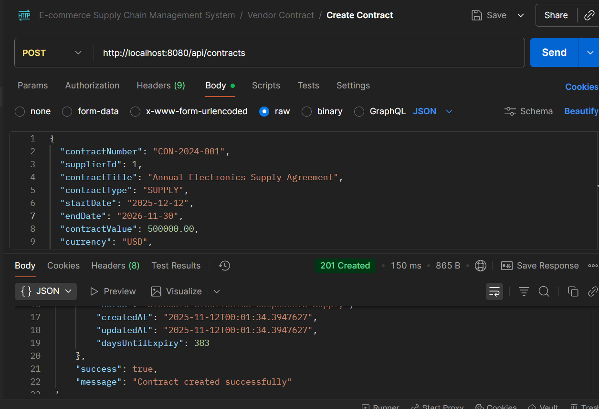

* **API Name: Create Contract**
* **Endpoint:**[**http://localhost:8080/api/contracts**](http://localhost:8080/api/contracts)
* **Method: POST**
* **Description: Creates a new contract, linking it to a specific supplier and defining its terms, value, and duration.**
* **Request Body:**

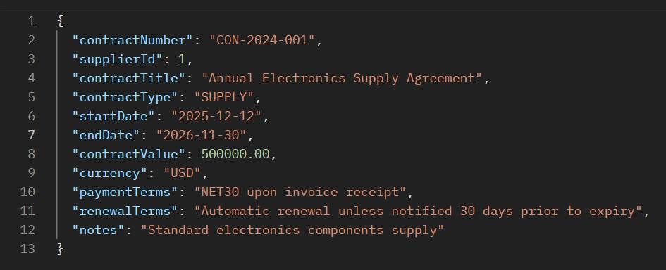

* **Respond Body:**

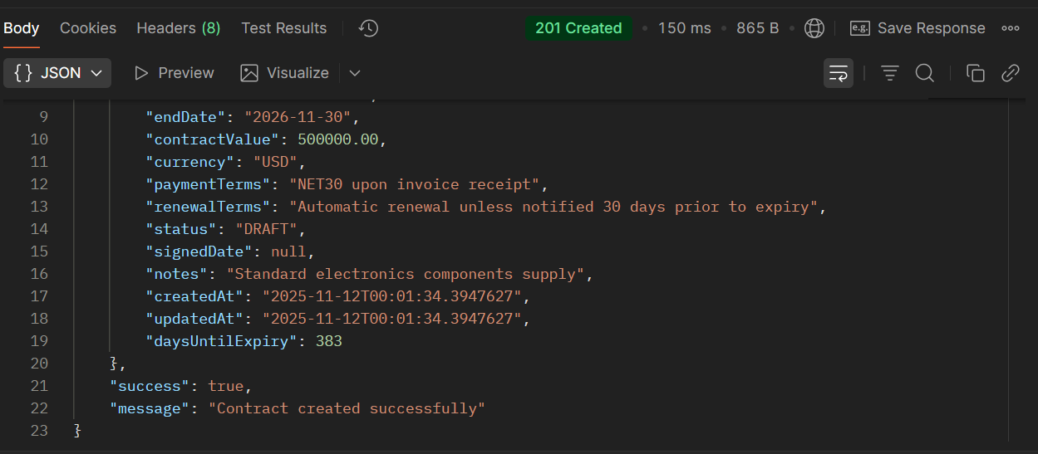

**API 2.2: Add SLA to Contract**

**First, create a contract using API 2.1 success case to get contractId**

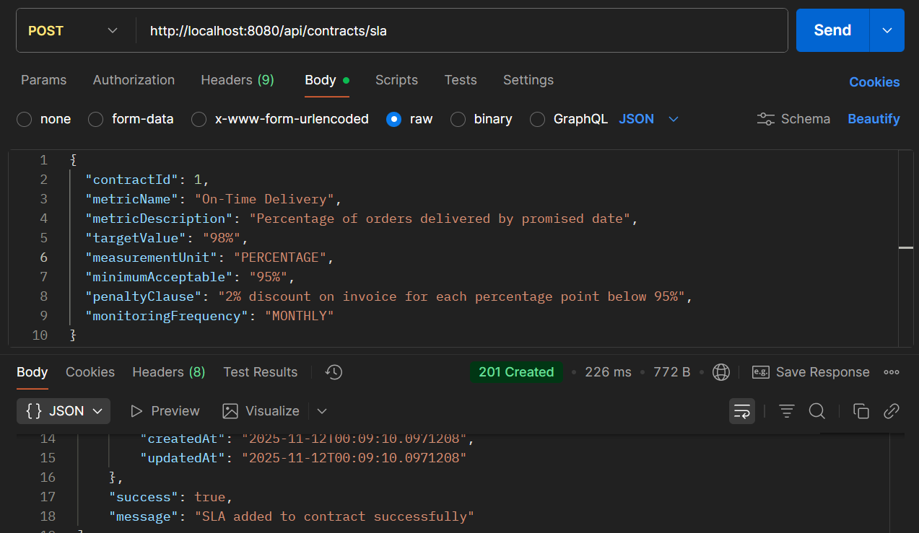

* **API Name: Add SLA to Contract**
* **Endpoint: http://localhost:8080/api/contracts/sla**
* **Method: POST**
* **Description:**Adds a Service Level Agreement (SLA) metric to an existing contract, defining performance targets, measurement units, and penalties for non-compliance.
* **Example Request Body:**

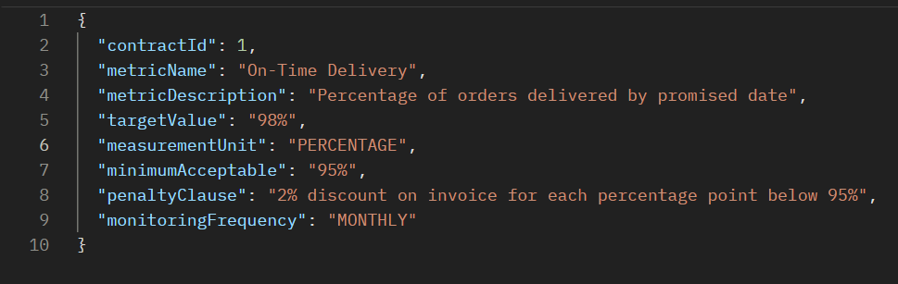

* **Respond Body:**

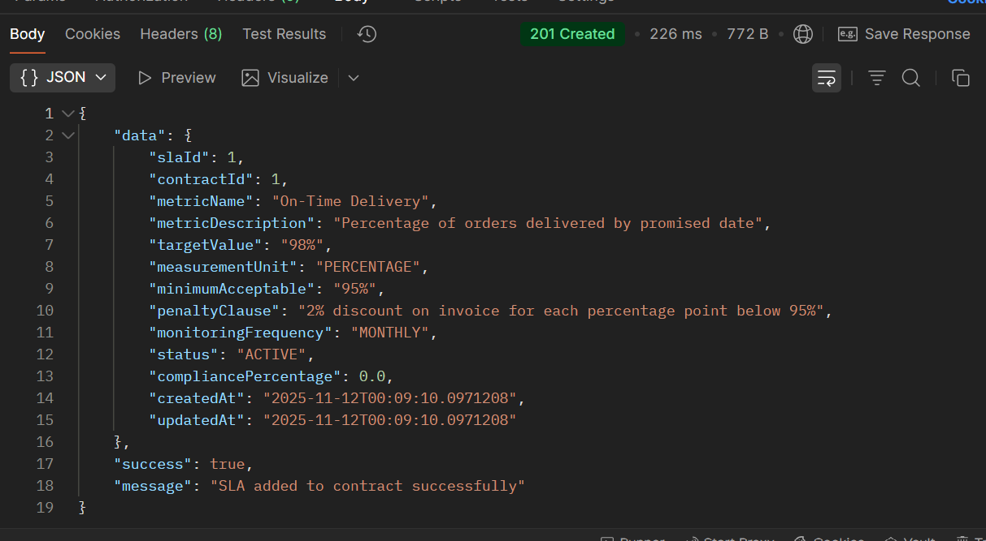

**Error Testing Scenarios For Process 2:**

**Error 1: Missing Required Payment Terms Field**

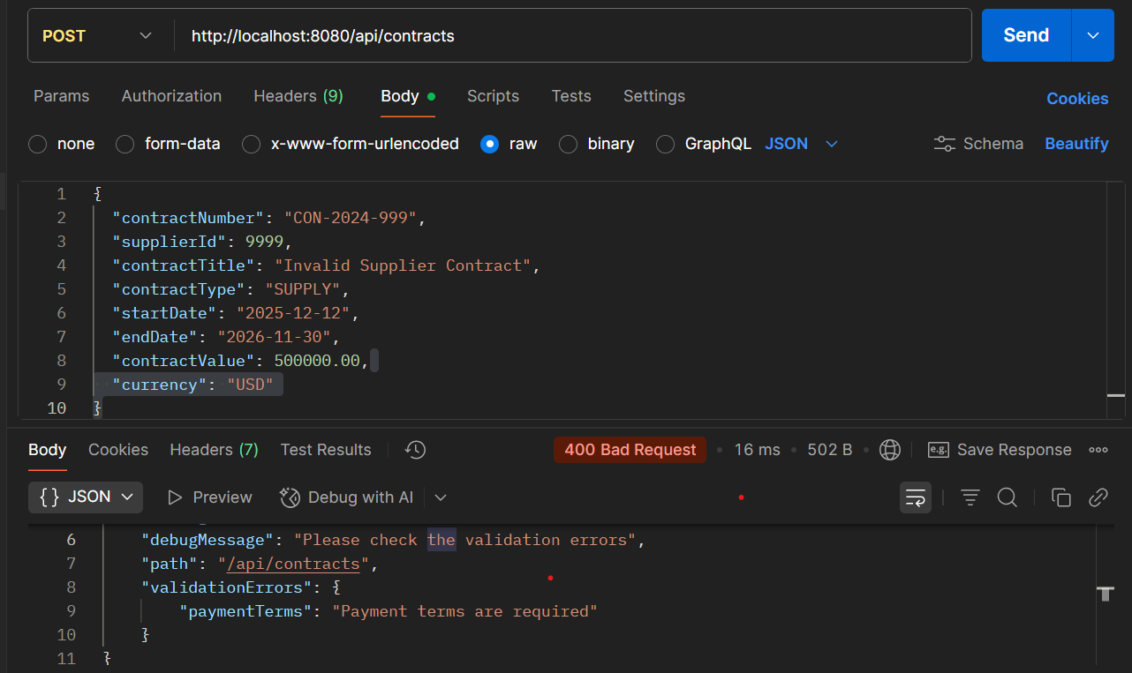

**PROCESS 3: PROCUREMENT OF GOODS**

**API 3.1: Create Purchase Order**

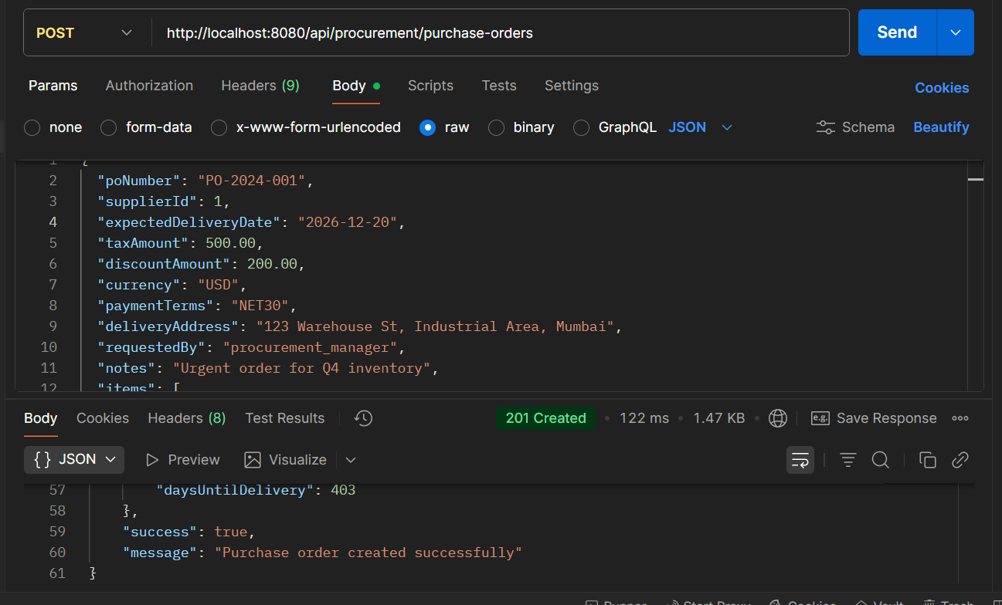

* **API Name: Create Purchase Order**
* **Endpoint:**[**http://localhost:8080/api/procurement/purchase-orders**](http://localhost:8080/api/procurement/purchase-orders)
* **Method: POST**
* **Description:**Creates a new purchase order for procurement, including header information and line items.
* **Request Body:**

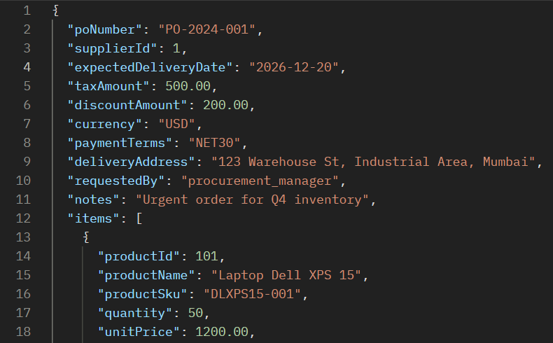

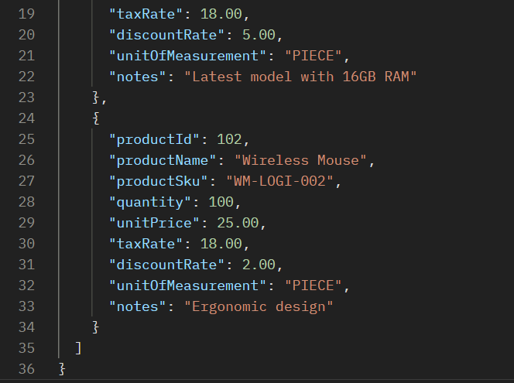

* **Response Body:**

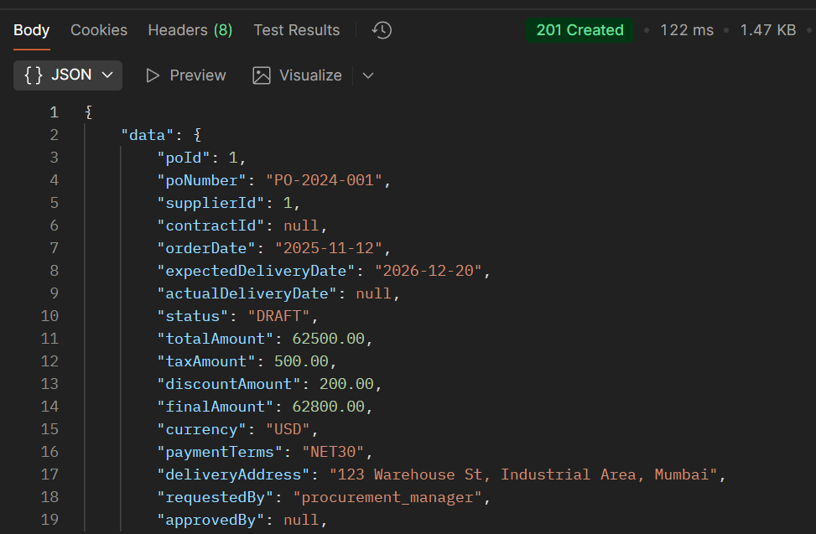

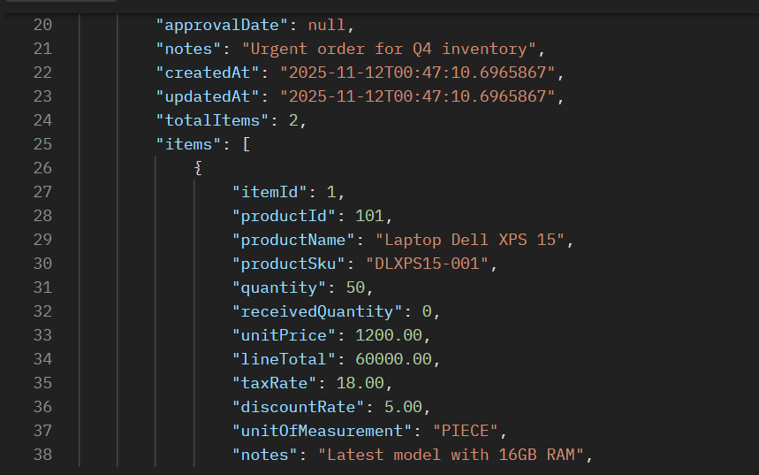 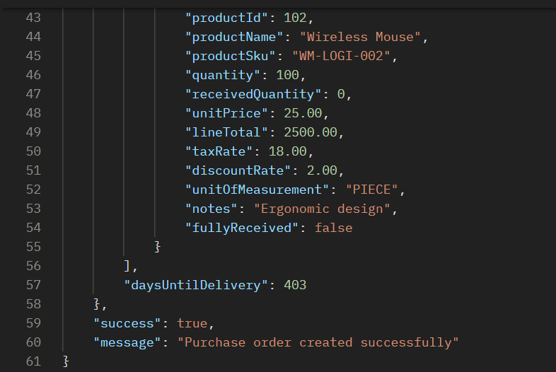

**API 3.2: Approve Purchase Order**

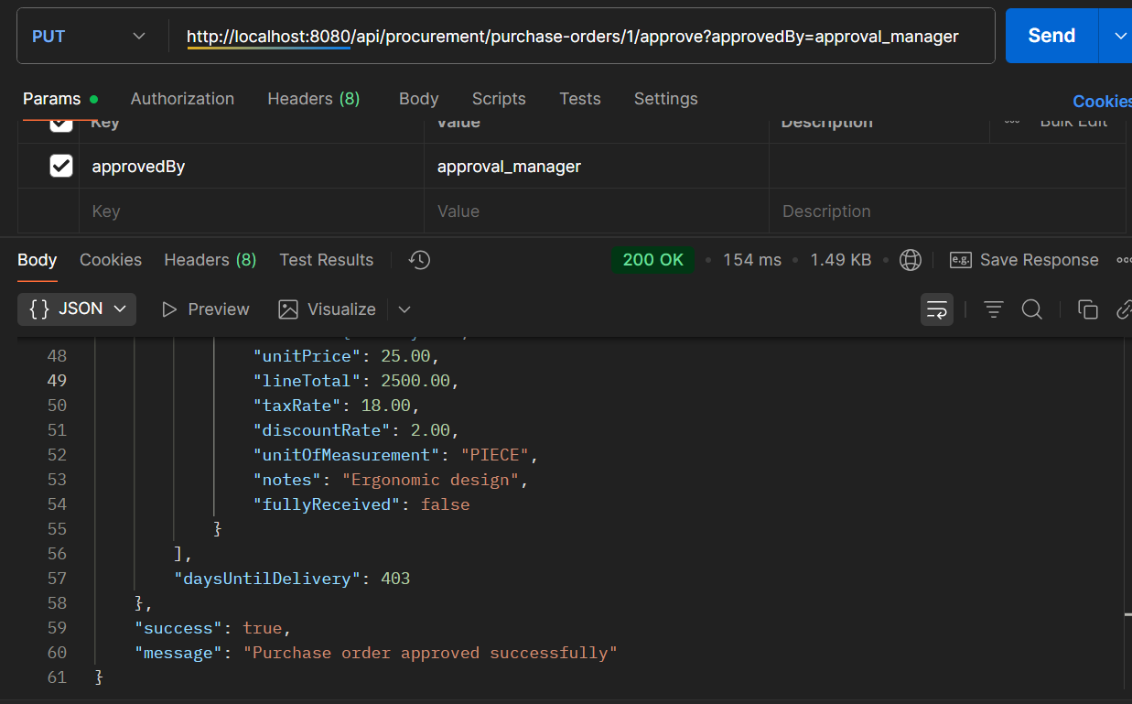

* **API Name: Approve Purchase Order**
* **Endpoint:**[**http://localhost:8080/api/procurement/purchase-orders/1/approve?approvedBy=approval_manager**](http://localhost:8080/api/procurement/purchase-orders/1/approve?approvedBy=approval_manager)
* **Method: PUT**
* **Description: Approves an existing purchase order. The {1} in the endpoint is a path parameter for the purchaseOrderId, and it requires a approvedBy query parameter to specify who is approving the order.**
* **Example Request Body:  
  *This endpoint likely doesn't require a request body, as all necessary data (PO ID and approver) is passed via the URL.***
* **Example Response Body:**

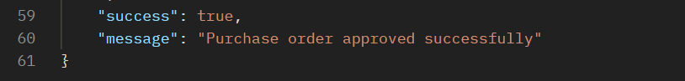

**Error Testing Scenarios for Process 3:**

**Error 1: Duplicate PO Number**

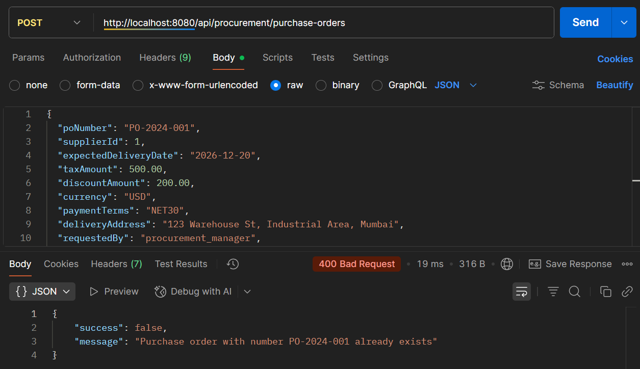

**PROCESS 4: GOODS RECEIVING & INSPECTION**

**API 4.1: Create Goods Receipt**

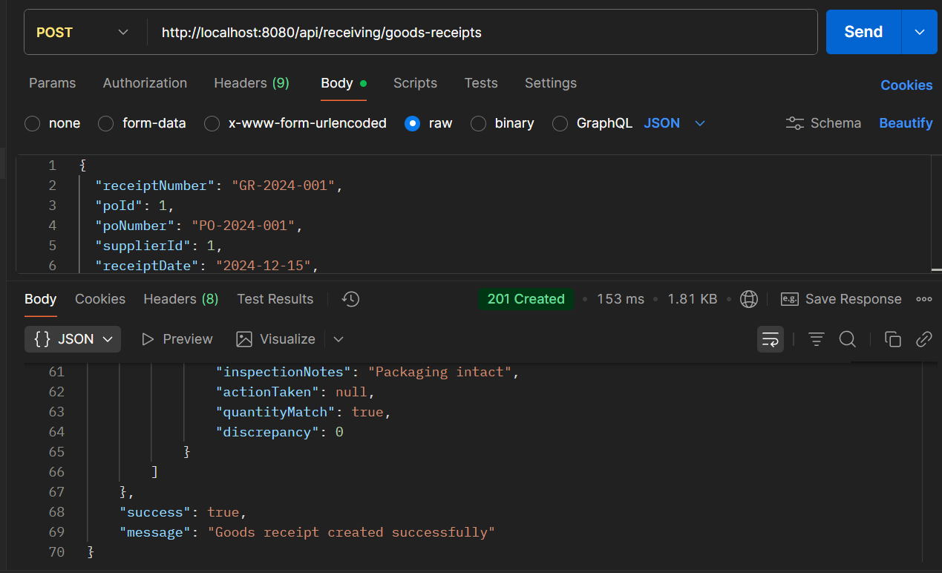

* **API Name: Create Goods Receipt**
* **Endpoint:**[**http://localhost:8080/api/receiving/goods-receipts**](http://localhost:8080/api/receiving/goods-receipts)
* **Method: POST**
* **Description:**Creates a goods receipt notice for received inventory against a purchase order, including inspection details and quantity verification.
* **Request Body:**

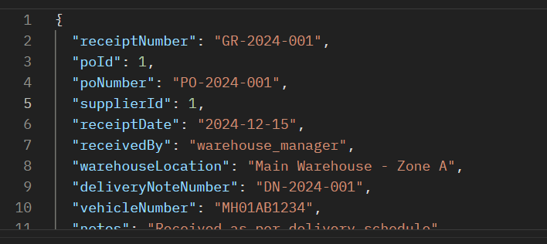

* **Respond Body:**

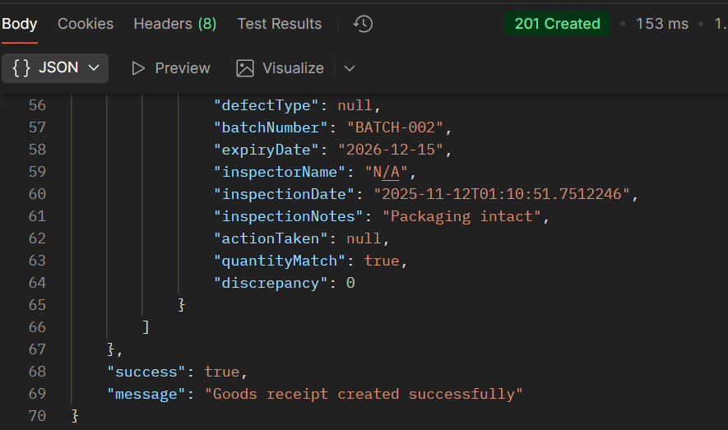

**API 4.2: Perform Quality Inspection:**

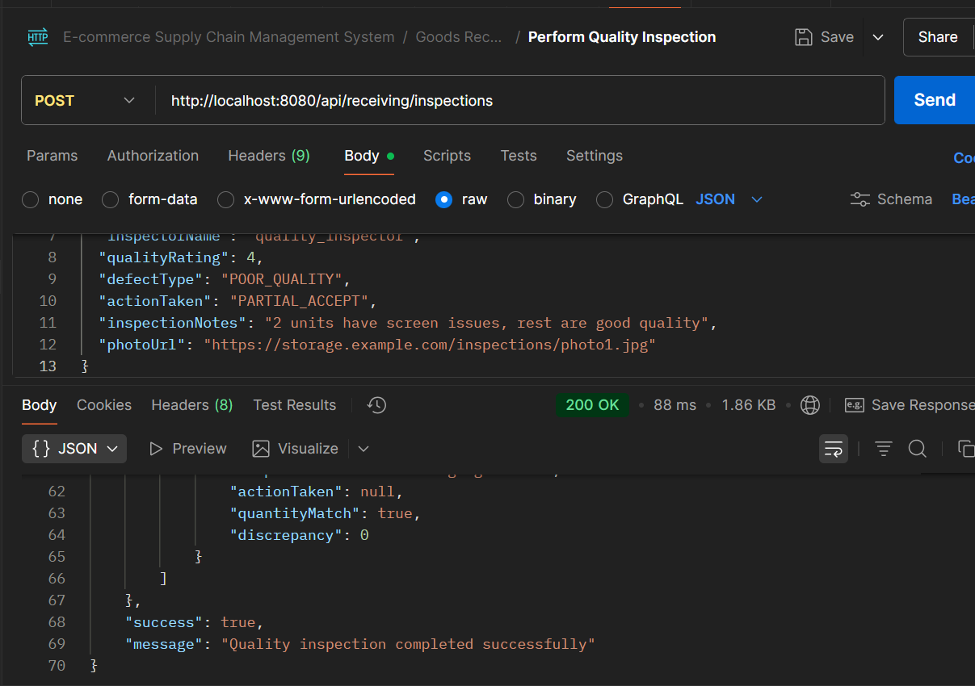

* **API Name: Create Quality Inspection**
* **Endpoint:**[**http://localhost:8080/api/receiving/inspections**](http://localhost:8080/api/receiving/inspections)
* **Method: POST**
* **Description:**Records quality inspection results for received goods, including defect classification, quality ratings, and actions taken.
* **Request Body:**

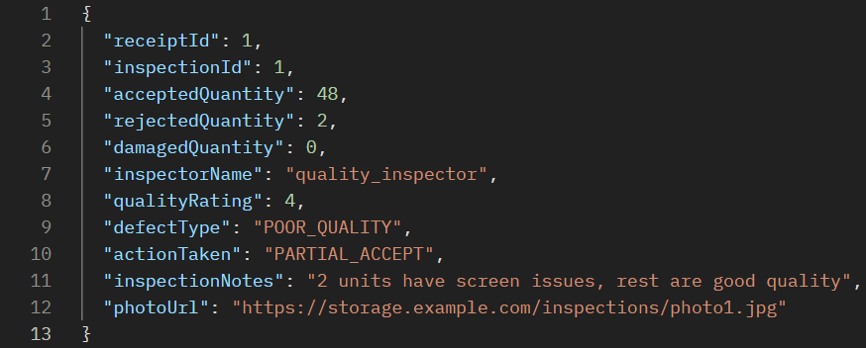

* **Respond Body:**

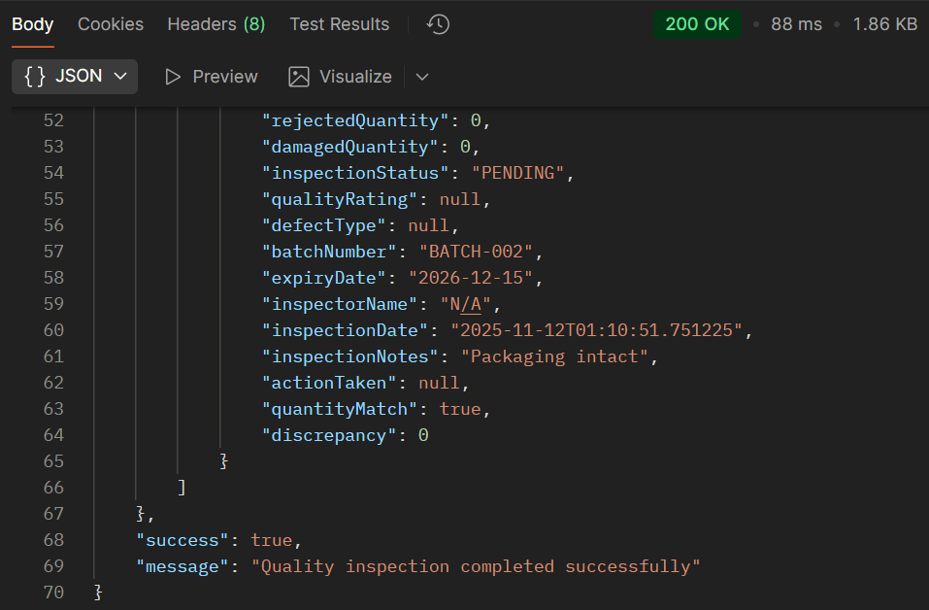

**ERROR Testing SCENARIOS FOR PROCESS 4**

**Error 1: Invalid Action Taken**

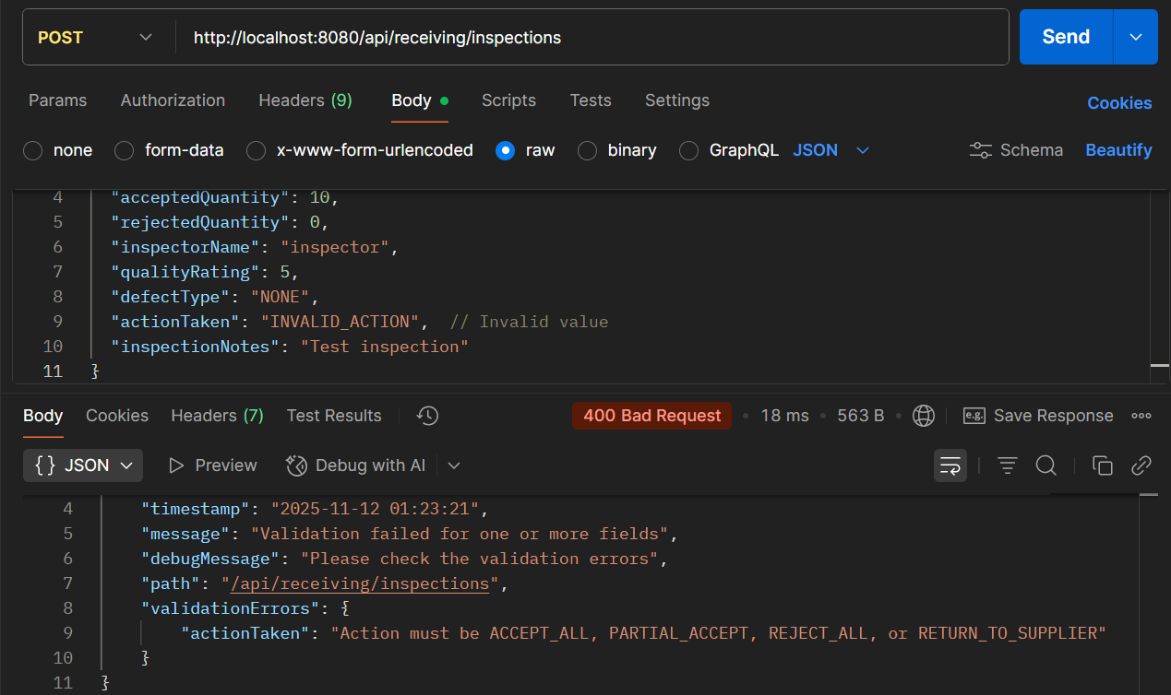

**PROCESS 5: STOCK ENTRY & CATALOG UPDATE**

**API 5.1: Add Product to Catalog**

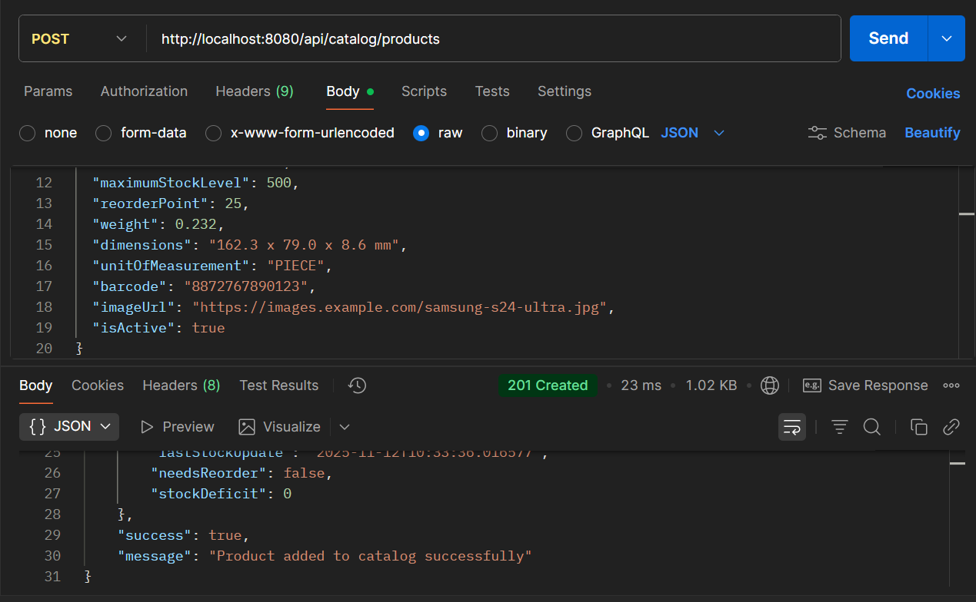

* **API Name: Add Product to Catalog**
* **Endpoint:**[**http://localhost:8080/api/catalog/products**](http://localhost:8080/api/catalog/products)
* **Method: POST**
* **Description: Adds a new product to the inventory catalog with comprehensive product details, stock management parameters, and product information.**
* **Request Body:**

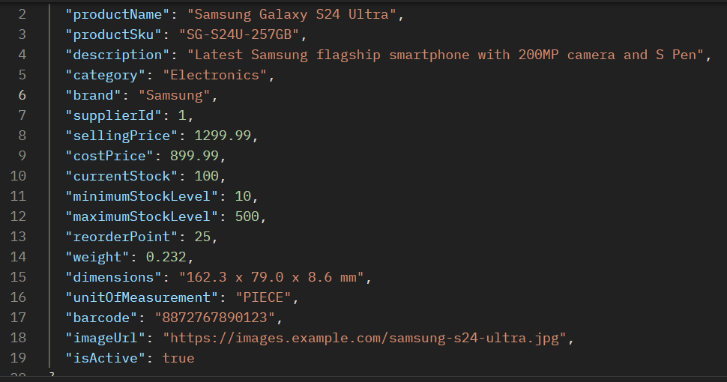

* **Respond Body:**

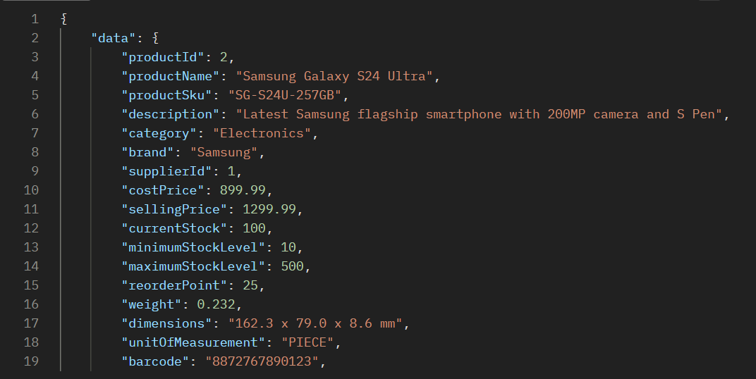

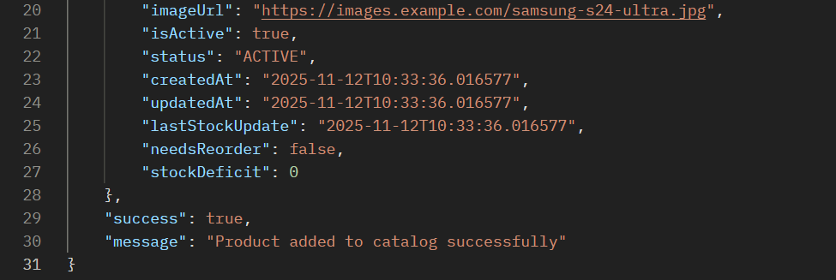

**API 5.2: Update Product Stock**

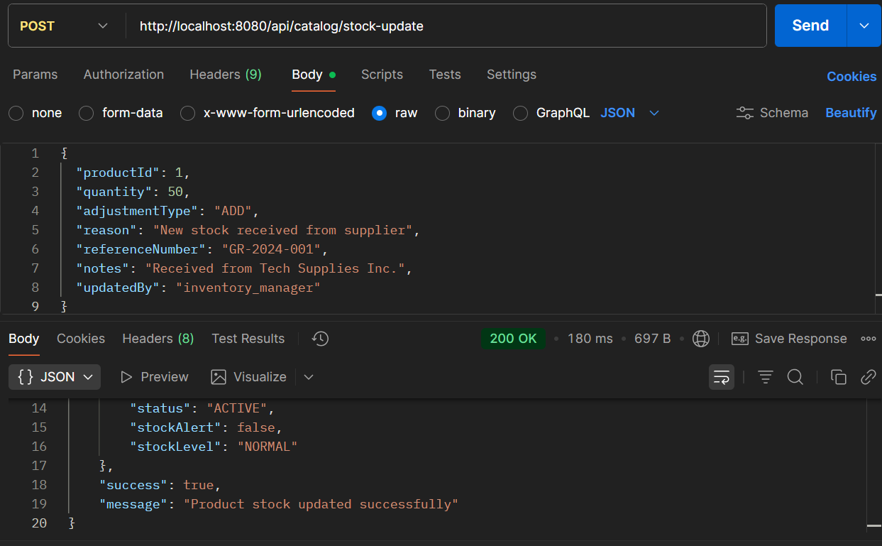

* **API Name: Generate Inventory Report**
* **Endpoint:**[**http://localhost:8080/api/reconciliation/inventory-report?warehouseId=1&reportType=SYSTEM_AUDIT**](http://localhost:8080/api/reconciliation/inventory-report?warehouseId=1&reportType=SYSTEM_AUDIT)
* **Method: POST**
* **Description: Generates comprehensive inventory reports with accuracy grading, performance ratings, and discrepancy analysis for specific warehouses and report types.**
* **Request Body:**

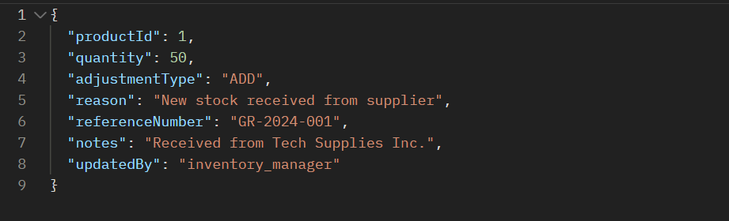

* **Response Body:**

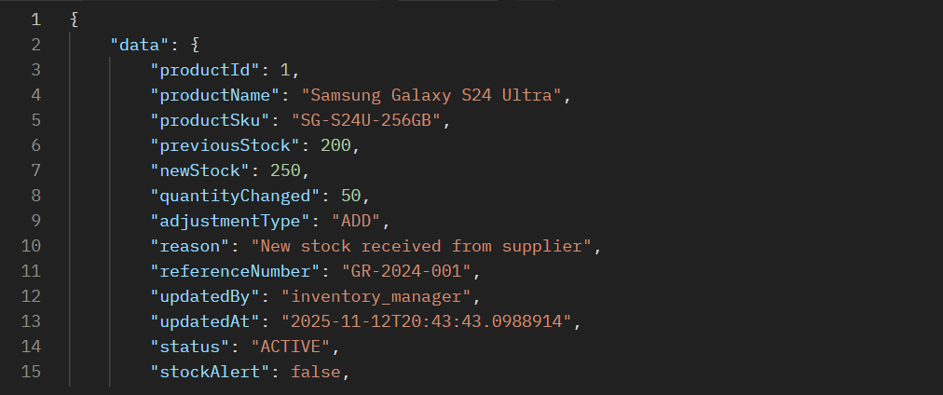

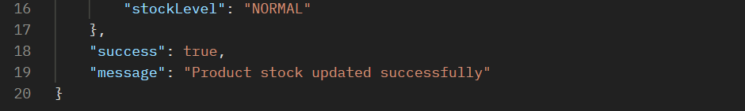

**Error Scenarios for Process 5**

**Error 1: Duplicate Product SKU**

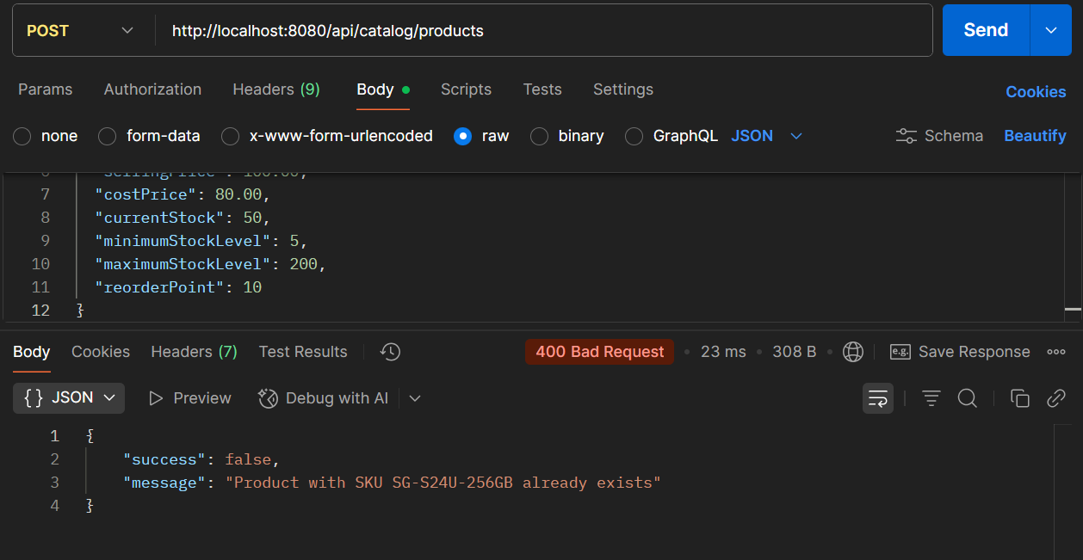

**Error 2: Invalid Adjustment Type**

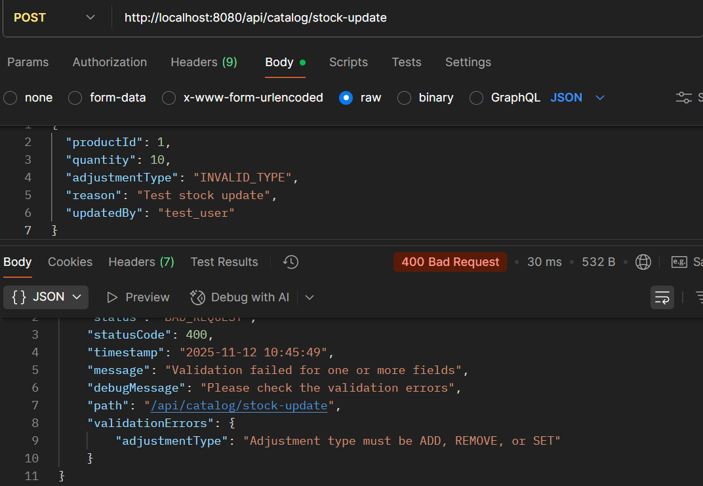

**Error 3: Non existing ID**

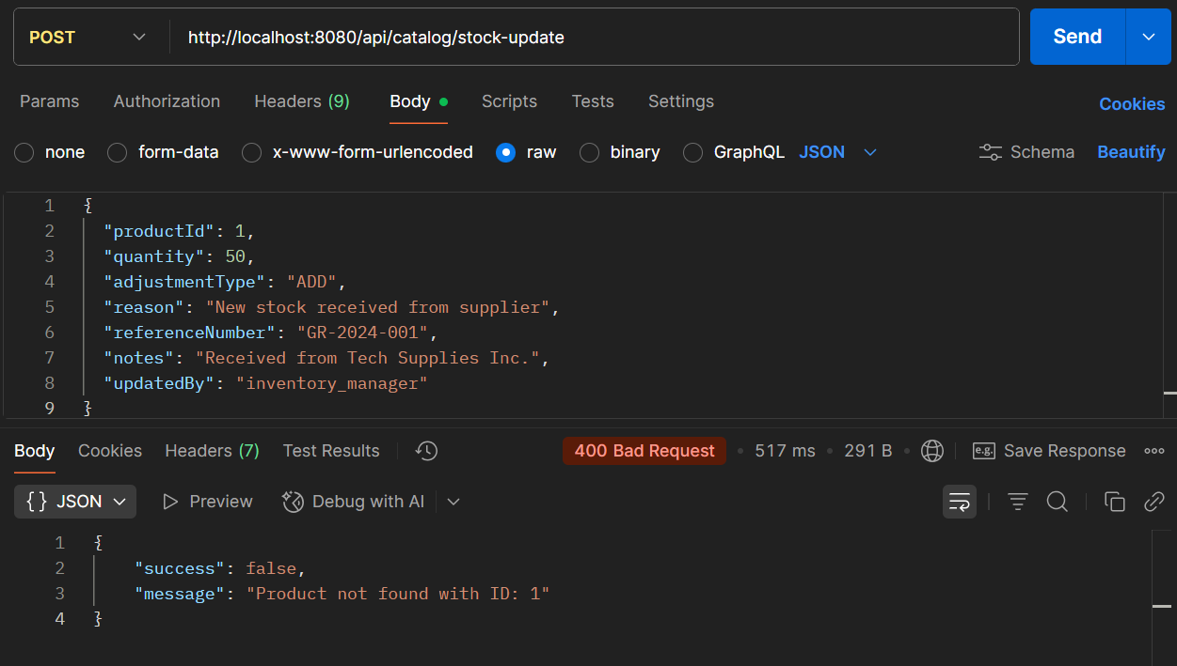

**PROCESS 6: INVENTORY MONITORING & STOCK ALERTS**

**API 6.1: Add to Inventory Monitoring**

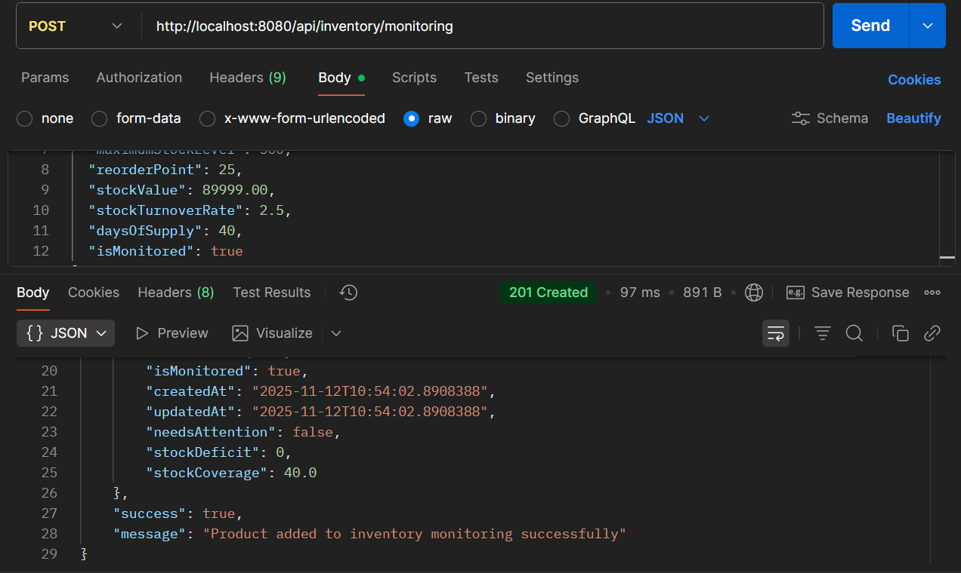

* **API Name: Add Product to Inventory Monitoring**
* **Endpoint:**[**http://localhost:8080/api/inventory/monitoring**](http://localhost:8080/api/inventory/monitoring)
* **Method: POST**
* **Description: Adds a product to inventory monitoring system with advanced inventory metrics, stock performance tracking, and automated alerting capabilities.**
* **Request Body:**

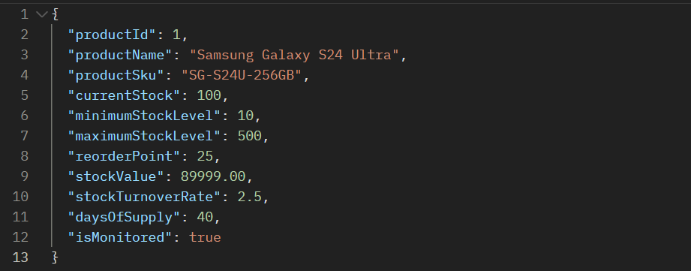

**Respond Body:**

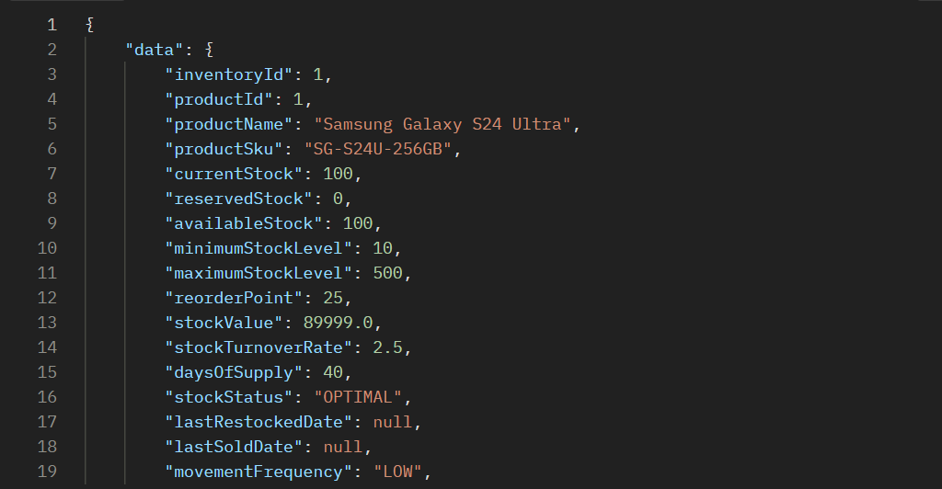

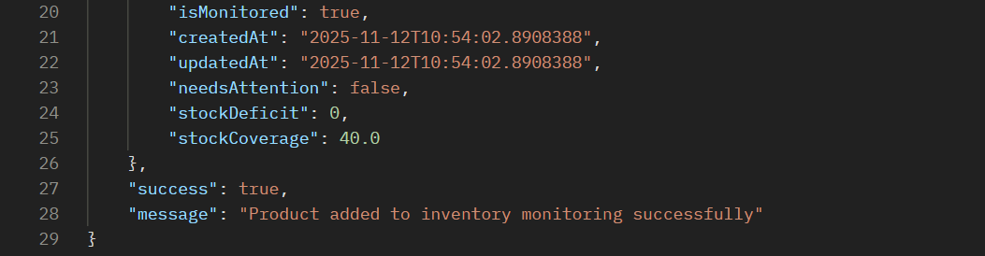

**API 6.2: Update Stock Alert**

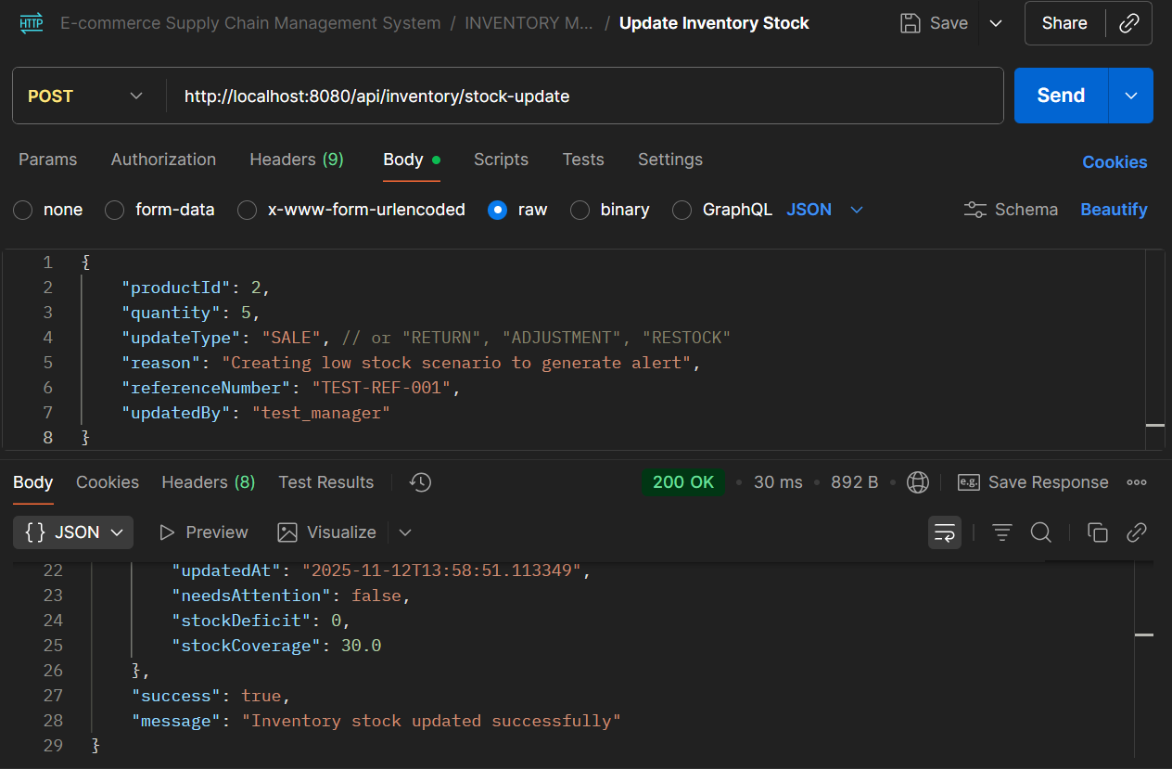

* **API Name: Update Inventory Stock**
* **Endpoint:**[**http://localhost:8080/api/inventory/stock-update**](http://localhost:8080/api/inventory/stock-update)
* **Method: POST**
* **Description: Updates inventory stock levels with different transaction types (sales, returns, adjustments, restock) and maintains audit trail for inventory movements.**
* **Request Body:**

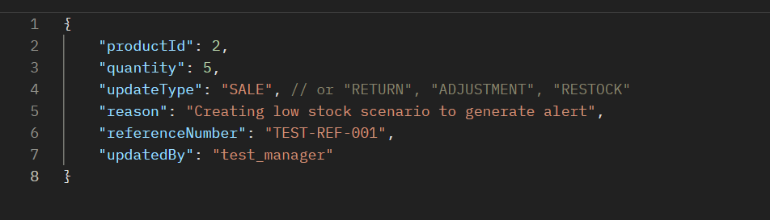

* **Respond Body:**

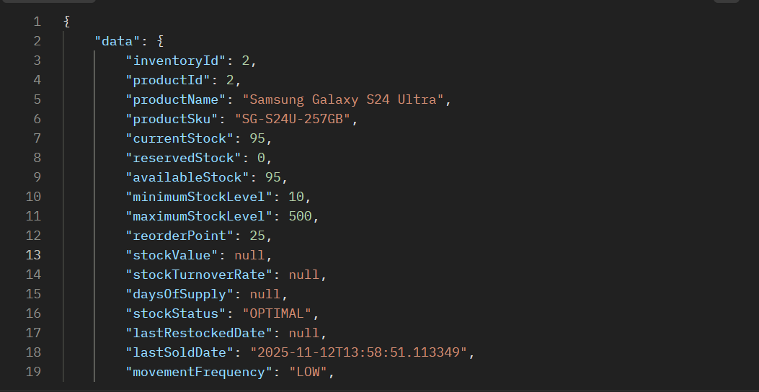

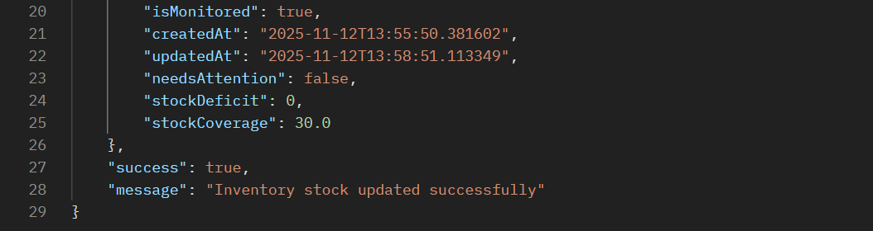

**API TO TEST LOW STOCK ALERT  
Step 1: Set Stock BELOW Reorder Point**

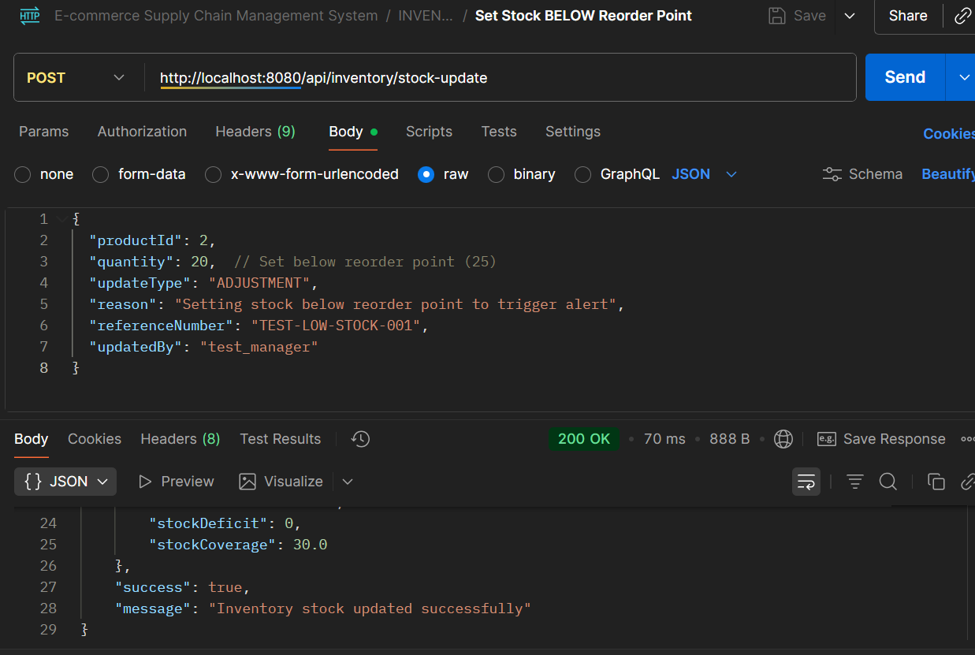

* **API Name: Update Inventory Stock**
* **Endpoint:**[**http://localhost:8080/api/inventory/stock-update**](http://localhost:8080/api/inventory/stock-update)
* **Method: POST**
* **Description: Updates inventory stock levels with different transaction types and maintains comprehensive inventory tracking and alerting system.**
* **Request Body:**

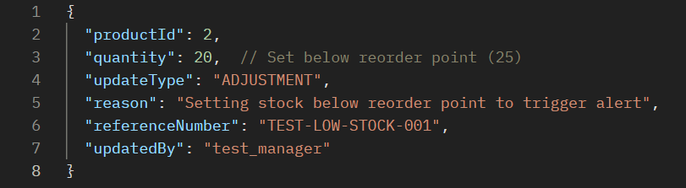

* **Respond Body:**

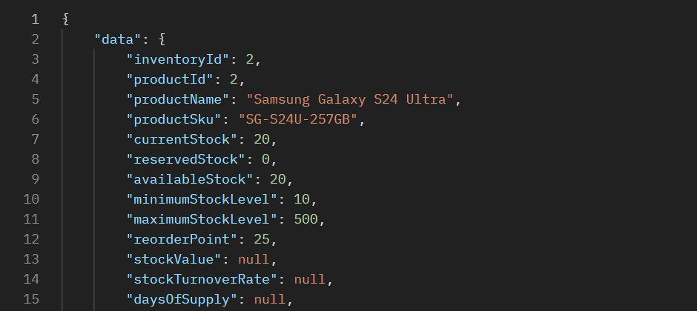

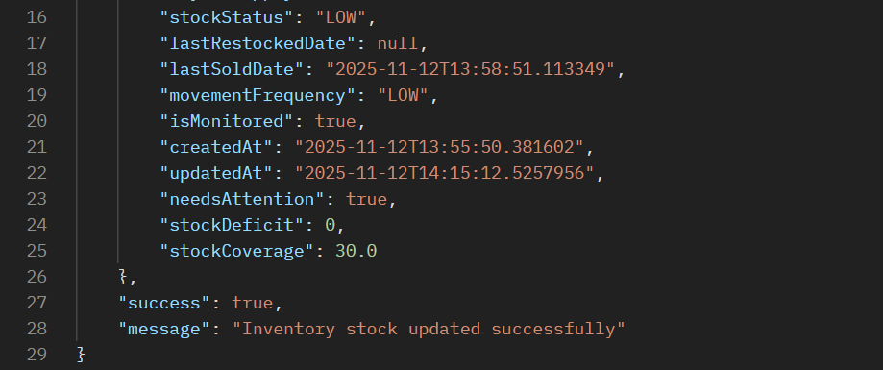

**Step 2: Run Health Check to Generate Alert**

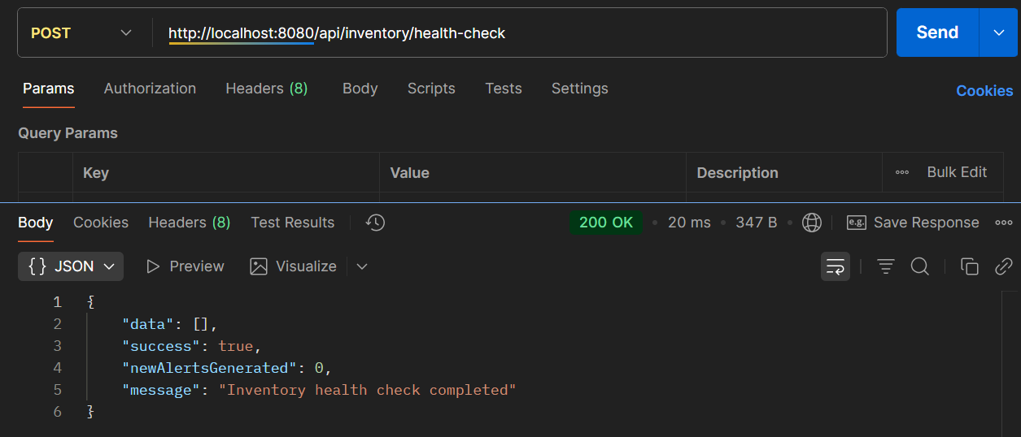

* **API Name: Inventory Health Check**
* **Endpoint:**[**http://localhost:8080/api/inventory/health-check**](http://localhost:8080/api/inventory/health-check)
* **Method: POST**
* **Description: Performs a system-wide inventory health check to identify stock issues, generate alerts for low stock, overstock, and other inventory anomalies.**
* **Example Request Body:**

***(NO BODY)***

* **Example Response Body:**

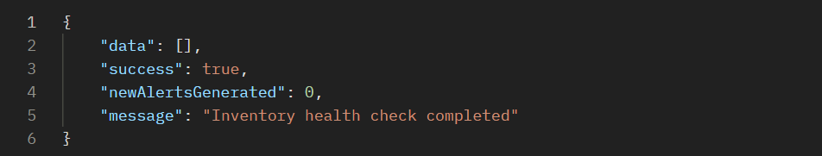

**Step 3: Get Active Alerts**

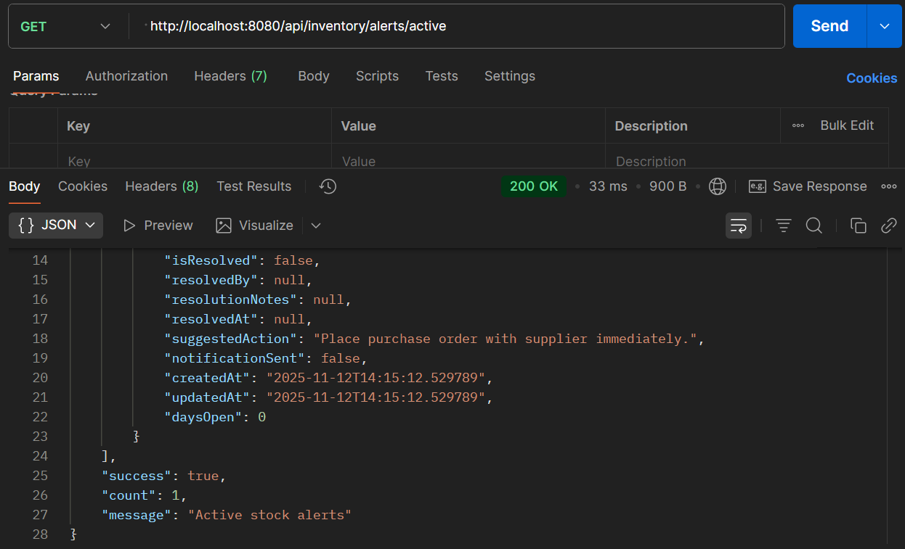

* **API Name: Get Active Inventory Alerts**
* **Endpoint:**[**http://localhost:8080/api/inventory/alerts/active**](http://localhost:8080/api/inventory/alerts/active)
* **Method: GET**
* **Description: Retrieves all active (unresolved) inventory alerts with detailed information including suggested actions and alert status.**
* **Example Request Body:  
  *This is a GET endpoint and does not require a request body.***
* **Example Response Body:**

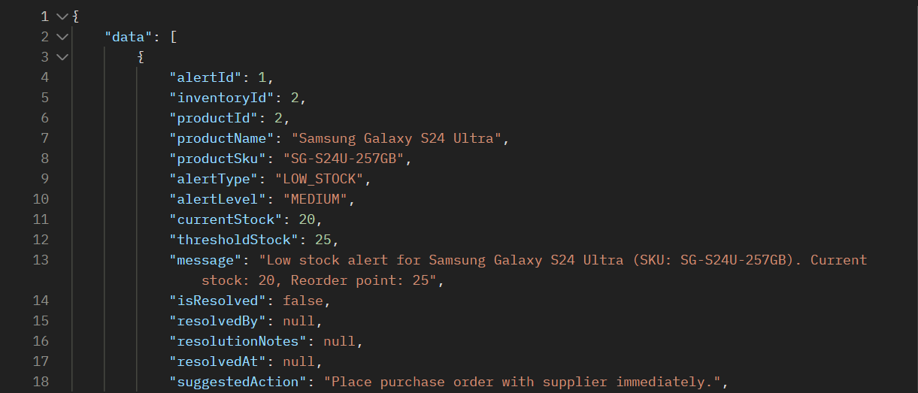

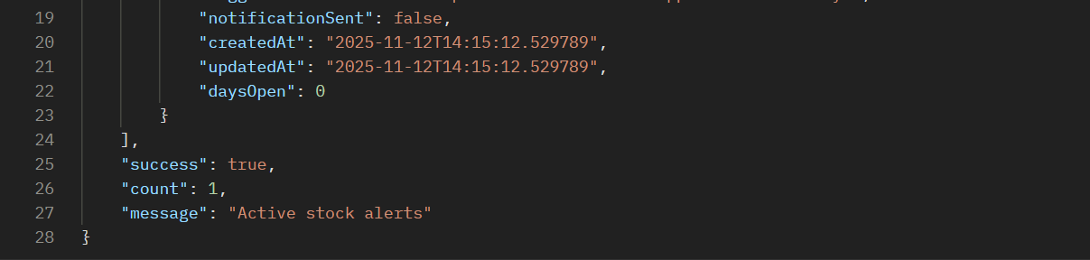

**Step 4: Low Stock Resolved**

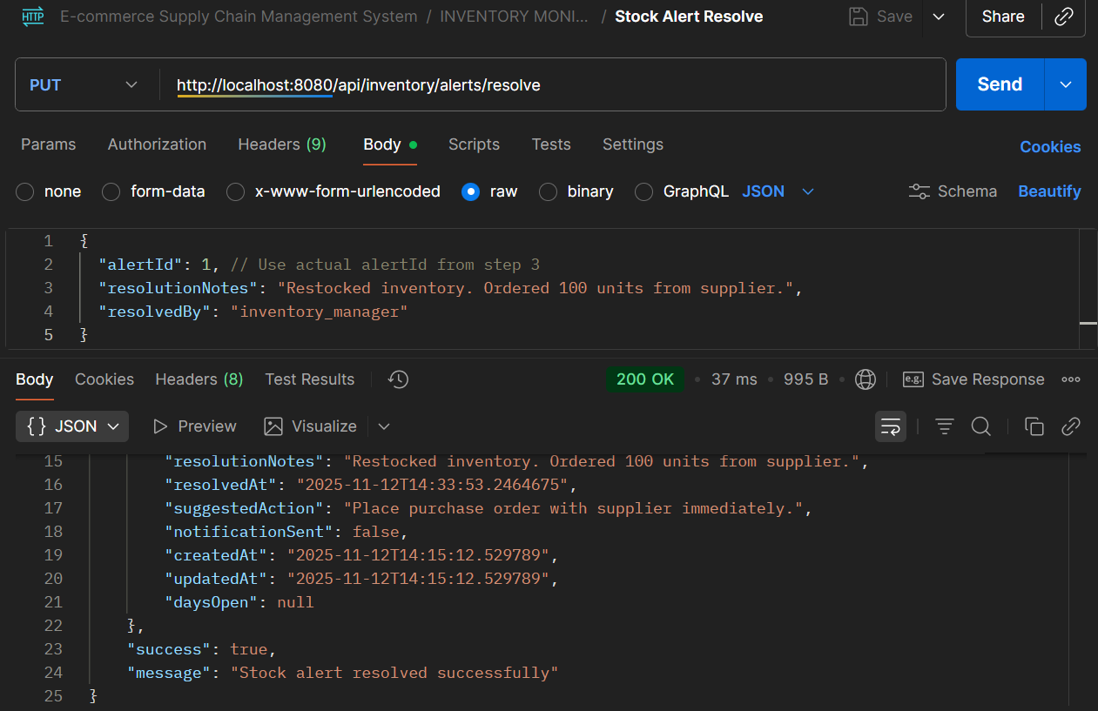

* **API Name: Resolve Inventory Alert**
* **Endpoint:**[**http://localhost:8080/api/inventory/alerts/resolve**](http://localhost:8080/api/inventory/alerts/resolve)
* **Method: PUT**
* **Description: Marks an active inventory alert as resolved with resolution details and audit trail.**
* **Request Body:**

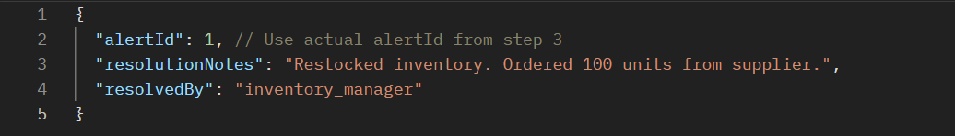

* **Respond Body:**

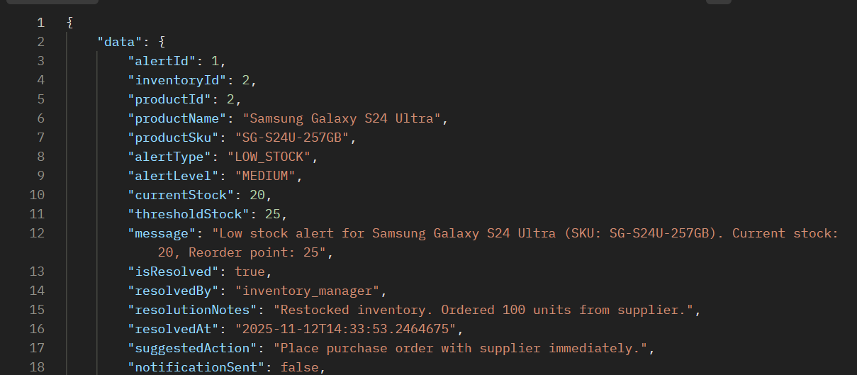

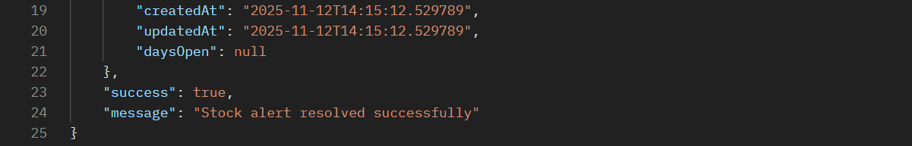

**NOTE:**

This API completes the inventory alert lifecycle by allowing users to resolve alerts with detailed resolution notes and tracking who resolved them and when. The system updates the resolvedAt timestamp and marks isResolved as true.

**PROCESS 7: DEMAND FORECASTING & REORDER PLANNING**

**API 7.1: Generate Demand Forecast**

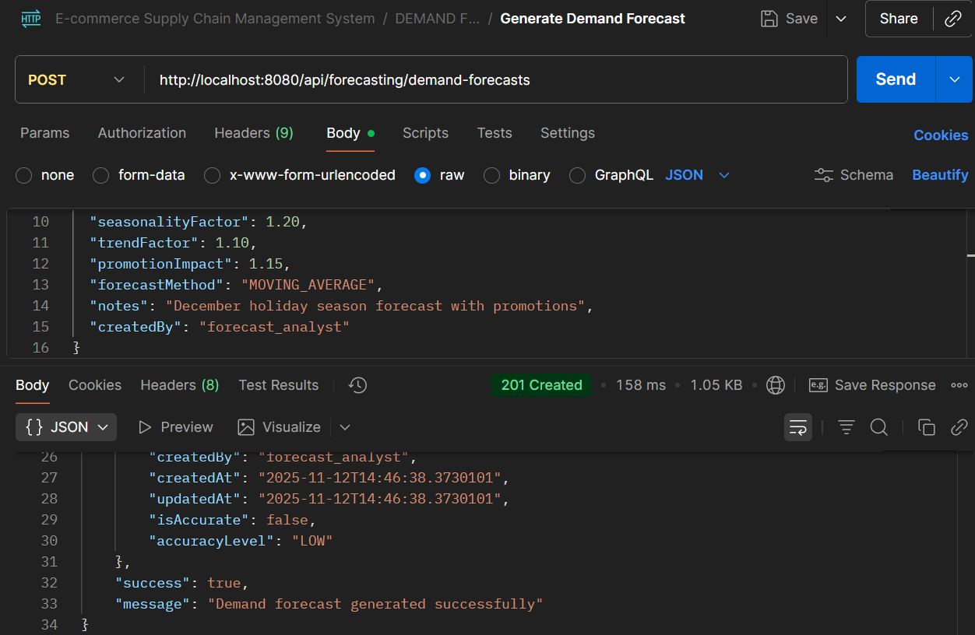

* **API Name: Generate Demand Forecast**
* **Endpoint:**[**http://localhost:8080/api/forecasting/demand-forecasts**](http://localhost:8080/api/forecasting/demand-forecasts)
* **Method: POST**
* **Description: Generates demand forecasts for products using various forecasting methods and factors like seasonality, trends, and promotions.**
* **Request Body:**

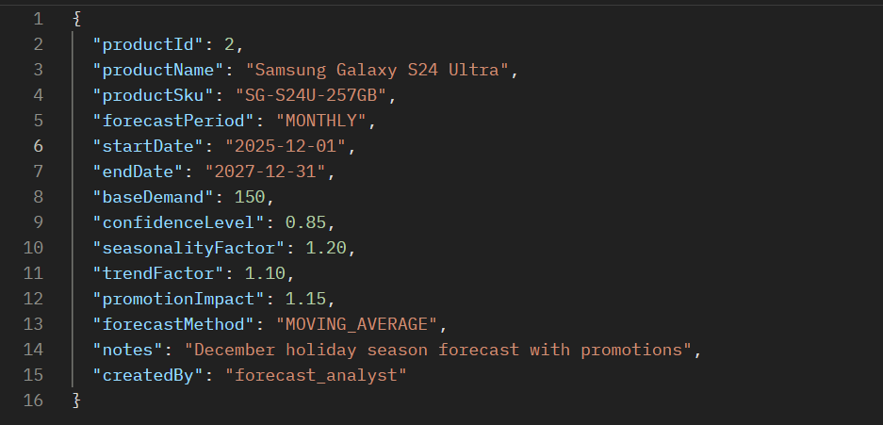

* **Respond Body:**

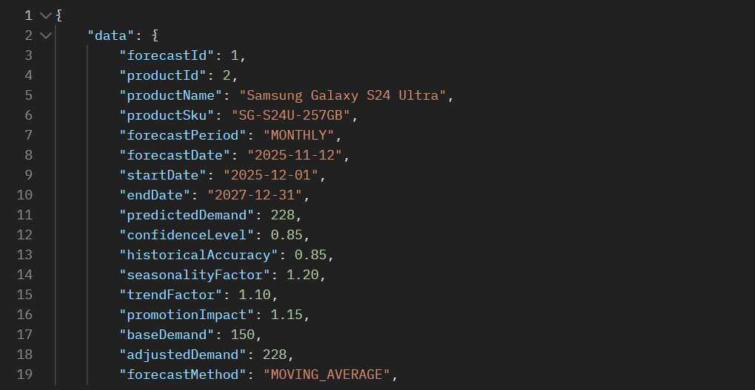

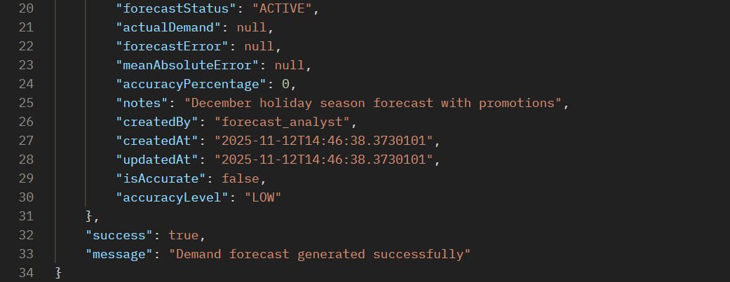

**API 7.2: Generate Reorder Plan**

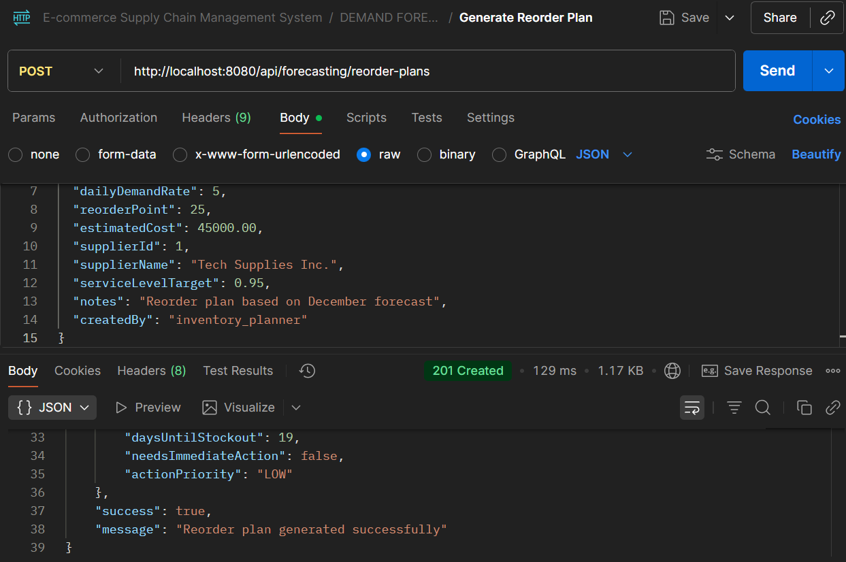

* **API Name: Generate Demand Forecast**
* **Endpoint:**[**http://localhost:8080/api/forecasting/demand-forecasts**](http://localhost:8080/api/forecasting/demand-forecasts)
* **Method: POST**
* **Description: Generates demand forecasts for products using various forecasting methods and factors like seasonality, trends, and promotions.**
* **Request Body:**

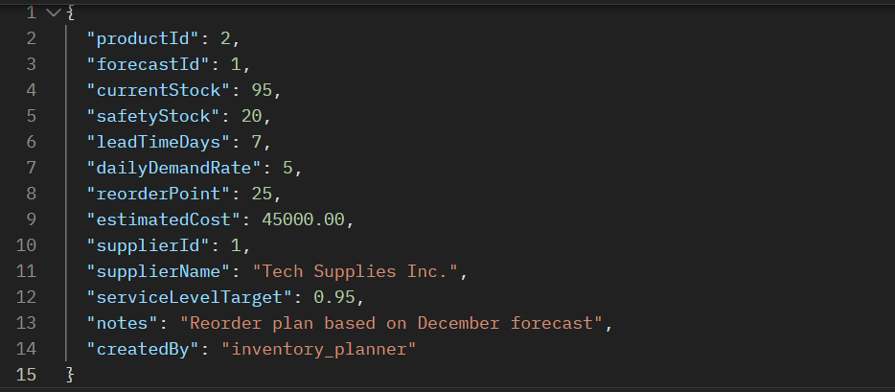

* **Respond Body:**

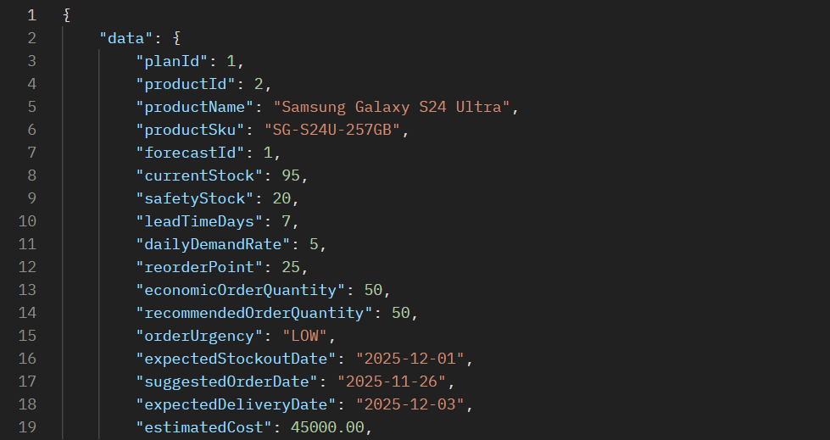

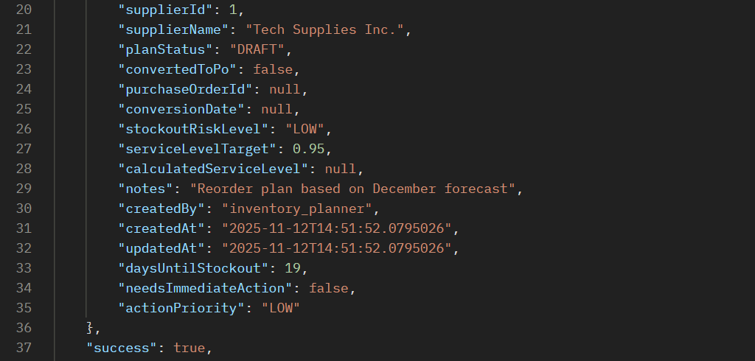



**ERROR SCENARIOS FOR PROCESS 7**

**Error 1: Invalid Forecast Period & Invalid Forecast Method**

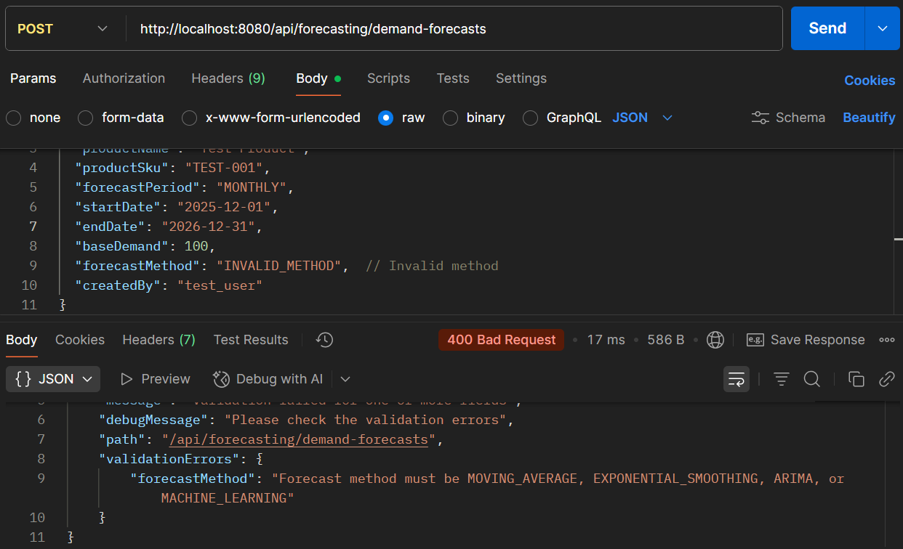

**Error 2: Invalid Forecast Period**

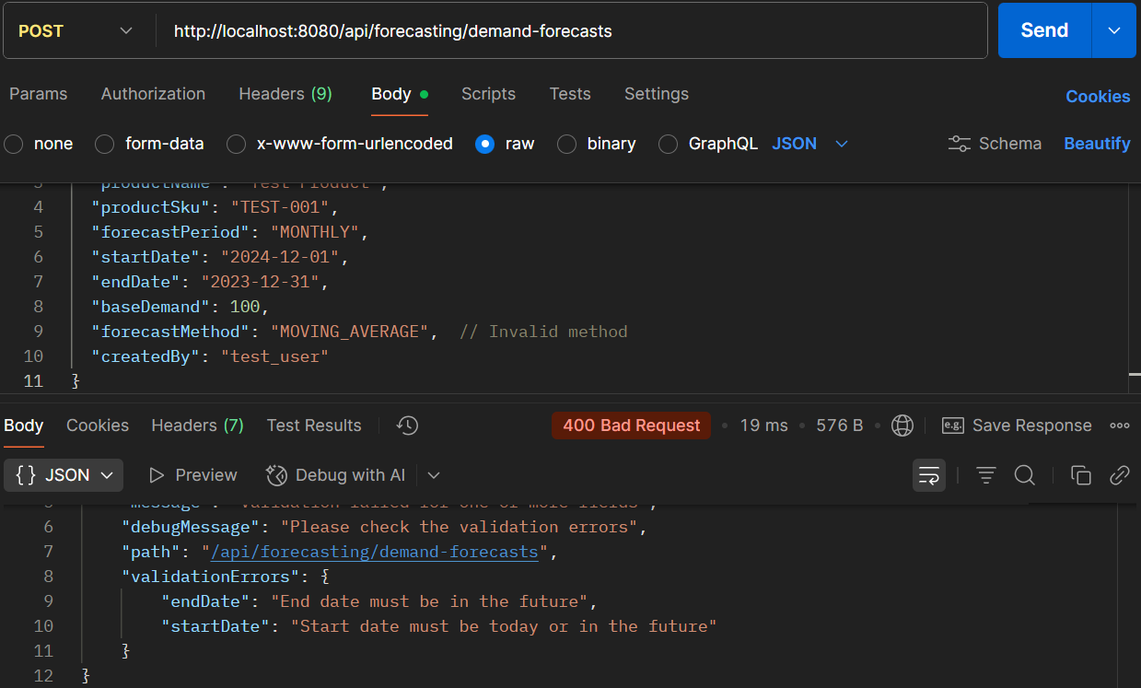

**PROCESS 8: WAREHOUSE STORAGE & SHELF PLACEMENT**

**API 8.1: Create Warehouse**

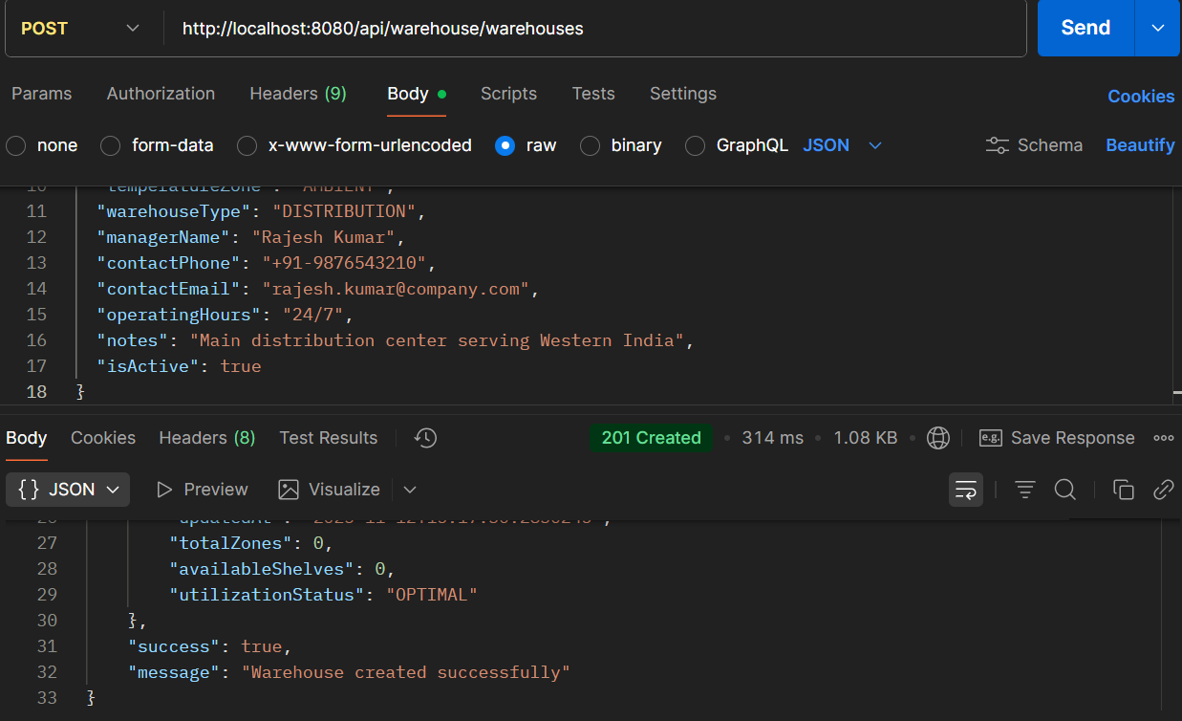

* **API Name: Create Warehouse**
* **Endpoint:**[**http://localhost:8080/api/warehouse/warehouses**](http://localhost:8080/api/warehouse/warehouses)
* **Method: POST**
* **Description: Creates a new warehouse facility with comprehensive details including location, capacity, contact information, and operational parameters.**
* **Request Body:**

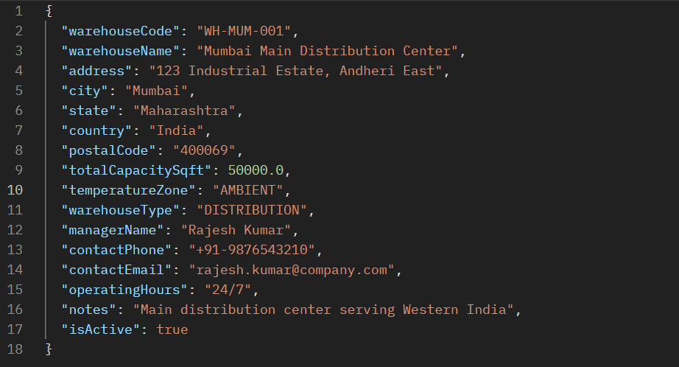

* **Respond Body:**

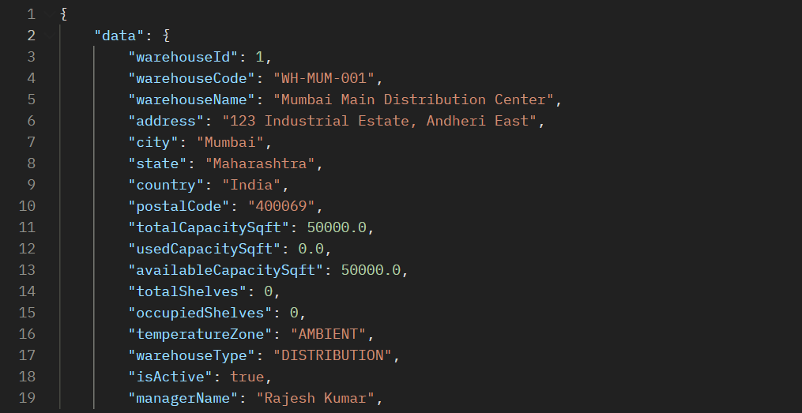

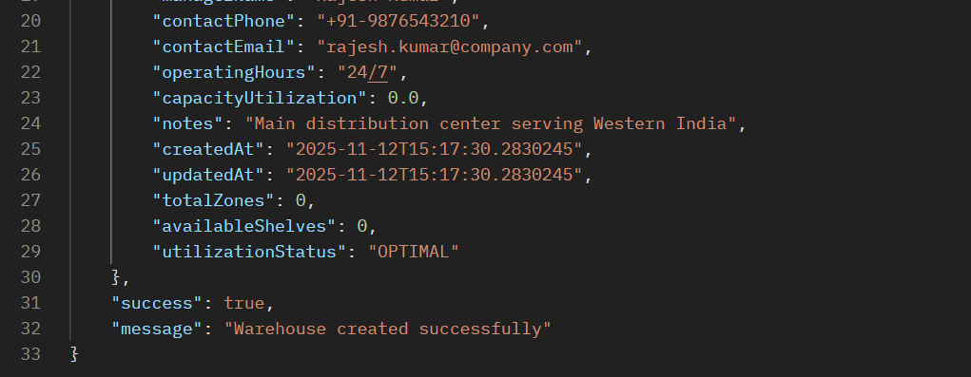

**API 8.2: Warehouses with Available Capacity**

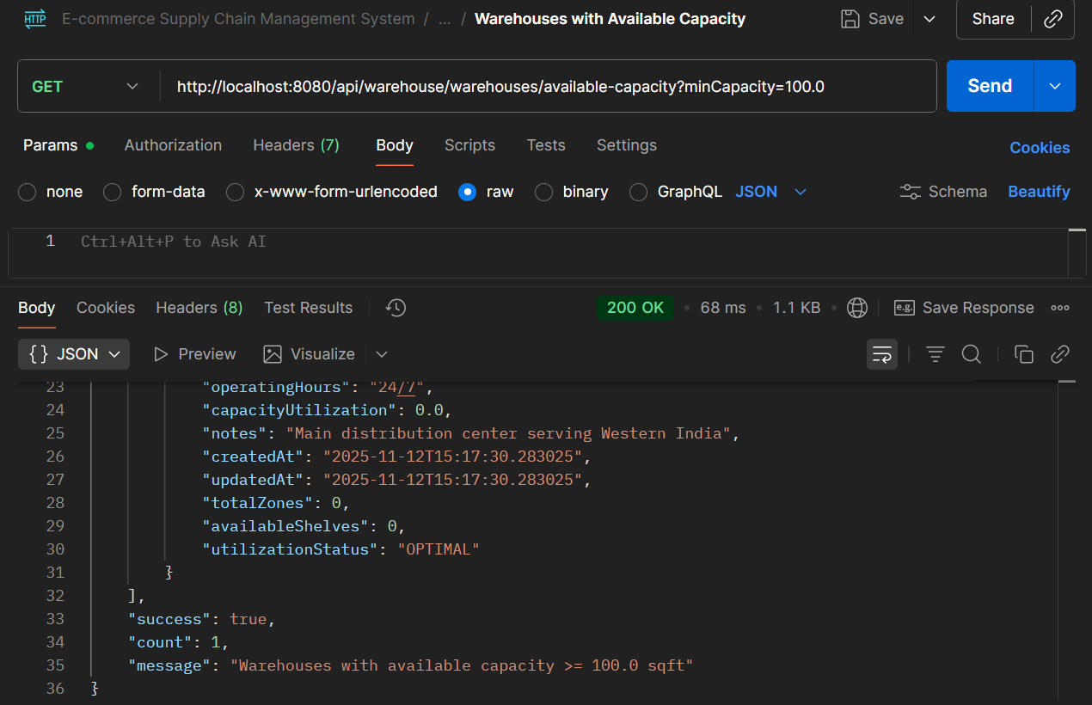

* **API Name: Get Warehouses with Available Capacity**
* **Endpoint:** [**http://localhost:8080/api/warehouse/warehouses/available-capacity?minCapacity=100.0**](http://localhost:8080/api/warehouse/warehouses/available-capacity?minCapacity=100.0)
* **Method: GET**
* **Description: Retrieves warehouses that have available capacity meeting specified criteria, used for inventory allocation and storage planning.**
* **Request Body:  
  *This is a GET endpoint and does not require a request body. It likely uses query parameters like*minCapacity=100*.***
* **Response Body:**

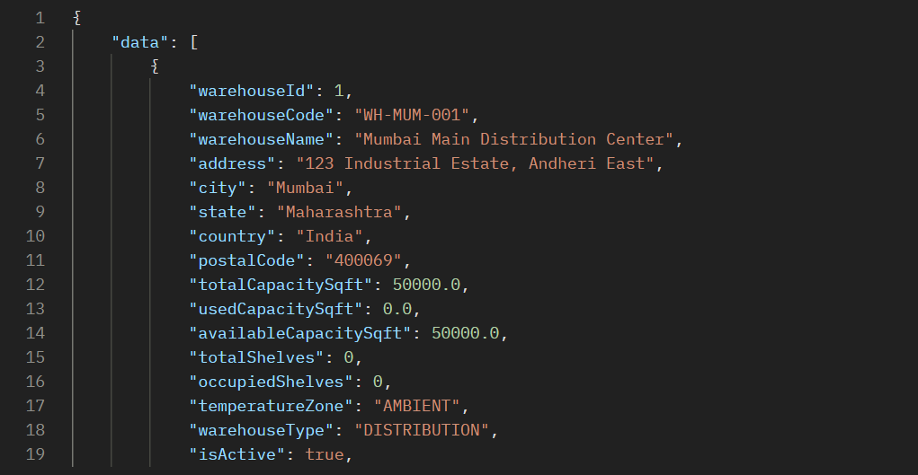

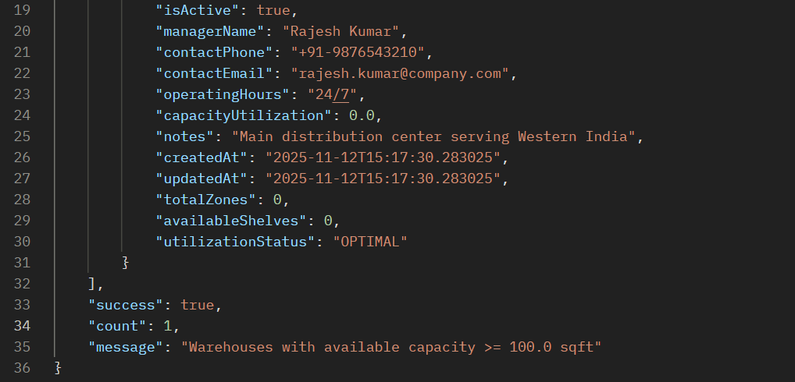

**ERROR SCENARIOS FOR PROCESS 8**

**Error 1: Invalid Warehouse Type**

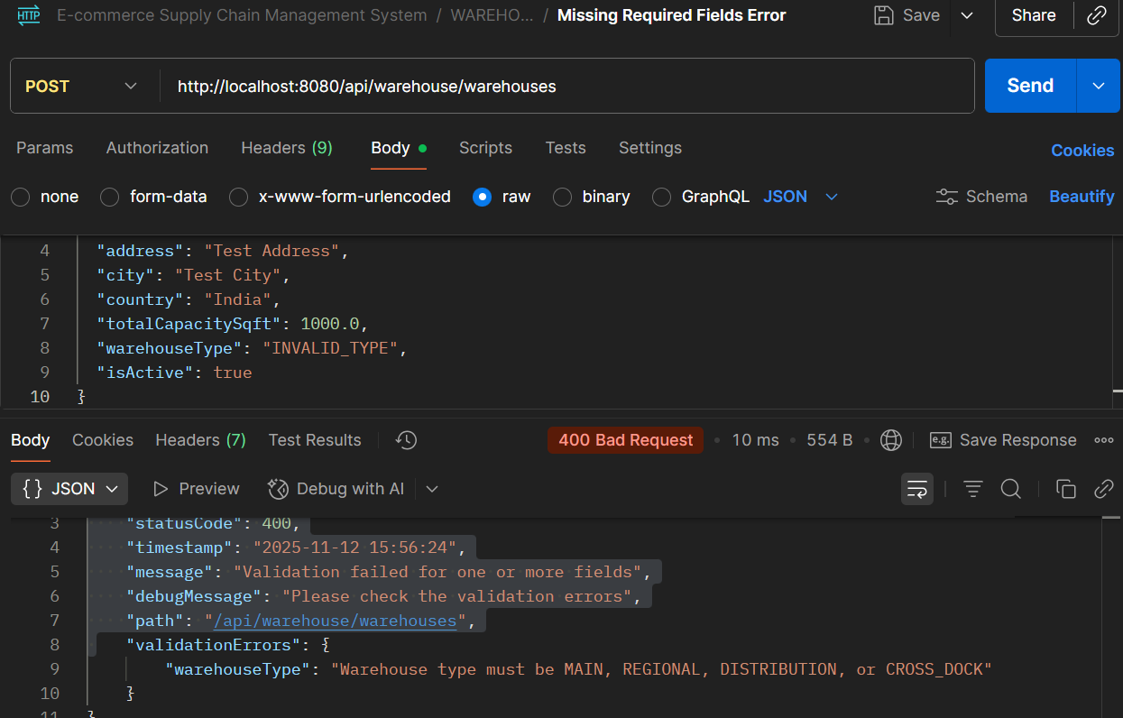

**Error 2: Missing Required Fields Error**

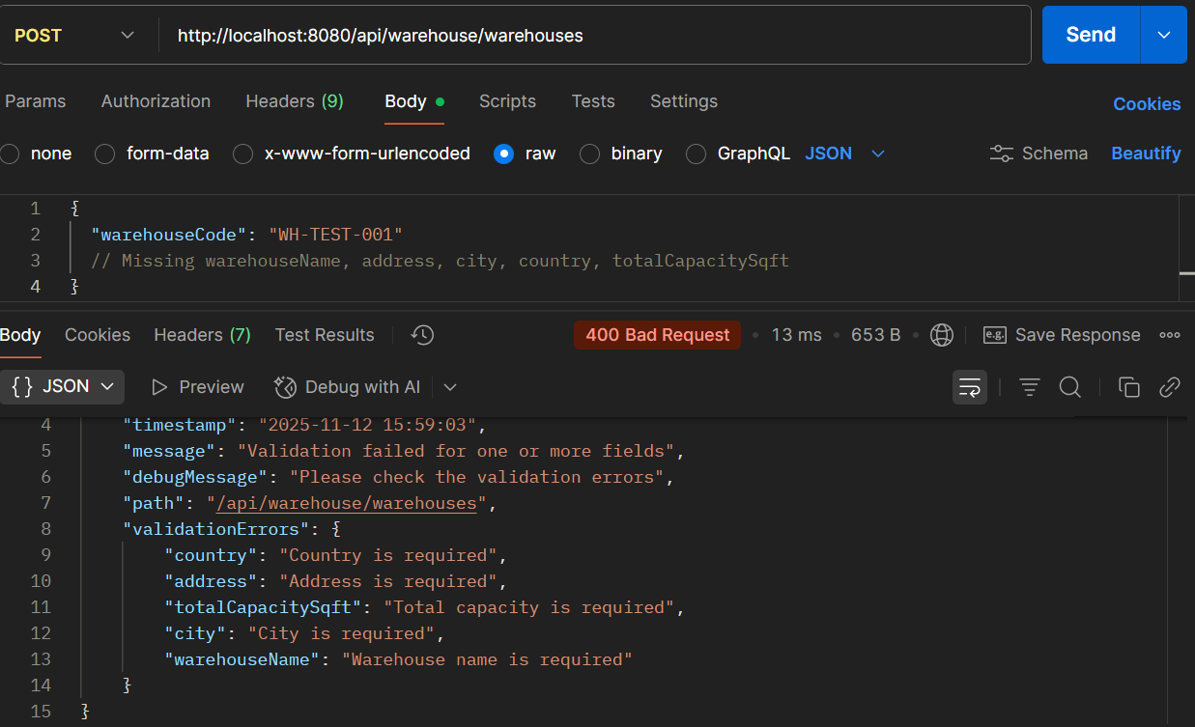

**PROCESS 9: ORDER PICKING & PACKAGING**

**API 9.1: Create Pick List**

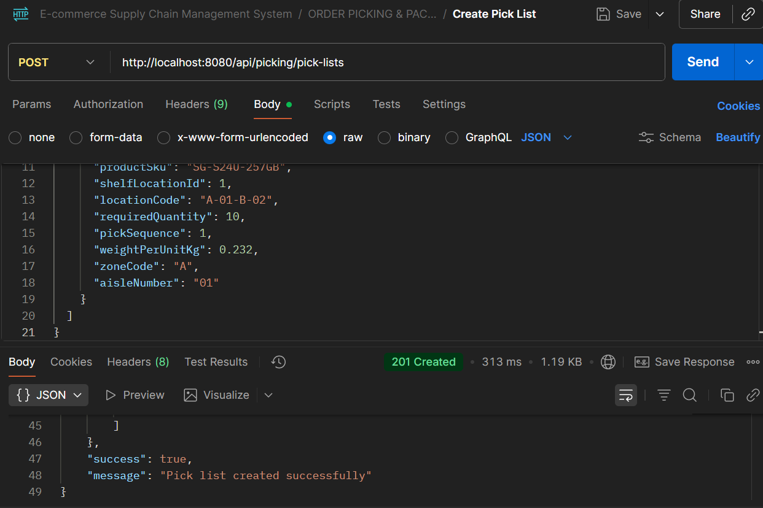

* **API Name: Create Pick List**
* **Endpoint:**[**http://localhost:8080/api/picking/pick-lists**](http://localhost:8080/api/picking/pick-lists)
* **Method: POST**
* **Description: Generates a pick list for warehouse order fulfillment with optimized picking sequence, location details, and product information.**
* **Request Body:**

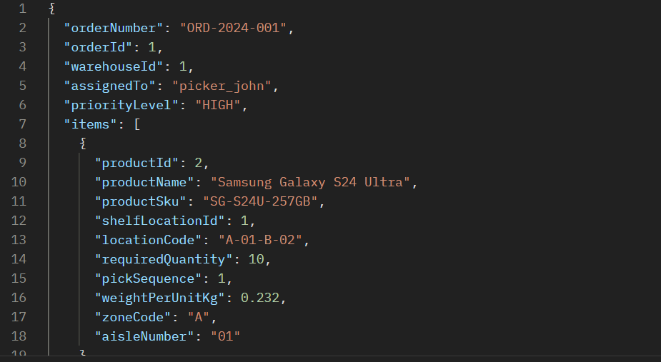

* **Respond Body:**

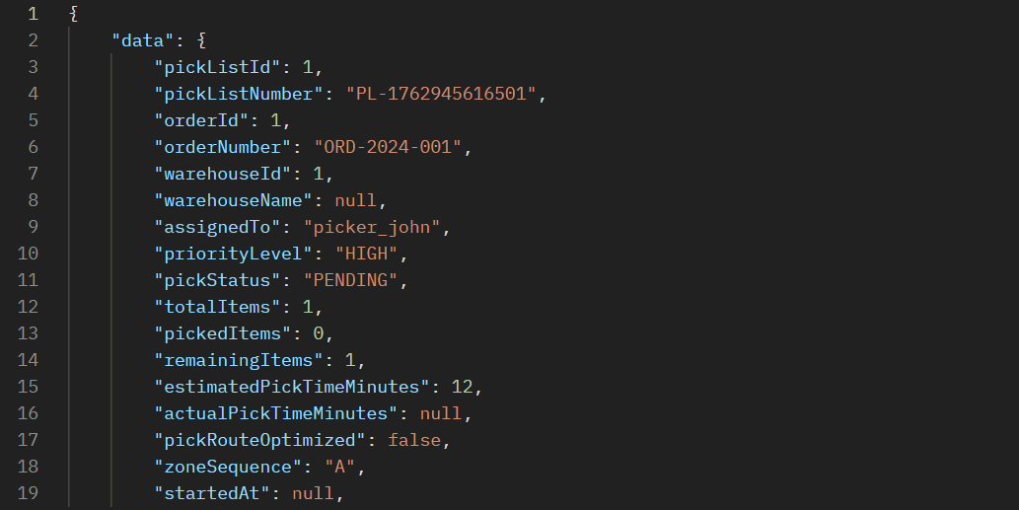

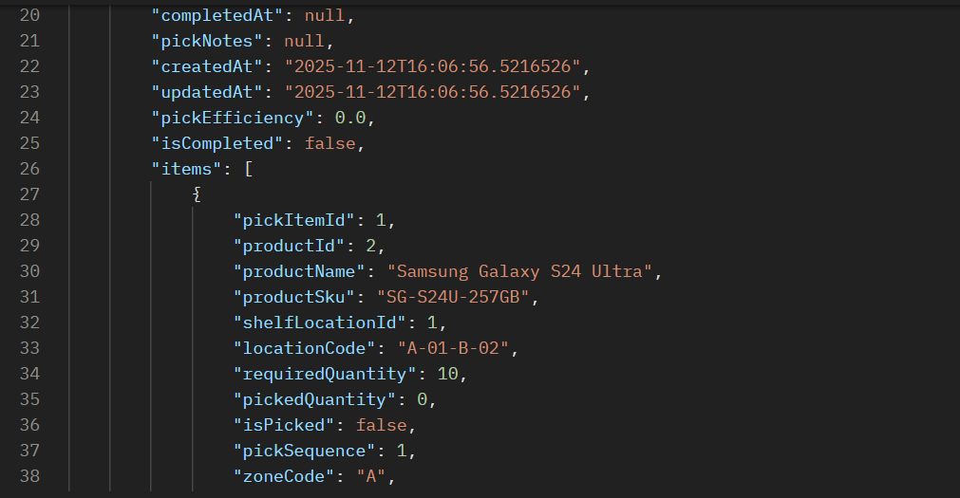

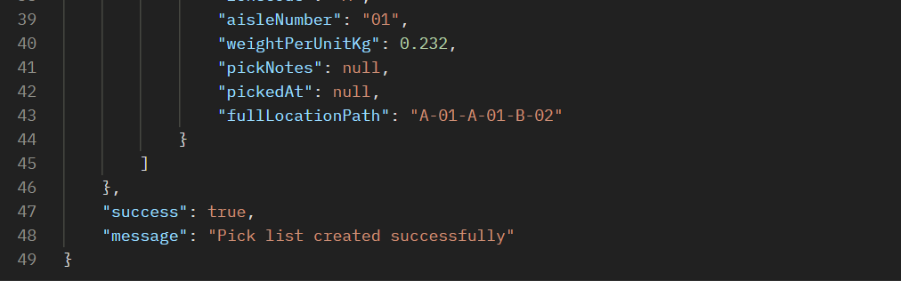

**API 9.2: Create Package**

**Step 1: Update Pick Item Status**

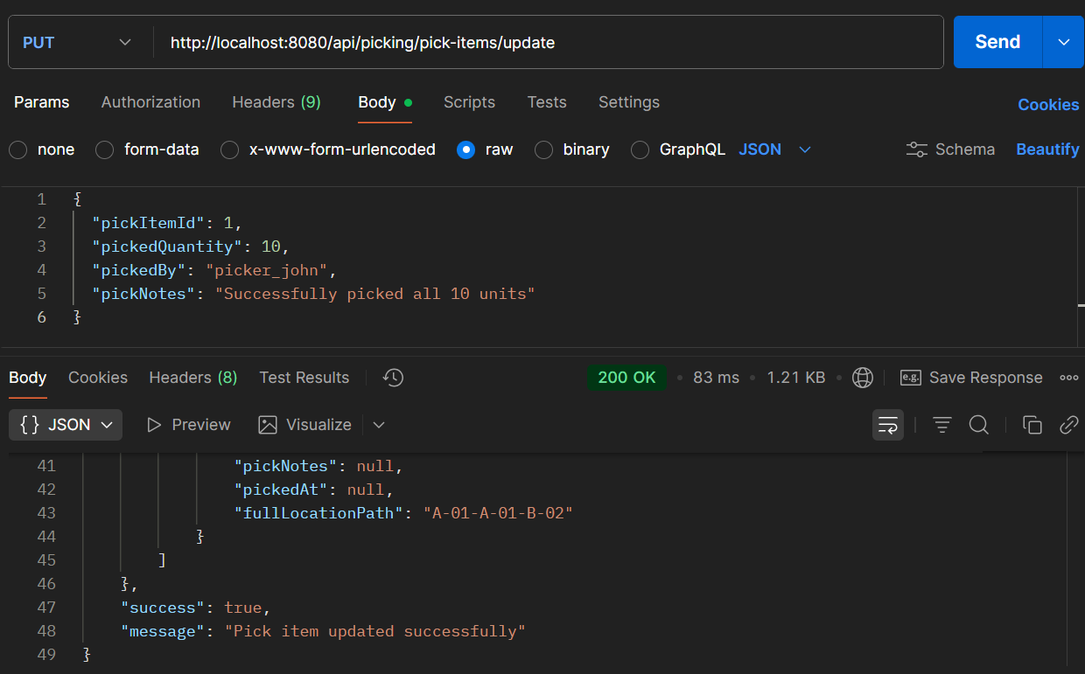

**Step 2: Then Create Package**

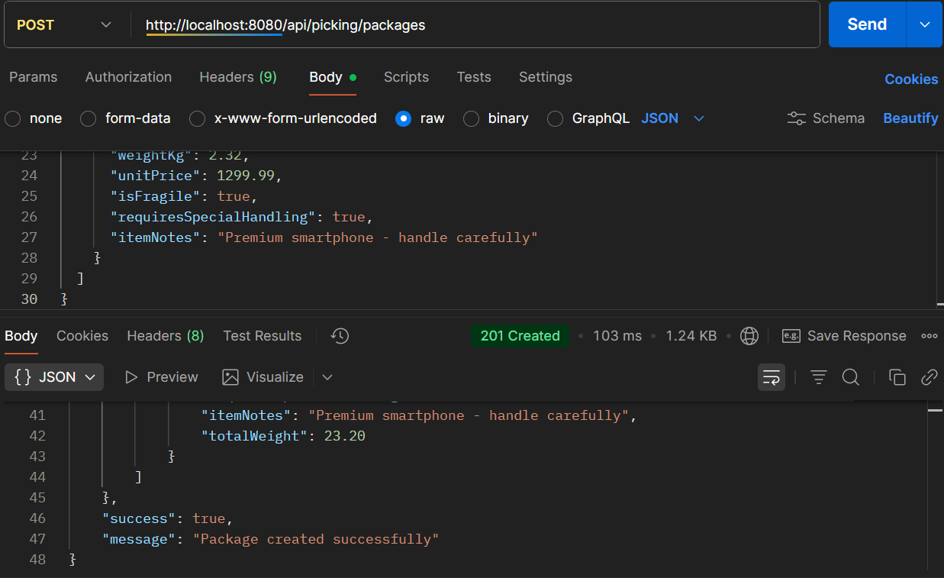

**ERROR SCENARIOS FOR PROCESS 9**

**ERROR 1: Invalid Package Type**

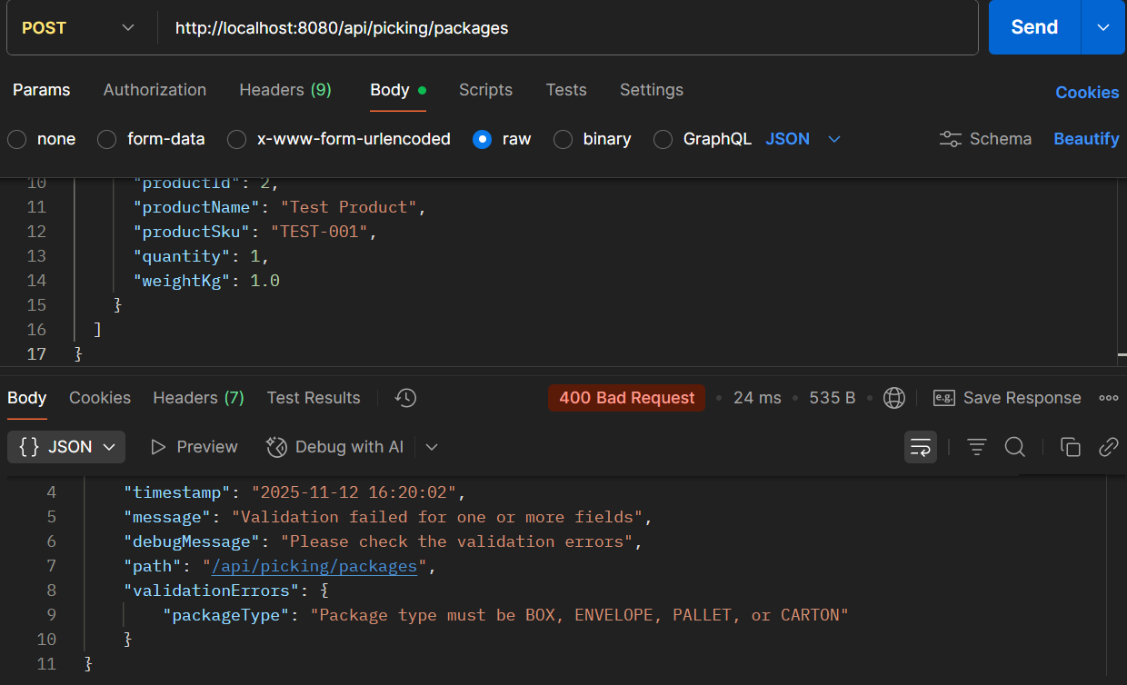

**ERROR 2: Zero Quantity in Pick List**

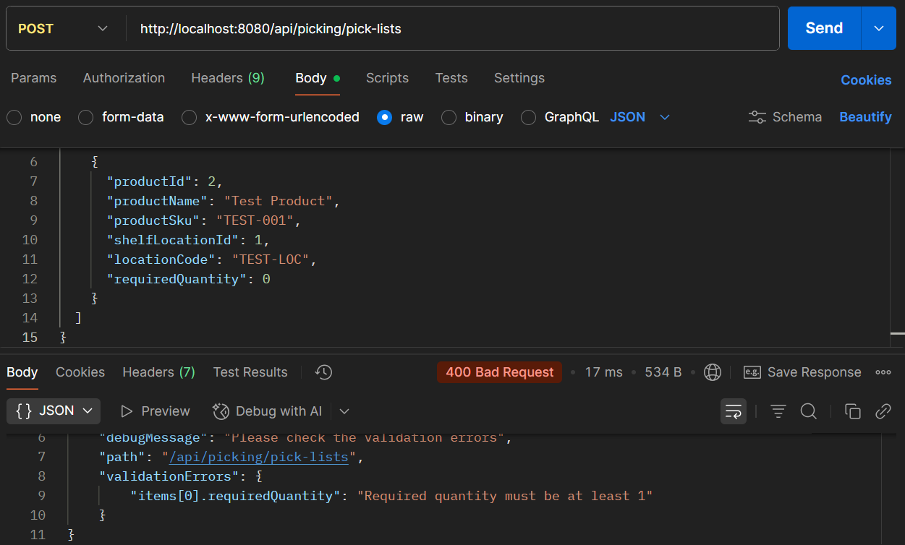

**PROCESS 10: QUALITY CONTROL BEFORE SHIPMENT**

**API 10.1: Create Quality Check**

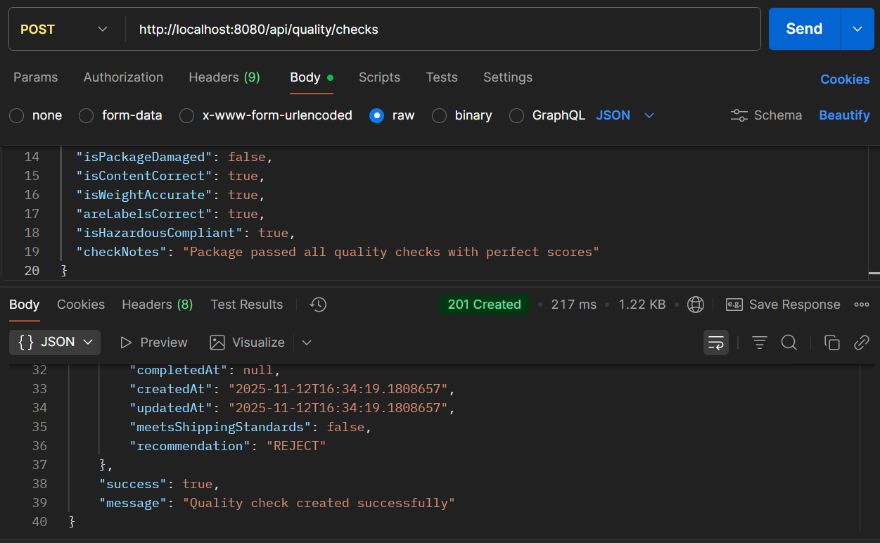

* **API Name: Create Quality Check**
* **Endpoint: http://localhost:8080/api/quality/checks**
* **Method: POST**
* **Description: Performs comprehensive quality checks on products/packages before shipping, evaluating multiple quality dimensions and providing recommendations.**
* **Request Body:**

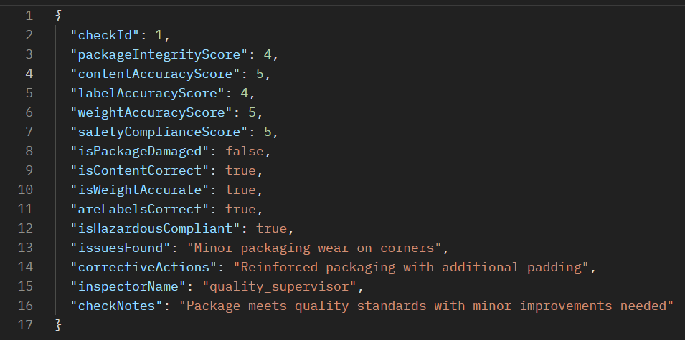

* **Respond Body**

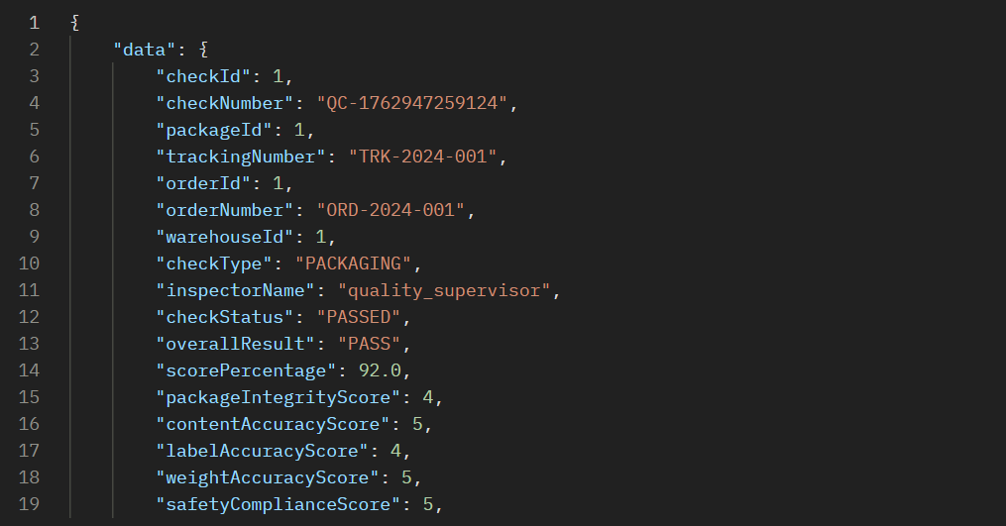

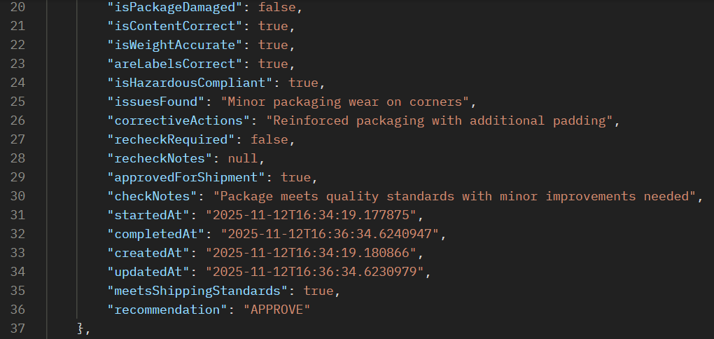



**API 10.2: Submit Quality Results**

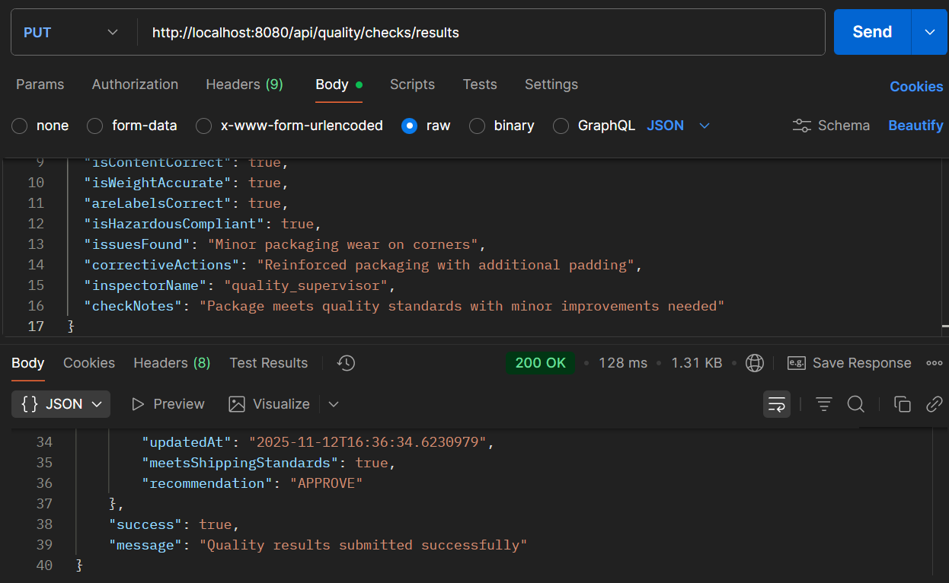

* **API Name: Submit Quality Check Results**
* **Endpoint: http://localhost:8080/api/quality/checks/results**
* **Method: PUT**
* **Description: Substitutes or updates quality check results with detailed issue tracking, corrective actions, and final recommendations for shipment approval.**
* **Request Body:**

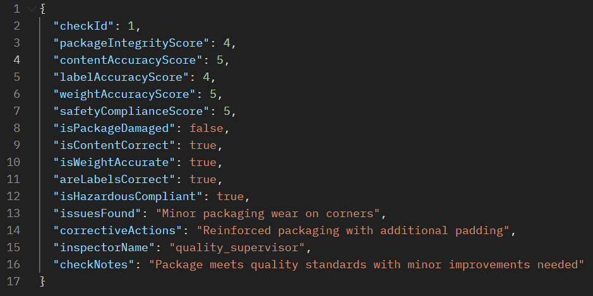

* **Respond Body:**

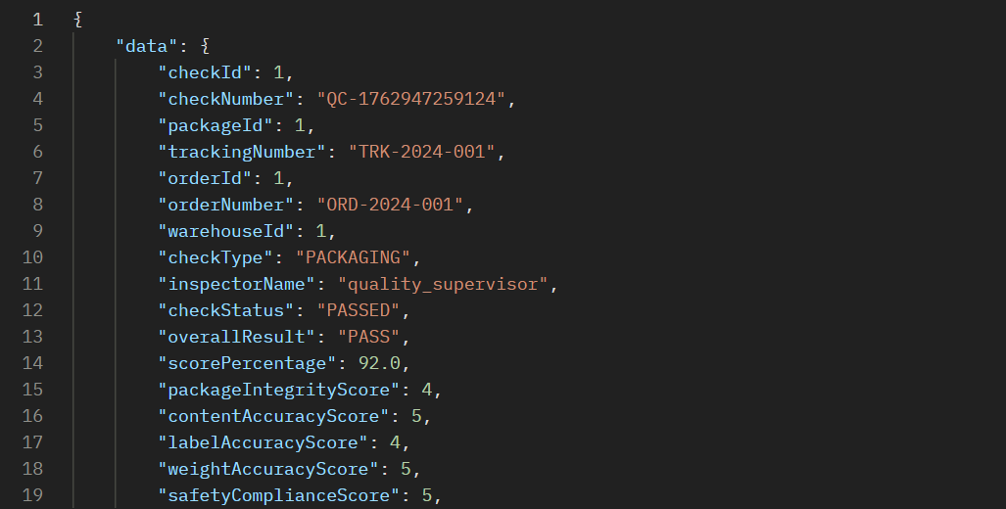

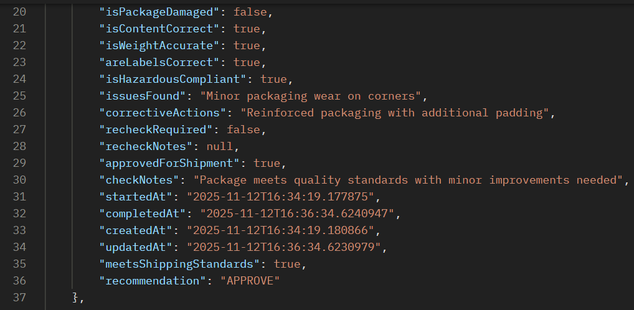



**ERROR SCENARIOS FOR PROCESS 10**

**Error 1: Invalid Check Type**

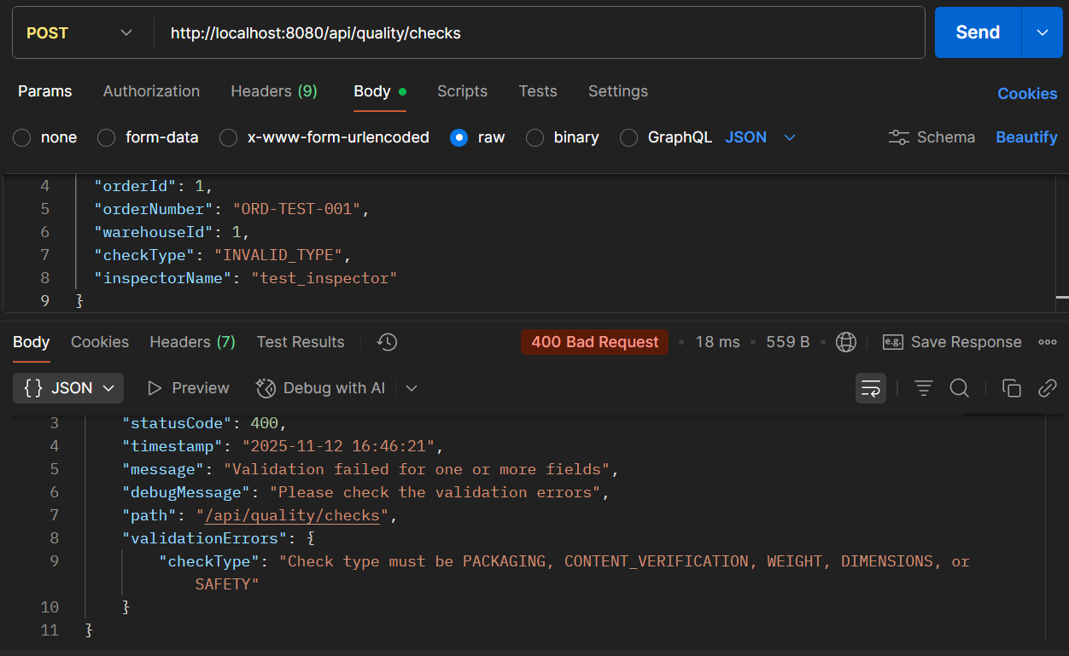

**ERROR 2: Missing Required Boolean Fields**

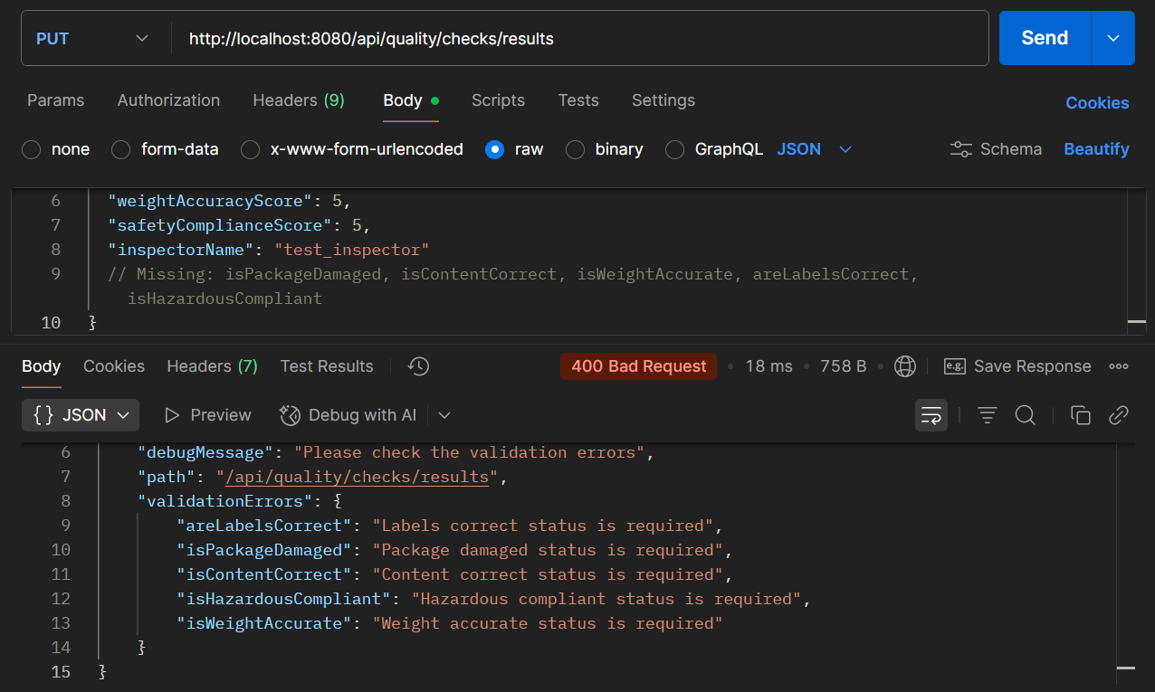

**PROCESS 11: SHIPMENT SCHEDULING & DISPATCHING**

**API 11.1: Create Shipment**

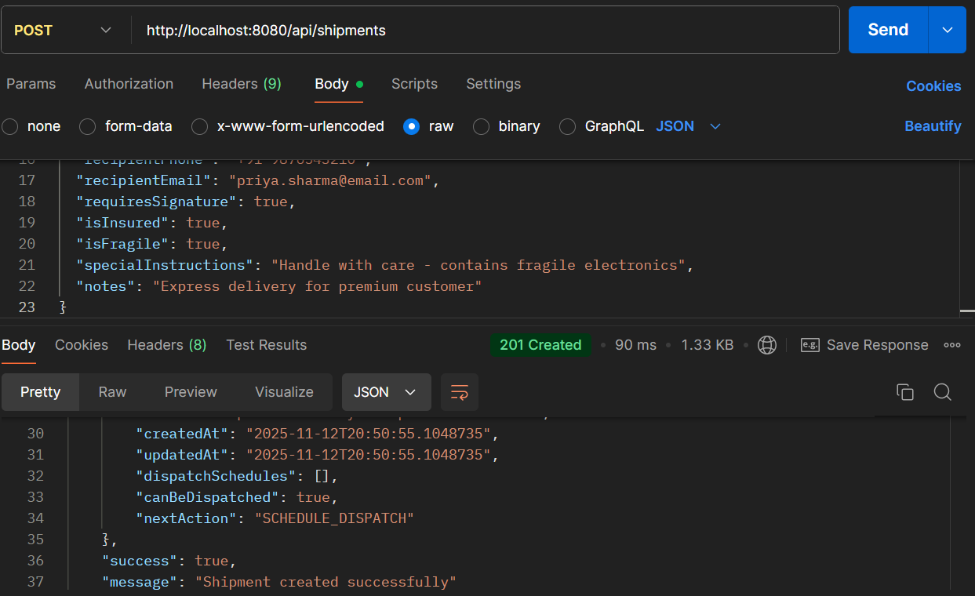

* **API Name: Create Shipment**
* **Endpoint:**[**http://localhost:8080/api/shipments**](http://localhost:8080/api/shipments)
* **Method: POST**
* **Description: Creates a new shipment with comprehensive delivery details, customer information, shipping preferences, and special handling instructions.**
* **Request Body:**

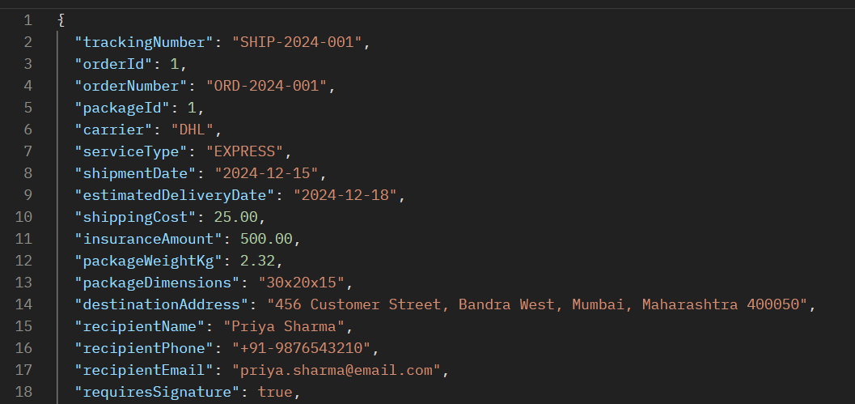

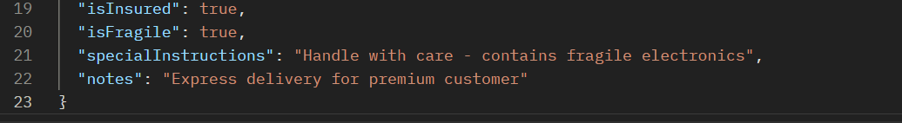

* **Respond Body:**

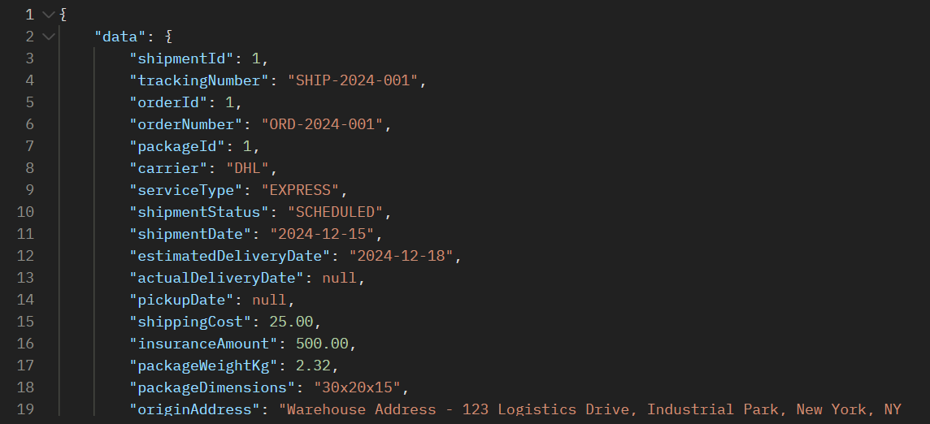

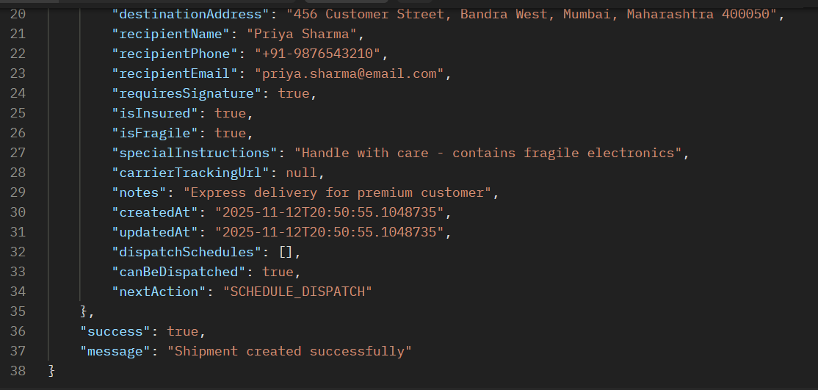

**API 11.2: Schedule Dispatch**

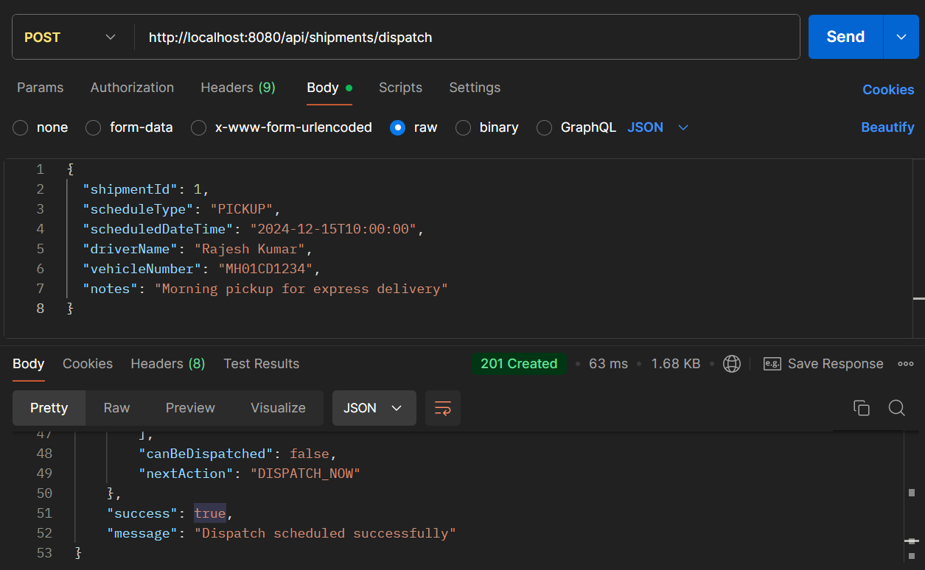

* **API Name: Schedule Shipment Dispatch**
* **Endpoint:**[**http://localhost:8080/api/shipments/dispatch**](http://localhost:8080/api/shipments/dispatch)
* **Method: POST**
* **Description: Schedules the dispatch of a shipment with pickup/delivery details, driver information, and vehicle assignment.**
* **Request Body:**

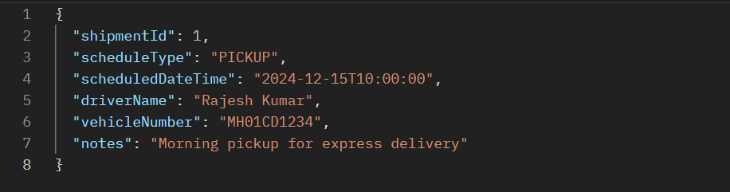

* **Respond Body:**

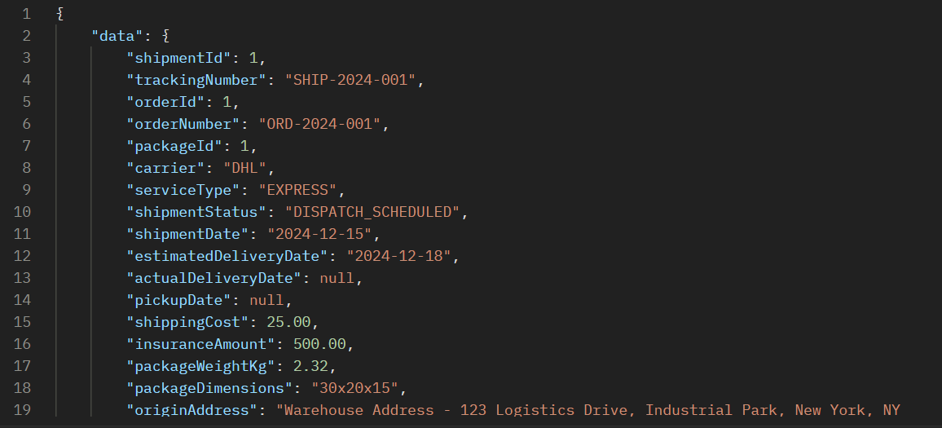

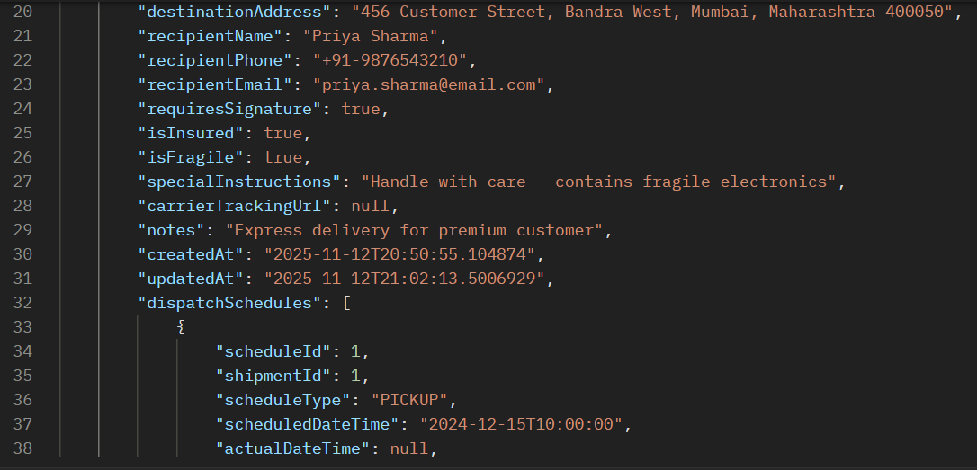

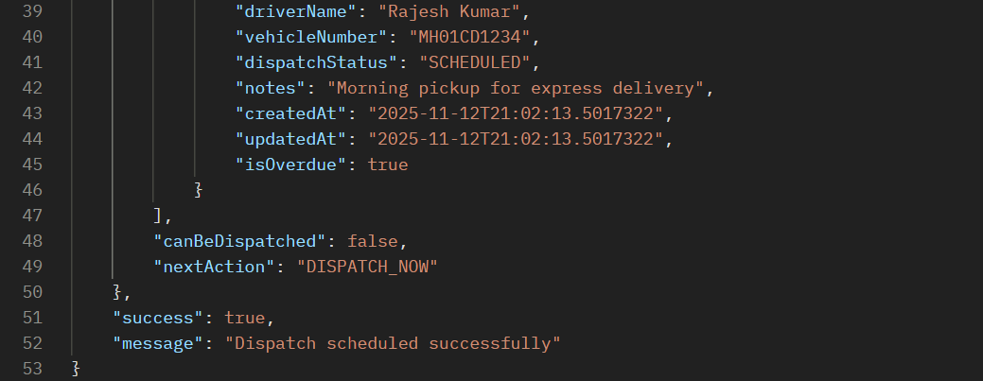

**ERROR SCENARIOS FOR PROCESS 11**

**Error 1: Missing Required Fields in Shipment**

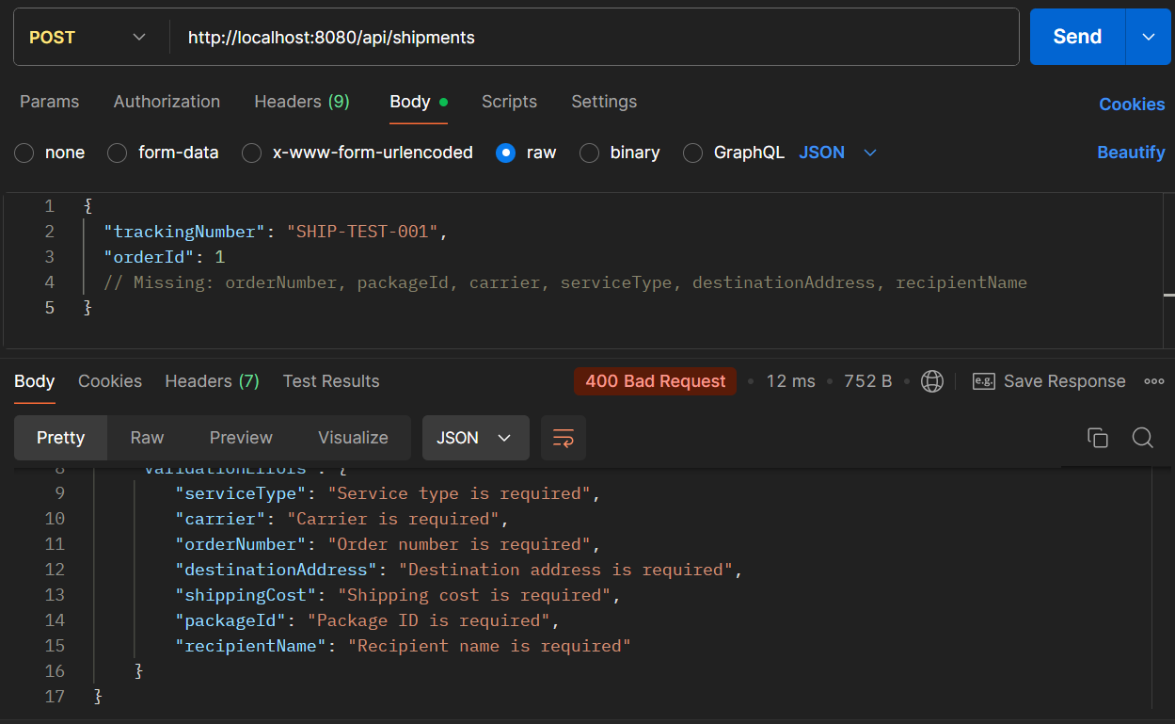

**Error 2: Invalid Dispatch**

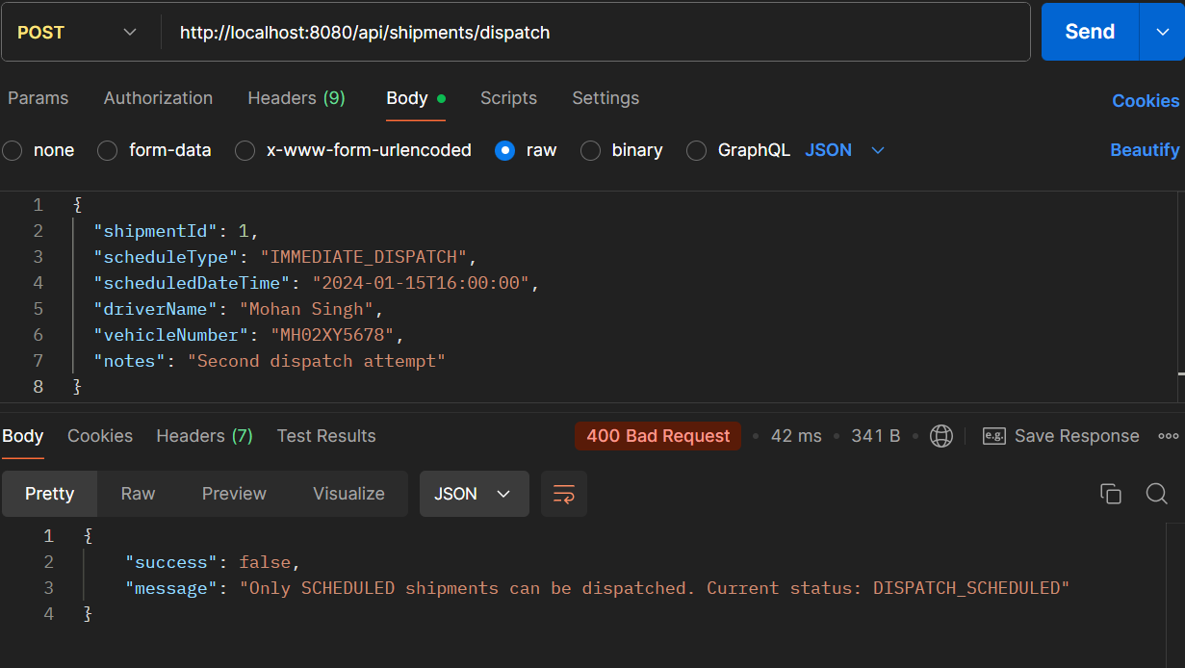

**🎯 PROCESS 12: TRACKING & DELIVERY UPDATES**

**API 12.1: Add Tracking Event**

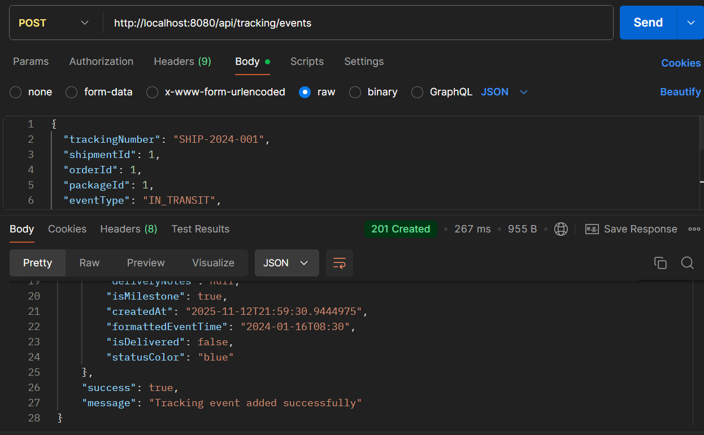

* **API Name: Add Tracking Event**
* **Endpoint:**[**http://localhost:8080/api/tracking/events**](http://localhost:8080/api/tracking/events)
* **Method: POST**
* **Description: Adds real-time tracking events to shipments, updating their status and providing visibility into the delivery progress.**
* **Example Request Body:**

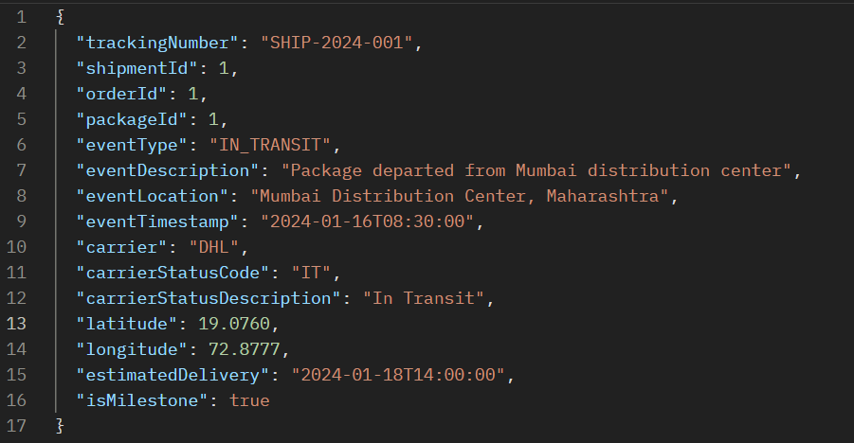

* **Respond Body:**

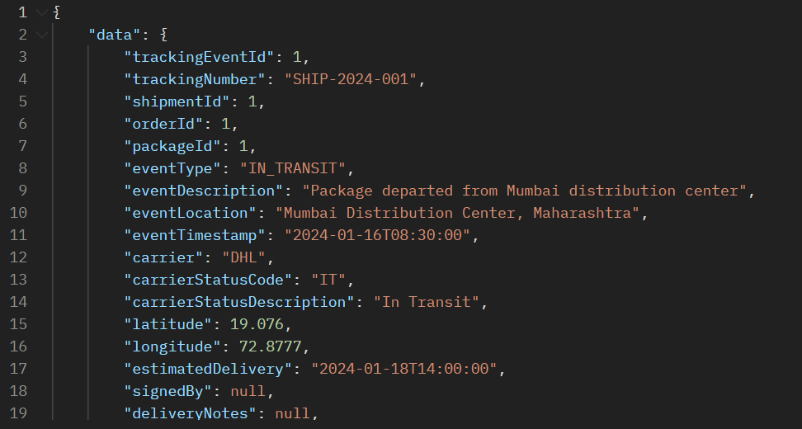

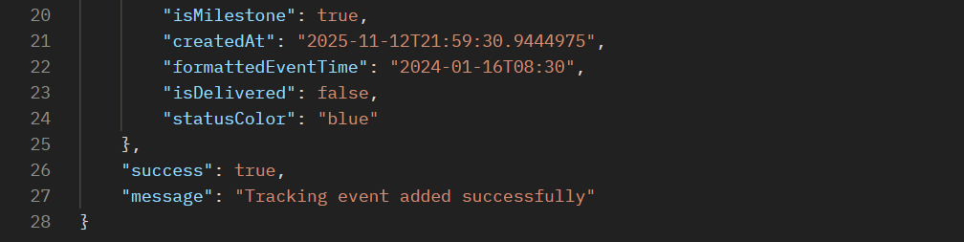

**API 12.2: Get Tracking Status**

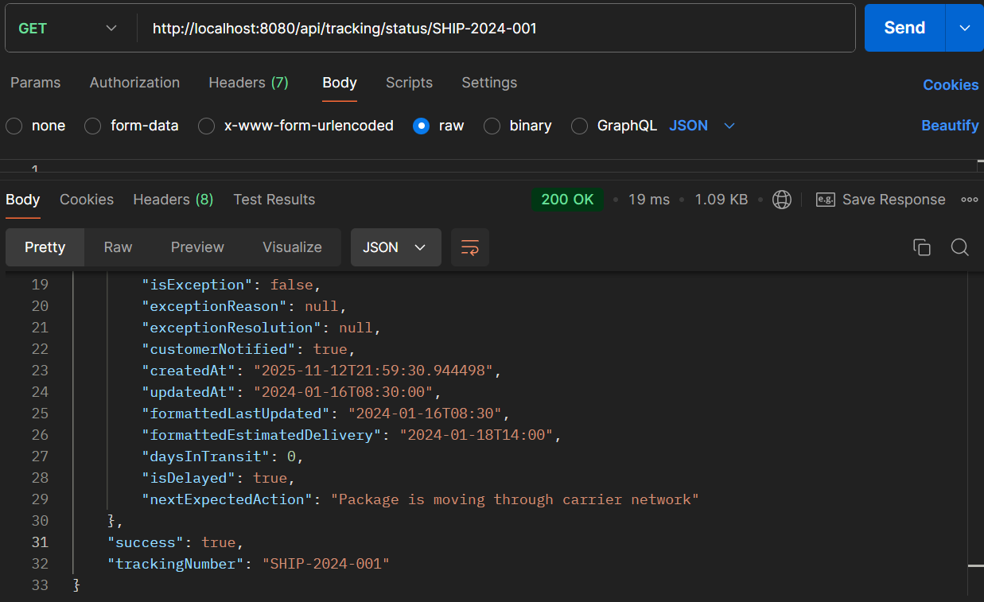

* **API Name: Get Tracking Status**
* **Endpoint:**[**http://localhost:8080/api/tracking/status/SHIP-2024-001**](http://localhost:8080/api/tracking/status/SHIP-2024-001)
* **Method: GET**
* **Description: Retrieves the current status and comprehensive tracking information for a specific shipment using its tracking number.**
* **Example Request Body:  
  *This is a GET endpoint and does not require a request body. The tracking number is passed as a path parameter.***
* **Example Response Body:**

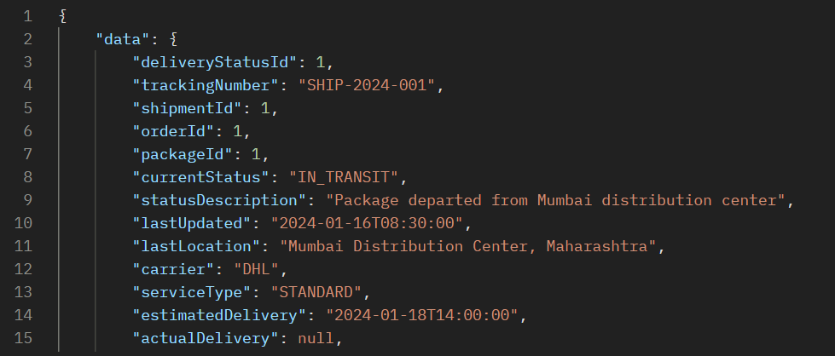

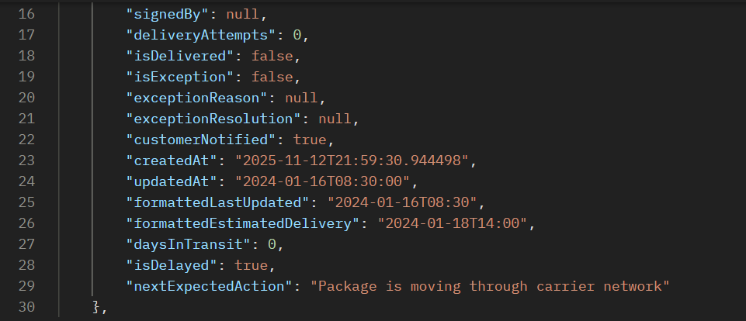



**ERROR SCENARIOS FOR PROCESS 12**

**Error 1: Invalid Event Type**

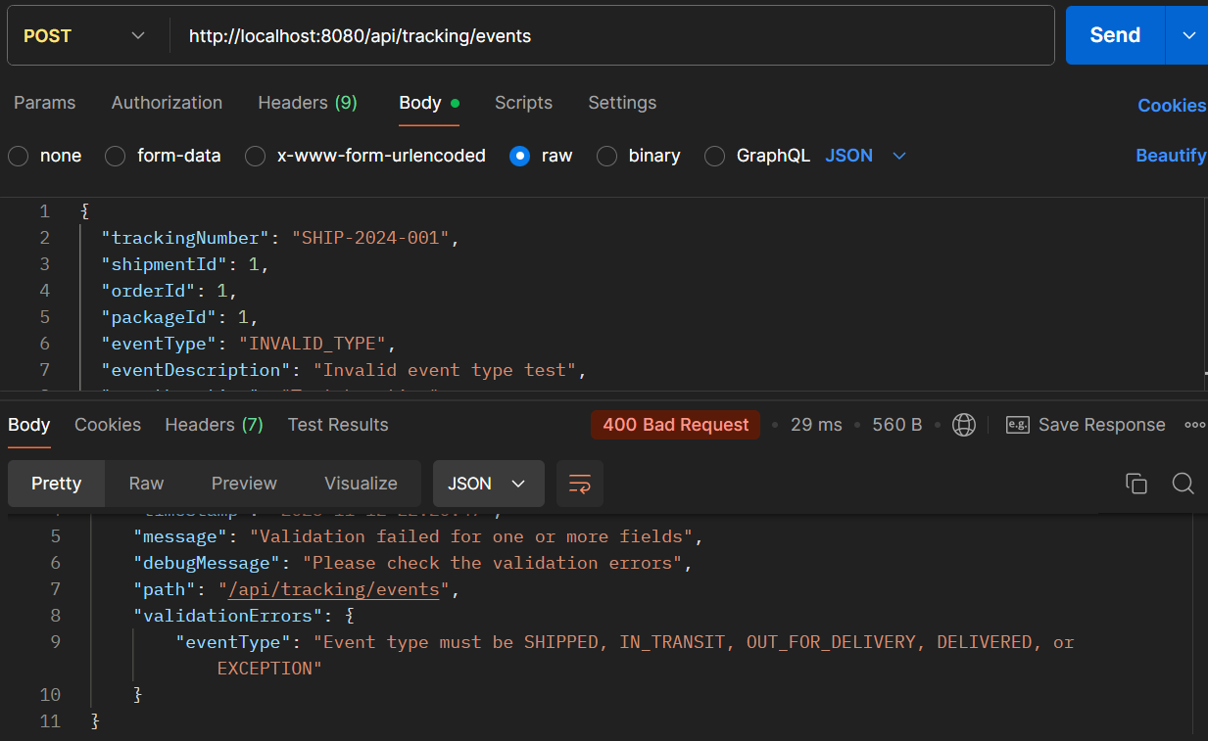

**Error 2: Get Status for Non-existent Tracking**

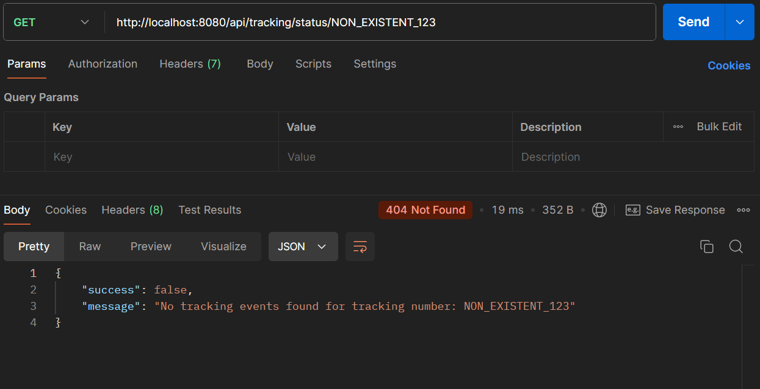

**PROCESS 13: DELIVERY EXCEPTIONS**

**API 13.1: Create Delivery Exception**

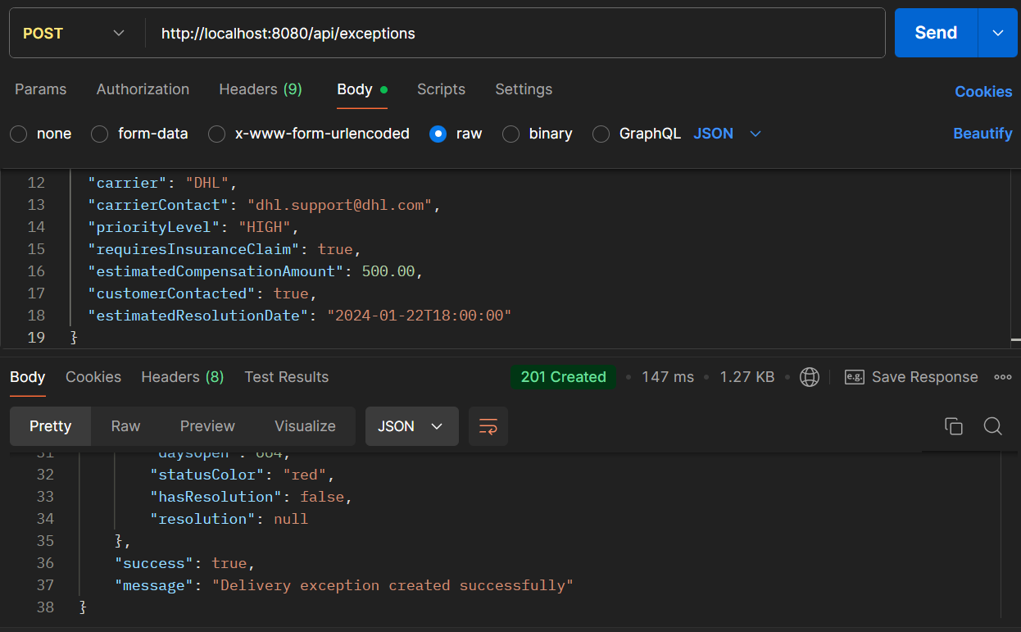

* **API Name: Create Exception**
* **Endpoint:**[**http://localhost:8080/api/exceptions**](http://localhost:8080/api/exceptions)
* **Method: POST**
* **Description: Logs and manages supply chain exceptions with comprehensive incident details, impact assessment, and resolution tracking.**
* **Request Body:**

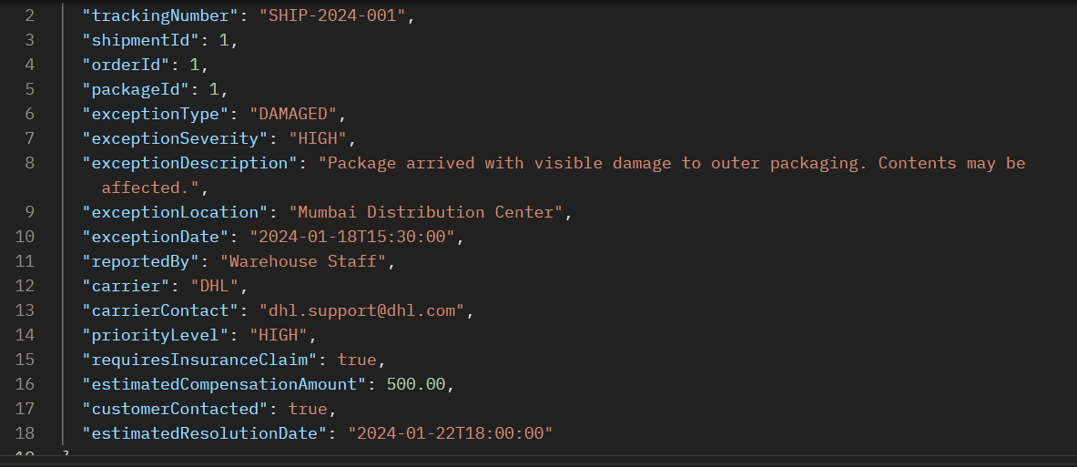

* **Respond Body:**

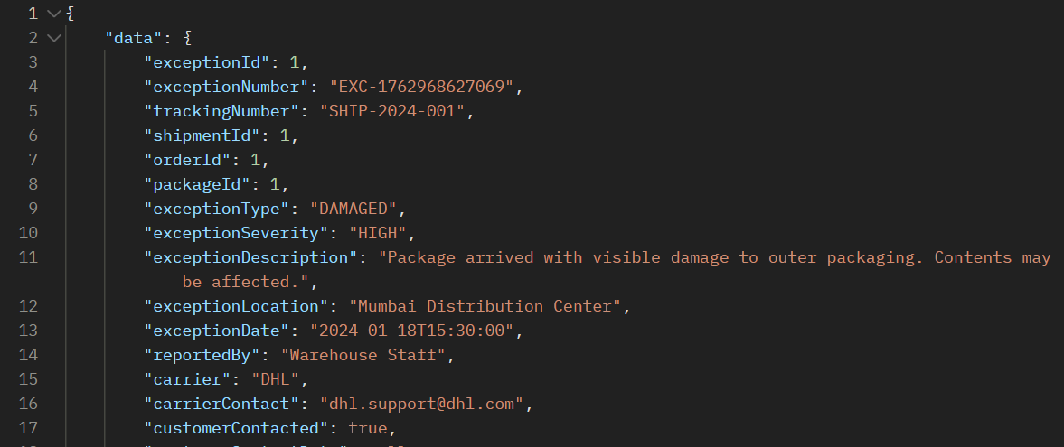

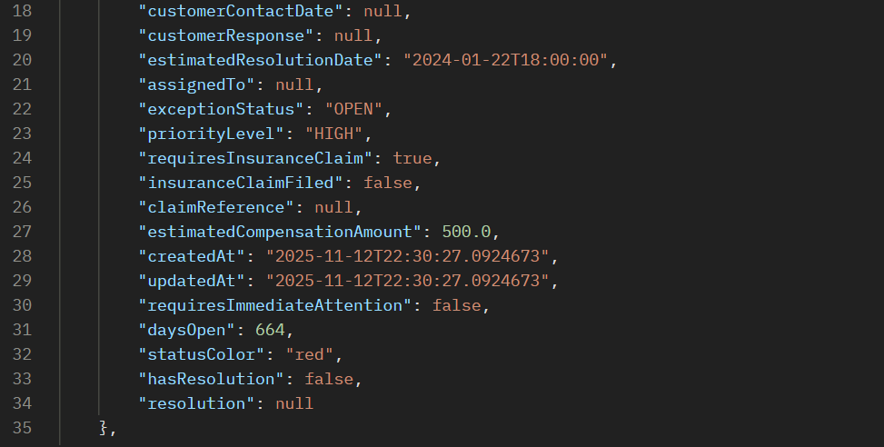



**API 13.2: Resolve Delivery Exception**

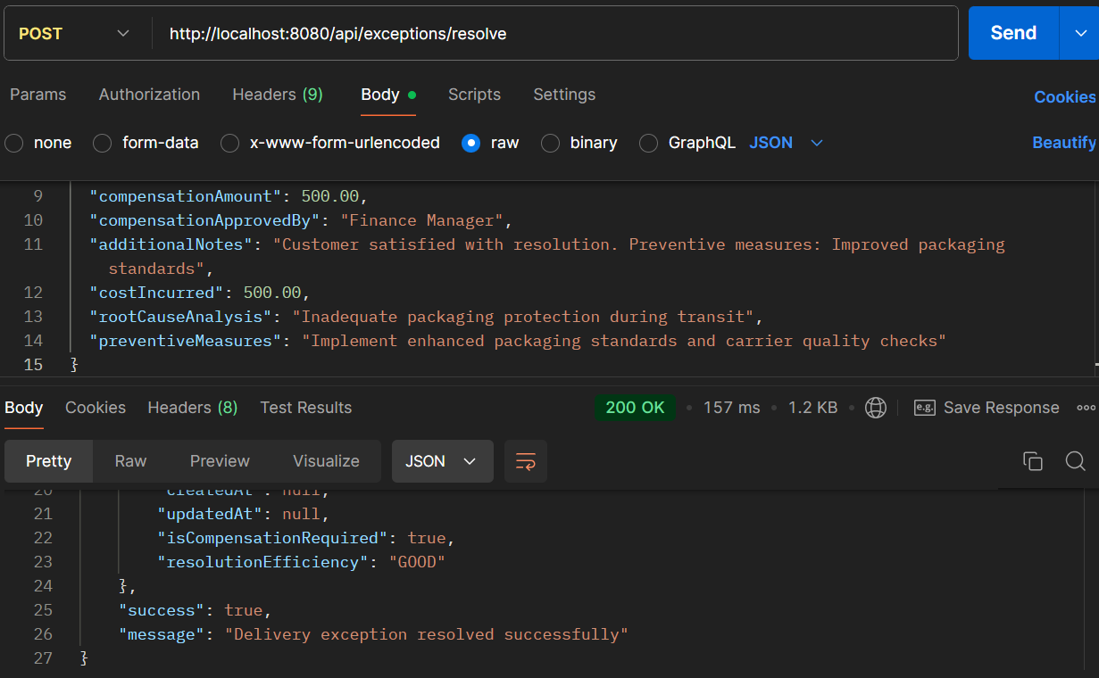

* **API Name: Resolve Exception**
* **Endpoint:**[**http://localhost:8080/api/exceptions/resolve**](http://localhost:8080/api/exceptions/resolve)
* **Method: POST**
* **Description: Resolves supply chain exceptions with comprehensive resolution details, financial compensation, root cause analysis, and preventive measures.**
* **Example Request Body:**

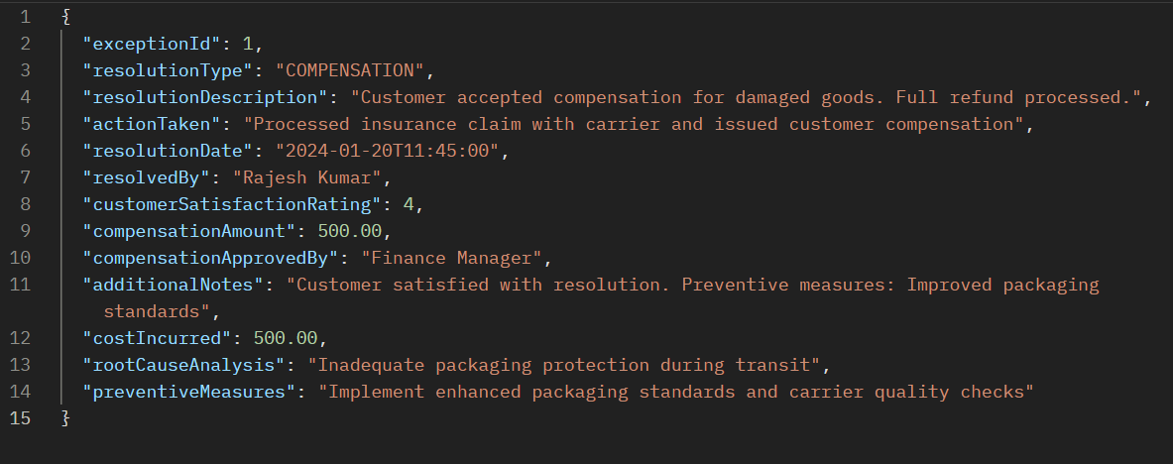

* **Respond Body:**

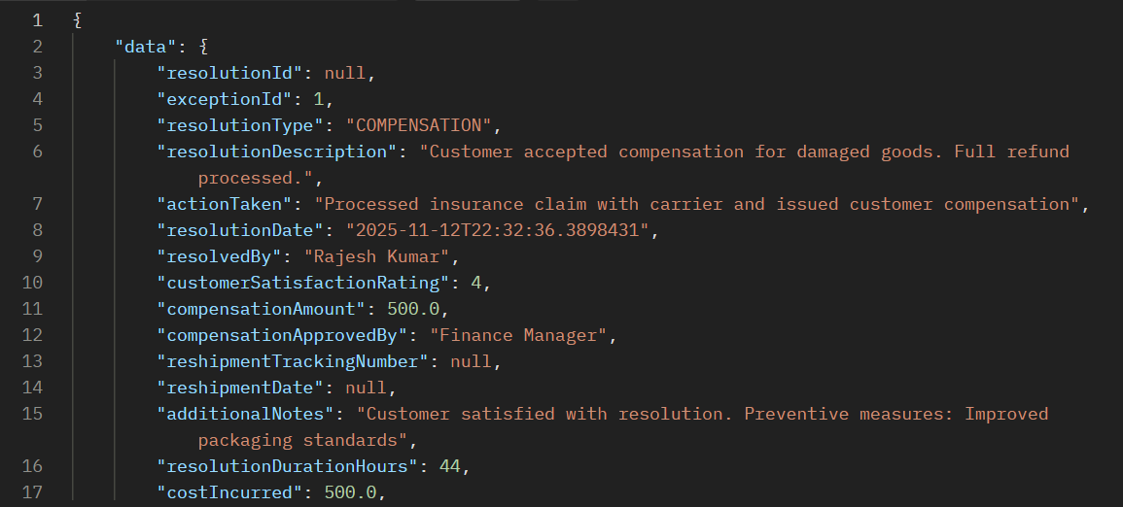

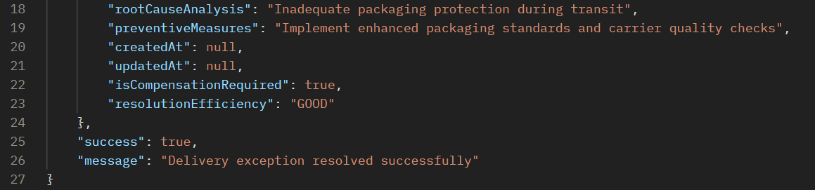

**ERROR SCENARIOS FOR PROCESS 13**

**Error 1: Invalid Exception Type**

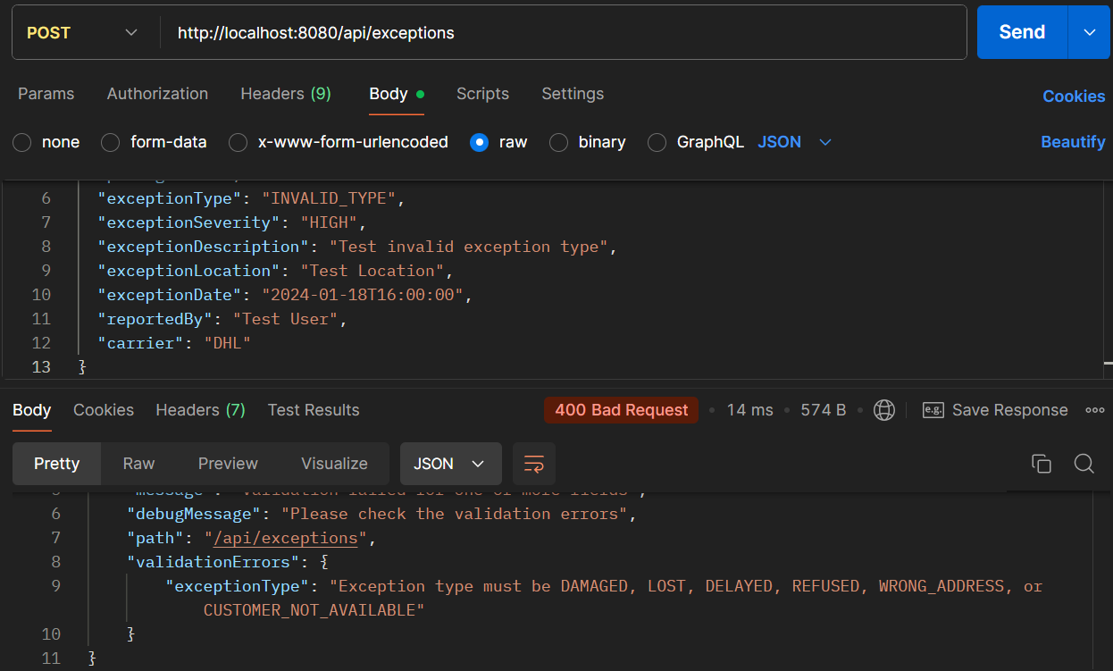

**Error 2: Resolve Non-existent Exception**

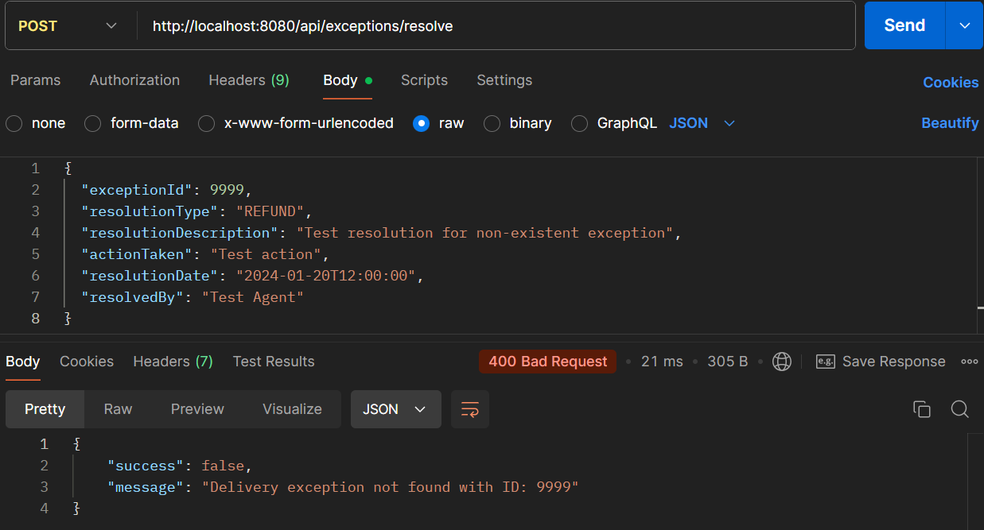

**PROCESS 14: RETURNS PROCESSING & RESTOCKING**

**API 14.1: Create Return Order**

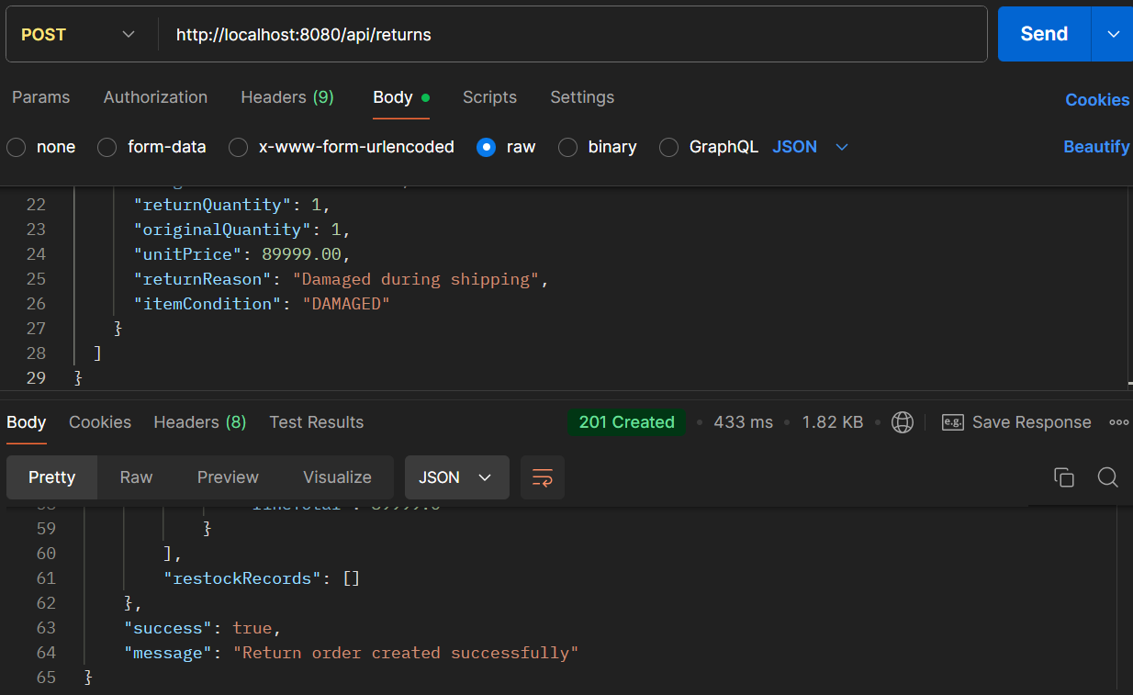

* **API Name: Create Return Order**
* **Endpoint: http://localhost:8080/api/returns**
* **Method: POST**
* **Description: Creates a return order for products being returned by customers, including return reasons, item conditions, and restocking details.**
* **Request Body:**

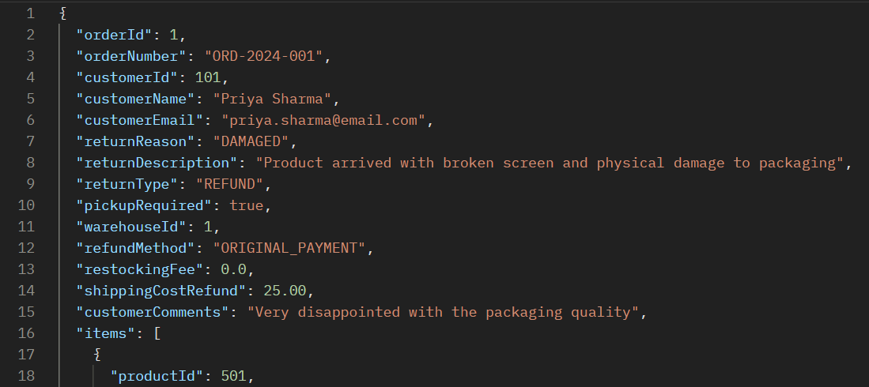

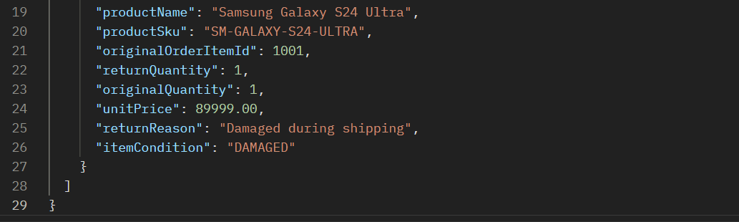

* **Respond Body:**

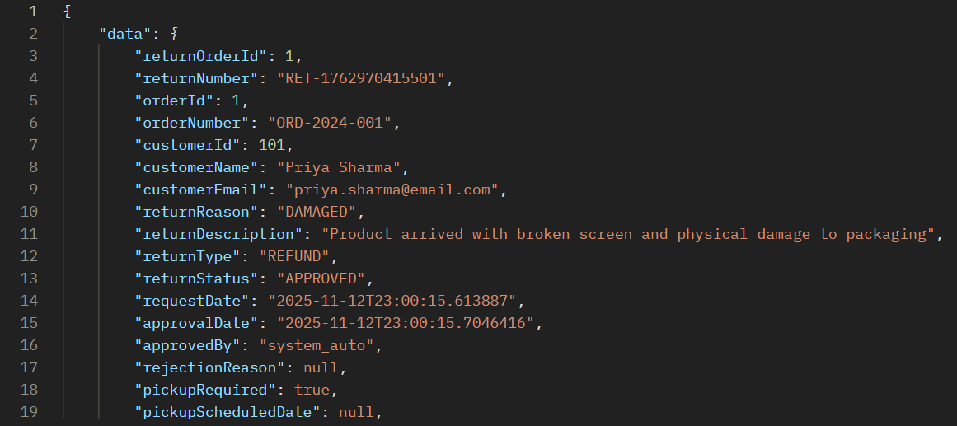

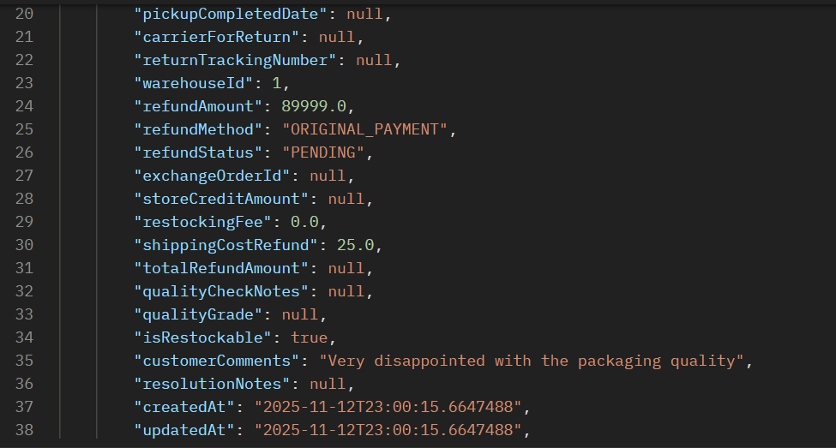

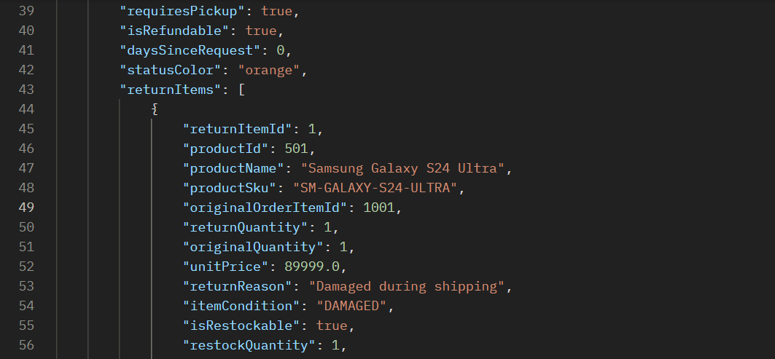

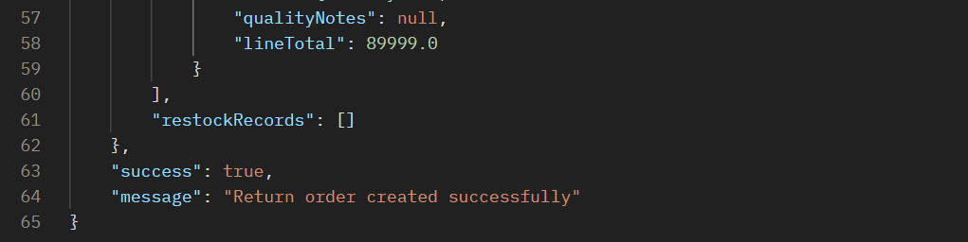

**API 14.2: Approval Return Order**

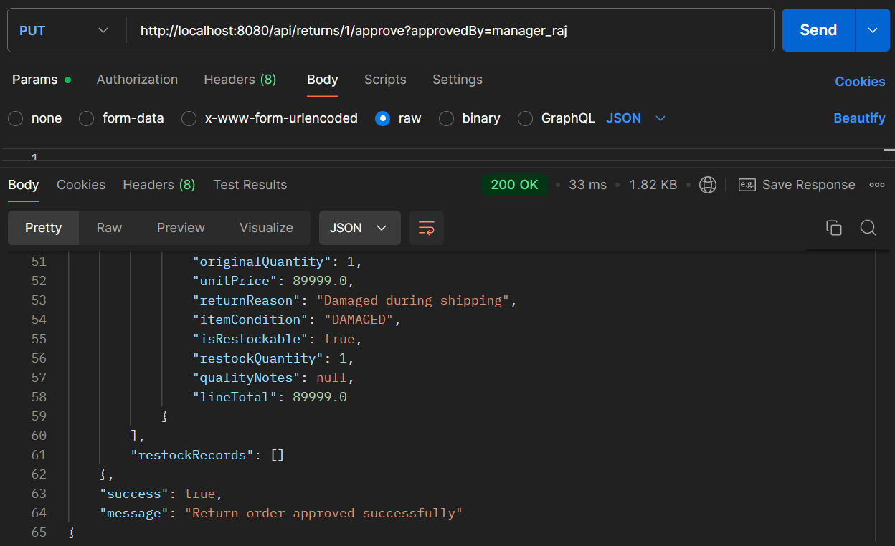

* **API Name: Approve Return Order**
* **Endpoint:**[**http://localhost:8080/api/returns/1/approve?approvedBy=manager_raj**](http://localhost:8080/api/returns/1/approve?approvedBy=manager_raj)
* **Method: PUT**
* **Description: Approves a return order, authorizing refunds, pickup arrangements, and restocking processes. The {1} in the endpoint is a path parameter for the returnId, and it requires an approvedBy query parameter.**
* **Example Request Body:  
  *This endpoint likely doesn't require a request body, as the approval decision and approver information are passed via the URL.***
* **Example Response Body:**

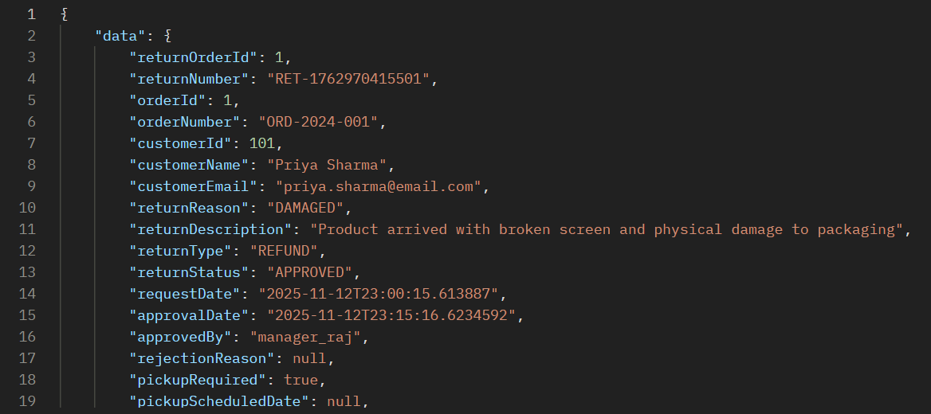

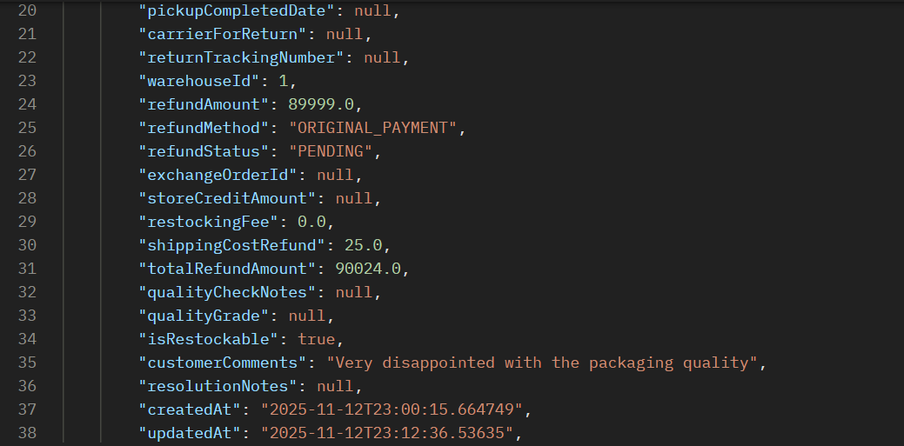

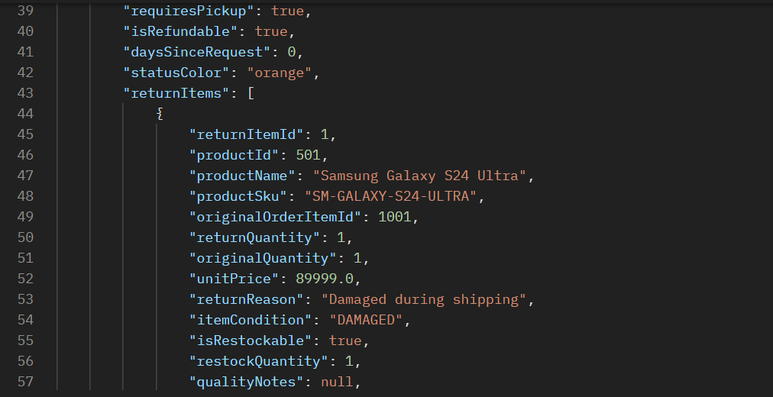

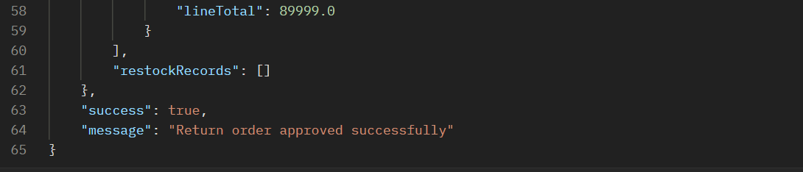

**ERROR SCENARIOS FOR PROCESS 14**

**Error 1: Invalid Return Order Status Error**

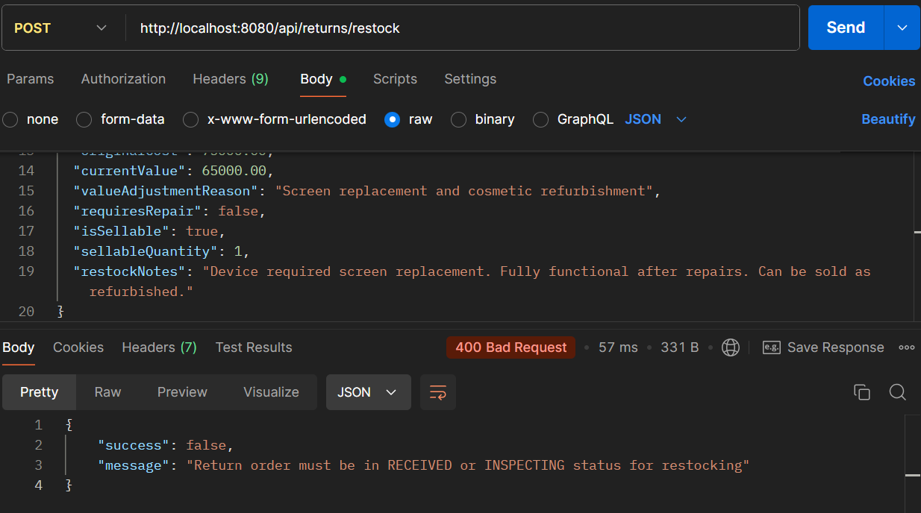

**Error 2: Invalid Restock Quantity**

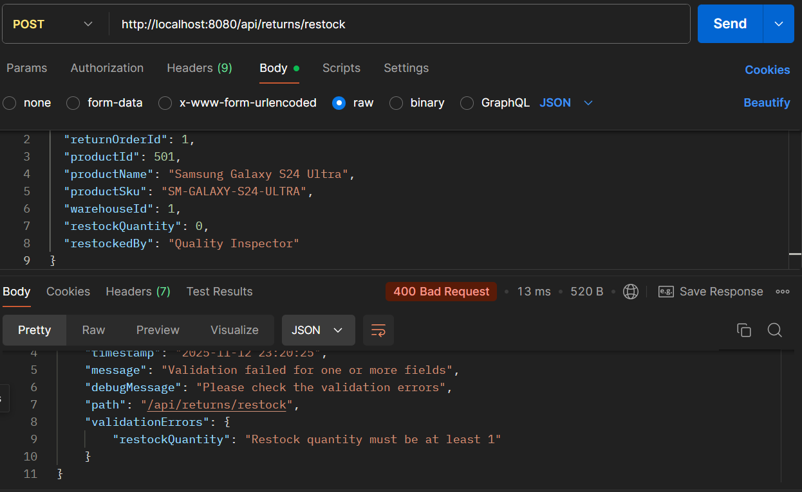

**PROCESS 15: INVENTORY RECONCILIATION & REPORTING**

**API 15.1: Create Reconciliation Report**

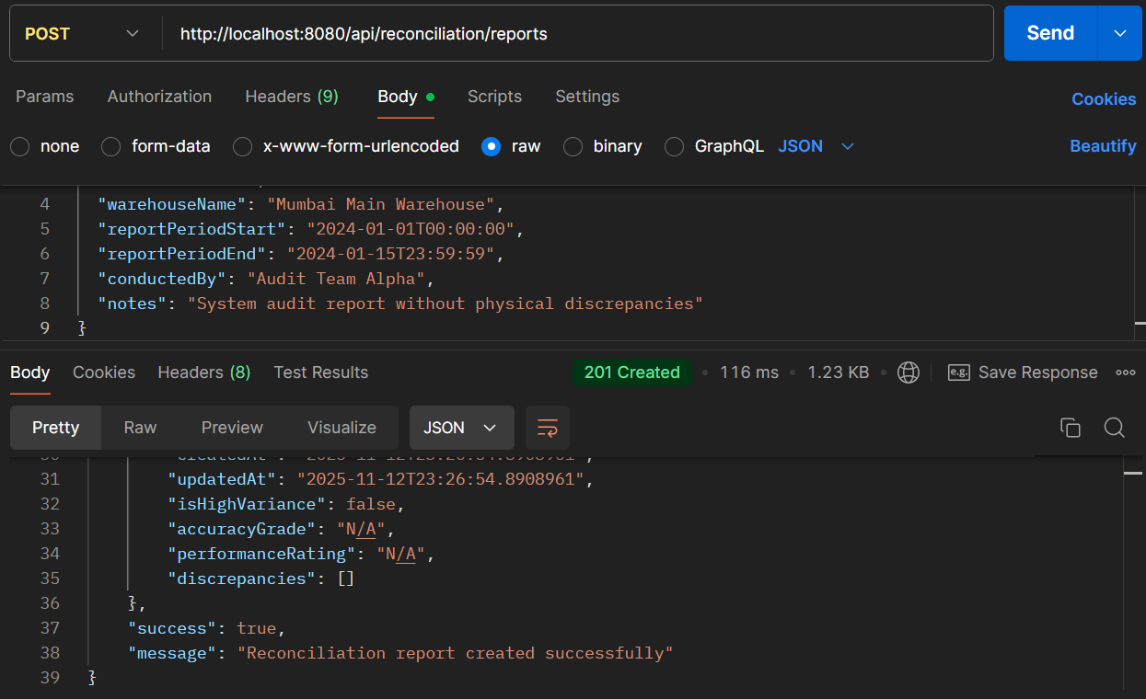

* **API Name: Create Reconciliation Report**
* **Endpoint: http://localhost:8080/api/reconciliation/reports**
* **Method: POST**
* **Description: Generates inventory reconciliation reports comparing system records with physical counts, identifying discrepancies and providing accuracy assessments.**
* **Request Body:**

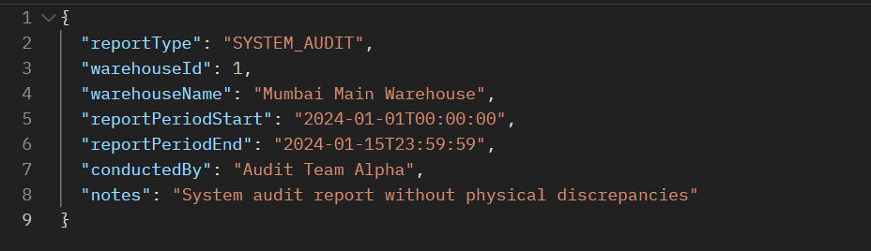

* **Respond Body:**

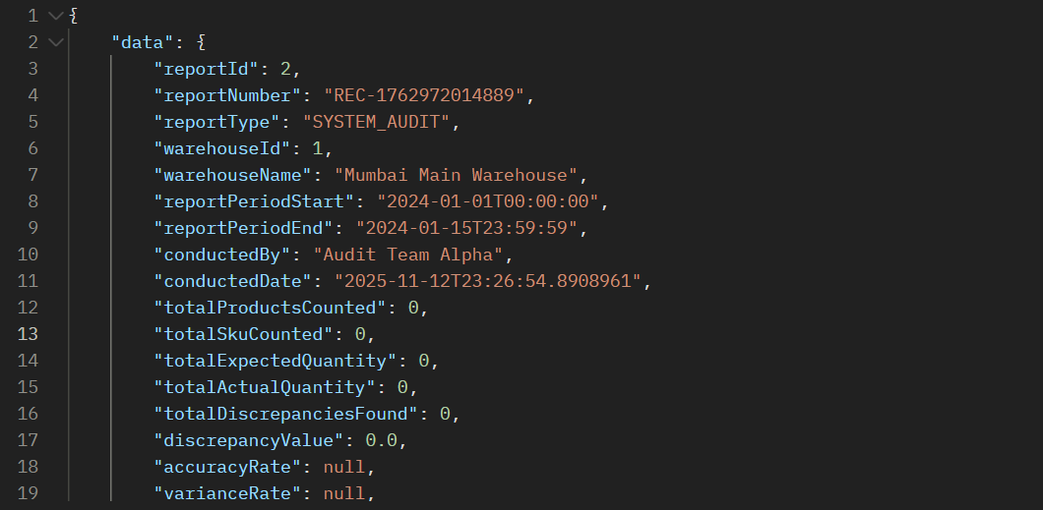

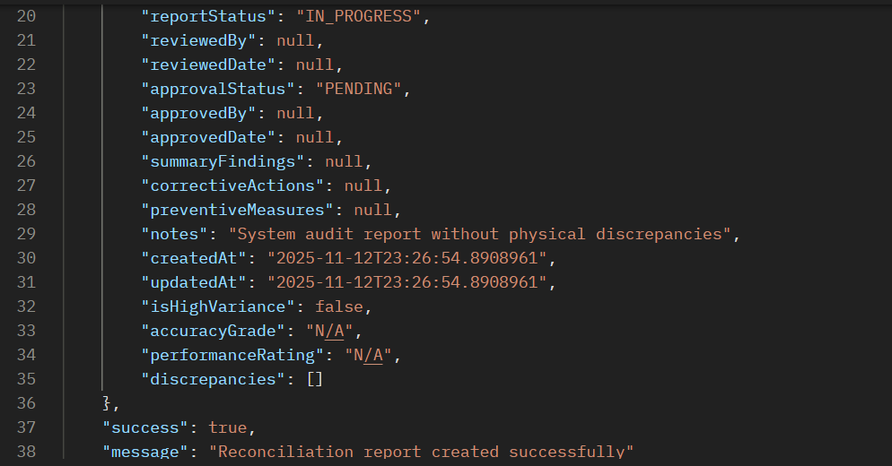

**15.2: Generate Inventory Report**

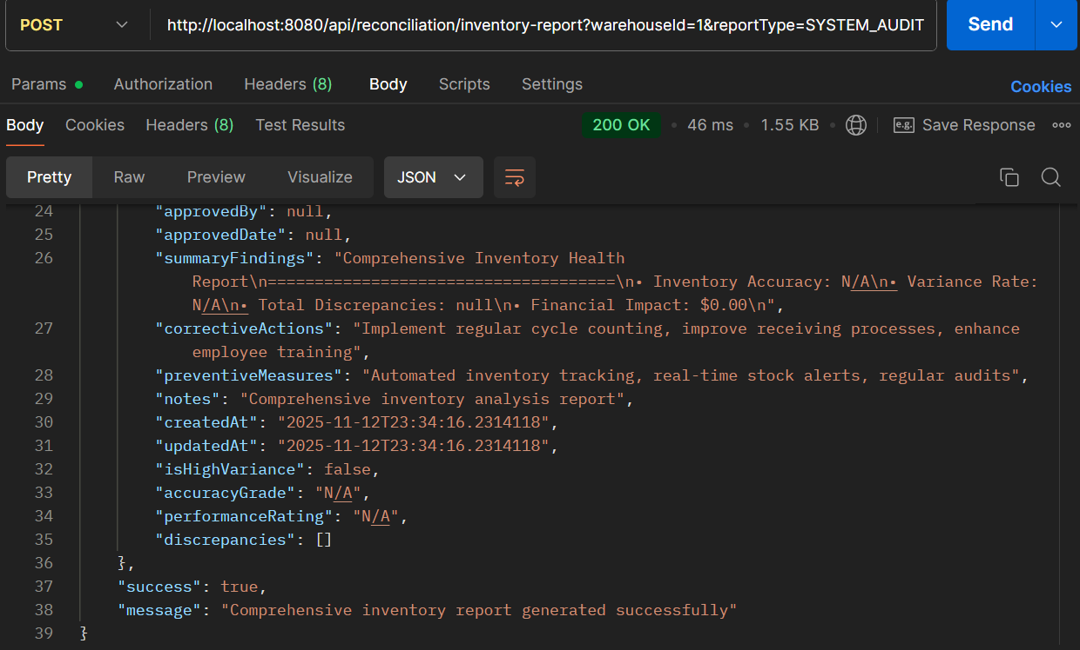

* **API Name: Generate Inventory Report**
* **Endpoint: http://localhost:8080/api/reconciliation/inventory-report?warehouseId=1&reportType=SYSTEM_AUDIT**
* **Method: POST**
* **Description: Generates comprehensive inventory reports with accuracy grading, performance ratings, and discrepancy analysis for specific warehouses and report types.**
* **Request Body:  
  *This endpoint uses query parameters (*warehouseId*and*reportType*) rather than a request body.***
* **Response Body:**

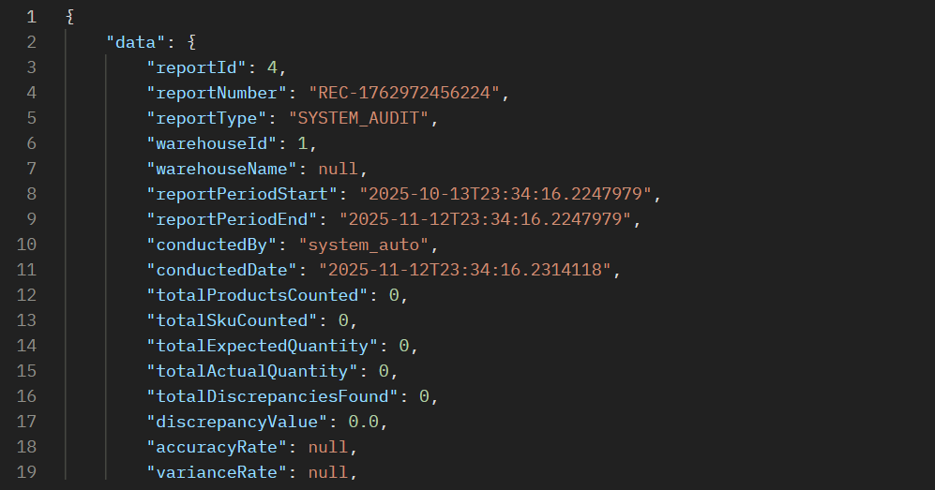

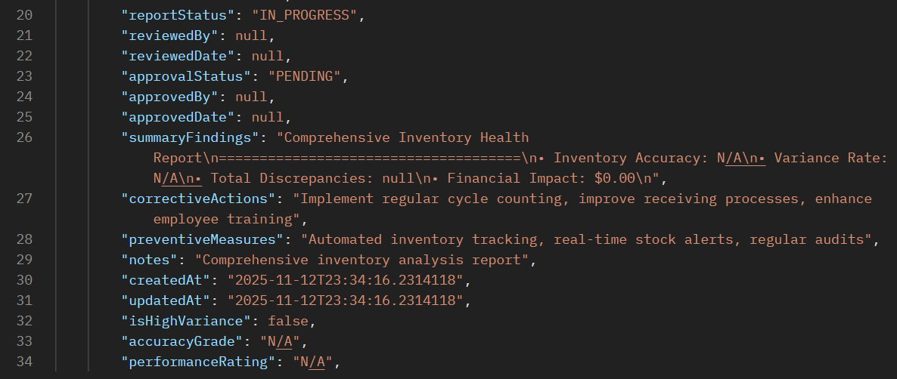

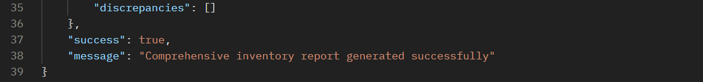

**ERROR SCENARIOS FOR PROCESS 12**

**Error 1: Invalid Report Type**

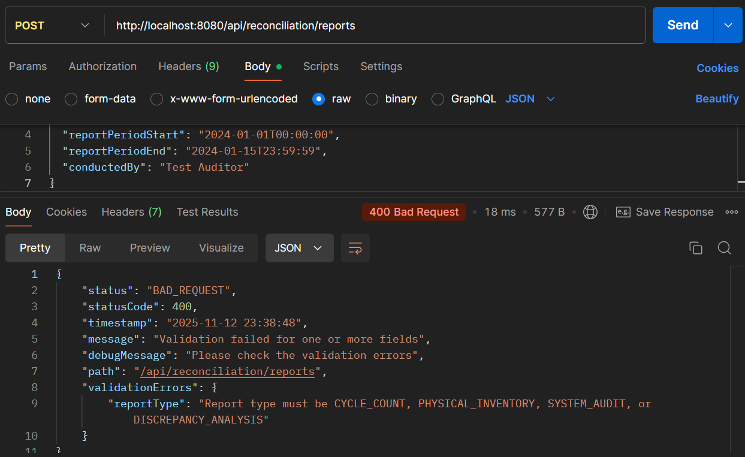

**Error 2: Get Non-existent Report**

